|  |
| --- |
| **Modals** |



**I will go to the mall.**

**I must go to the mall.**

**I have to go to the mall.**

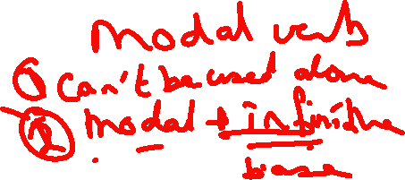

**I can go to the mall.**

**I could go to the mall.**

**I should go to the mall.**

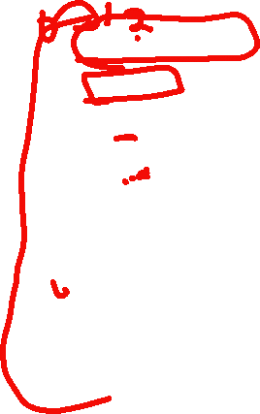

**I might go to the mall.**

**I may go to the mall.**

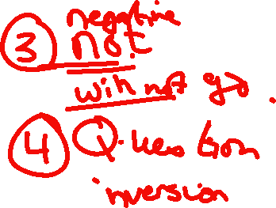

**I would go to the mall.**

**I ought to go to the mall.**

|  |
| --- |
| **Will+ inf** |

**I am hungry. I will buy a sandwich.**

**I will be twenty next month.**

**I will help you with your homework.**

**Will you give me a lift home?**



**I think it will be rainy tomorrow.**

**Modals of Obligation and prohibition**

**Must/have to/should/can**

**Mustn’t/don’t have to/shouldn’t/can’t**

**Obligation**

1. **Must + inf. Internal obligation personal obligation / the speaker ‘s opinion**
2. It’s a ___________

* You **must obey** the school rules.

When the speaker decides that something is necessary.

* You **must listen** to your teacher.
* You **must attend** the meeting.
* I **must finish** the report by tomorrow.

2. I’m __________ logical assumption.



* It’s Sunday, He **must be** at home.
* I’m sure she knows him She **must know** him.



3.**__________________**

Order which is likely to be obeyed



* You **must take** an aspirin to get rid of your headache.
* You **must follow** a healthy diet.

**Prohibition**

1. **Mustn’t+ inf.**

It’s **____________** to do something/you **______________**to do something/it’s_____________.

* You **mustn’t drive** fast. it is forbidden.
* You **mustn’t talk** in the library rule
* You **mustn’t park** your car on double yellow lines it’s against the law.



1. **Have to +inf. 1) External obligation**



**2)** **Facts not for personal rules**

It’s _______________to do something.

* We **have to be** at the airport at 9 o’clock.

Somebody else other than the speaker has made the decision

* You **have to attend** the meeting.
* You **have to take off** your shoes.

**Prohibition**

1. **Don’t/Doesn’t have to/Didn’t have to** **It isn’t necessary to do something but you can if you want.**

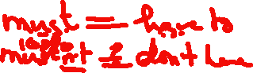

* She **doesn’t have to work** tonight.
* You **don’t have to take** a taxi; dad will drive you to the airport.



1. **Should+ inf. Duty (obligation)**

Should is less emphatic than must

1. Something is **_________________**/**probable.**



* It’s10 o’clock. He **should be** at home.



2. Advice 1)_________________ an action

2) ____________ someone to do something

3) The_______________ to do.

* You **should follow** a healthy diet. a piece of advice which may or may not be followed.



**Prohibition**

1. **Shouldn’t +inf.** You ___________________to do.

* Students **shouldn’t point** at people. It is rude.



* Student **shouldn’t leave** their homework until late in evening.

1. **Can+ inf.**
2. _________ you are **allowed**.

* All citizens over the age of 18 **can/are allowed** to vote.
* You **can have** another piece of pizza if you want.

1. ______________.

* He **can drive** a car.

1. ________  **general** possibility.

* It **can get** very hot in July.
* The streets **can get** very slippery when it rains.
* You **can see** the lake from your window.

**Prohibition**



1. **Can’t +inf.**
2. ________________.

* She **can’t dance**.



1. ____________________________



You **can’t come** in yet-the floor is wet.

