  **Writing Task**

**Our value: Self – belief and hard work will always earn you success**

Name: _____________ Date: / /

Grade (6)

Objective: To practise using past simple and past continuous to describe the picture.

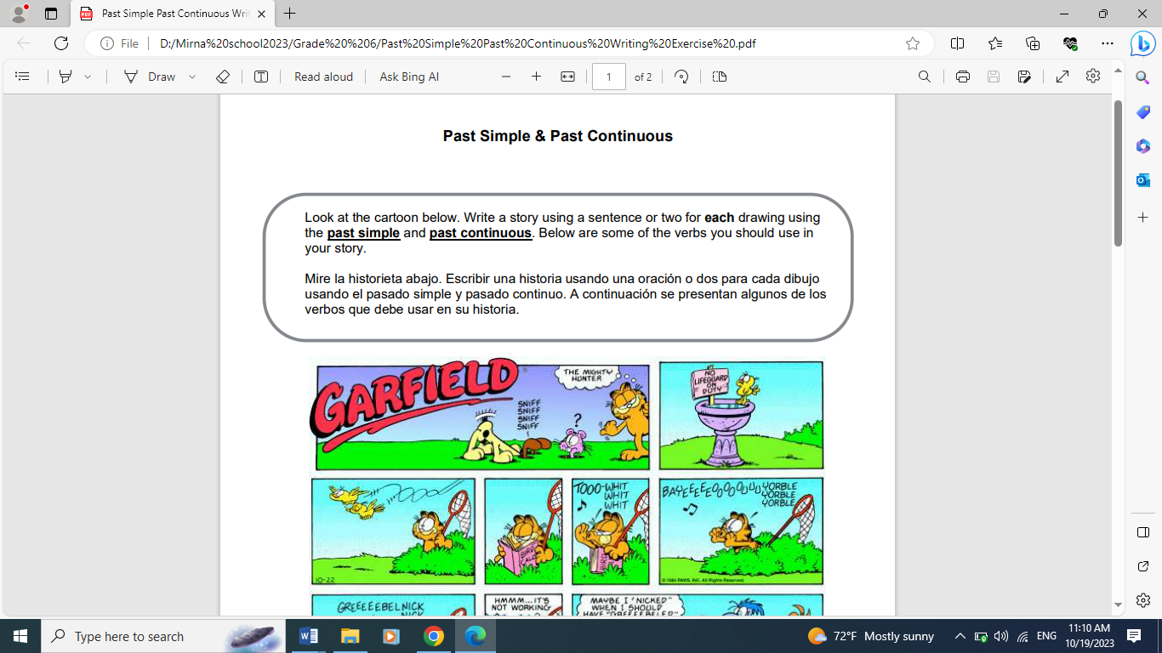

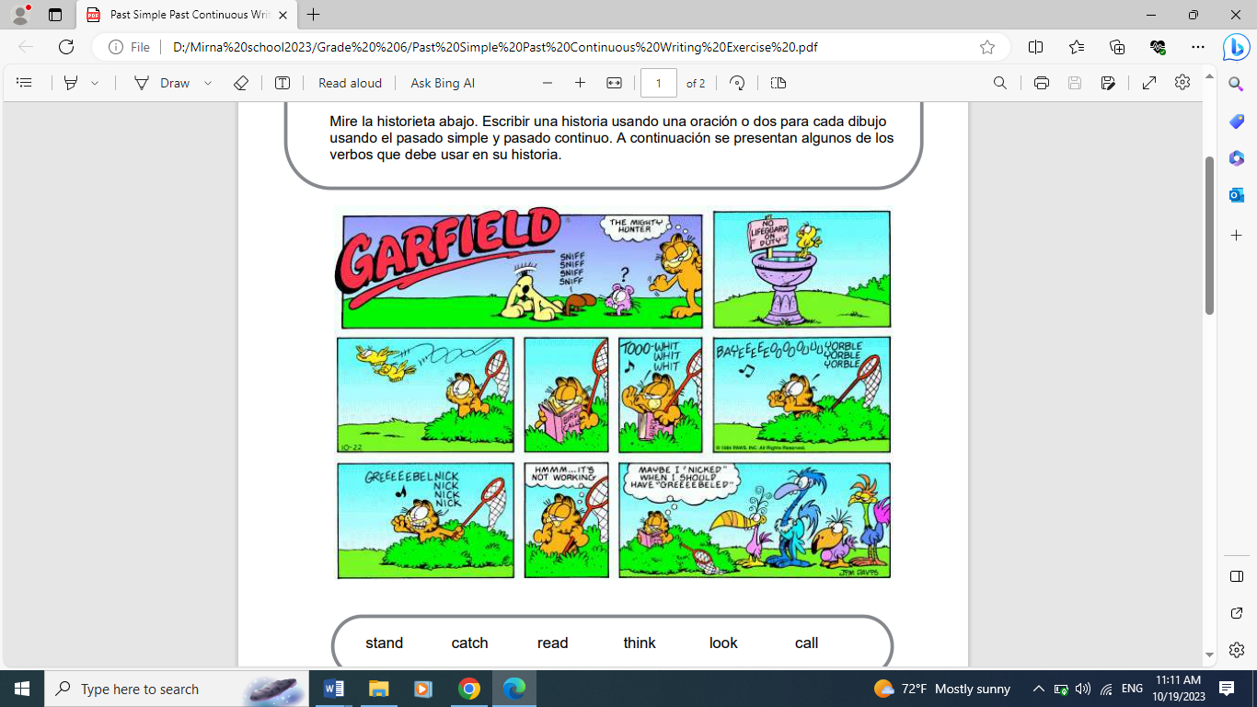

not/be, leave

try, chirp

read, help, catch

walk, see, fly

stand, sniff, search

One day, while Garfield was standing, he saw that Odie was sniffing the ground to search for food. So, he decided to find his food, too. While he was walking, two birds were flying. He decided to catch them. He tried a lot, but unfortunately, he couldn’t catch any of them.

Suddenly, Garfield got an idea. He brought a book about the sounds of the bird’s chirping to help him catch the birds. He tried chirping in different ways, but it didn’t work.

At last, he tried a different sound. While he was chirping, various kinds of huge birds appeared. He wasn’t lucky that day because he couldn’t catch the little birds.

Teacher: Mirna Al-Sahawneh.

Coordinator’s Signature: ___________________