

**Lab Report** **|** Lower Secondary

Stage of (6-8)

1st Semester | 2023-2024

|  |  |
| --- | --- |
| **Subject:** Biology | Lab report: test for food  Name:  Grade 7 (all sections) |
| **Objectives:** To test for the presence of starch, fat, and protein in food. | |

We can test for the presence of these important compounds in food by using chemical reagents that react in predictable ways in the presence of these nutrients.

**Preparing food samples for food tests:**

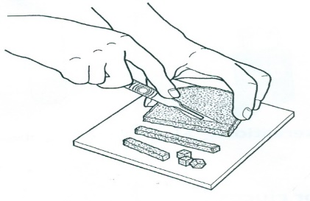Use the following procedure to prepare food samples to be tested for starch, fat and protein.

1. Chop up each food in turn.
2. Grind up a small amount of each in a little water so that the nutrients can be released from the food material, making a suspension.

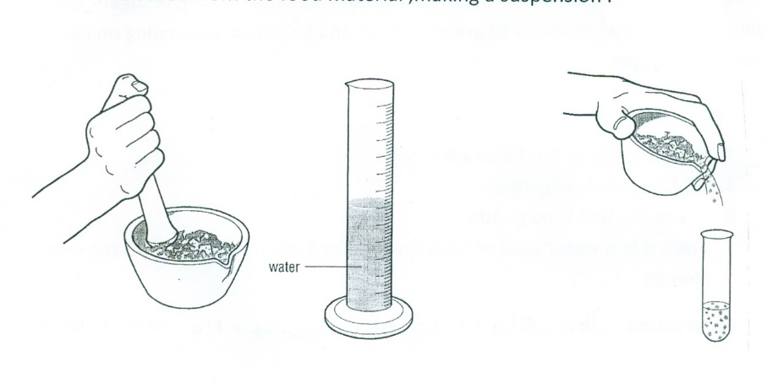

1. Pour the suspension into a test tube.
2. Clean the scalpel, tile, mortar and pestle after each food has been prepared.
3. Make a suitable test for each kind of food.

**Food test 1: Test for starch using iodine:**

* Add three drops of **iodine solution** to each food suspension prepared before.
* Shake the test tube gently.

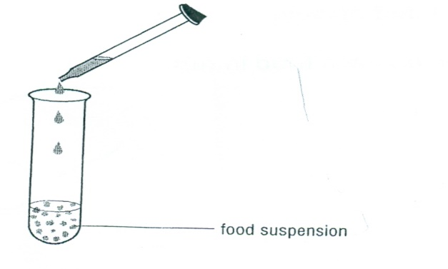

Observation: **the color will change into blue-black.**

**Food test 2: *Test for fat using ethanol:***

* Put a sample of food into a test tube.
* Add **2cm3 of ethanol** and shake.
* Add the ethanol to an equal volume of **cold water.**

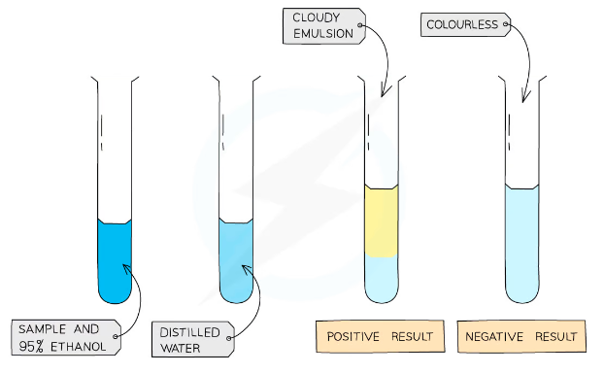

Observation: **a white cloudy layer (emulsion) will form.**

**Food test 3: Test for protein using biuret reagent:**

1. Add a small quantity of food sample in a test tube.
2. Add 3 drops of Biuret reagent to the tube.
3. shake the test tube gently.

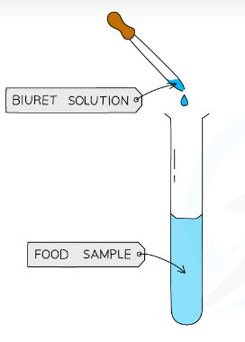

Observation: **the color will change to purple.**

* **Check your understanding:**

Complete the following table.

|  |  |  |
| --- | --- | --- |
| **Food** | **Reagent** | **Positive test result** |
| Starch | Iodine | Turns blue-black |
| Fat | Ethanol | Turns cloudy |
| Protein | Biuret | Turns purple |