**Study Sheet** **|** Lower Secondary

Stage (6-8)

1st Semester | 2023-2024

Name: ________________________

Grade: ________________________

|  |  |
| --- | --- |
| **Subject:** English – **Proofreading Skills** | **Unit 2: Amazing Arts** |
| **Objective:**   * To practice the skill of proofreading. | |

**What is proofreading?**

Proofreading is simply careful reading. As you review every word, sentence, and paragraph, you will find errors. Once you find these errors, start fixing them.

**Common errors include:**

* **capitalization and punctuation**
* **fragment sentences**
* **spelling**
* **grammar**

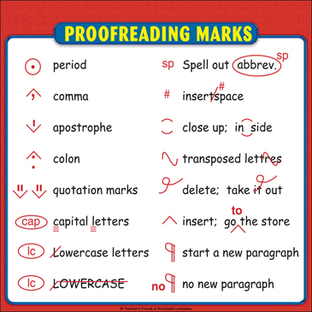**These are some common symbols used to indicate mistakes while proofreading:**

**Practice one:**

**Read the following text and underline the mistakes, then rewrite the corrected text on the lines provided.**

**What is a healthy diet?**

Eating a healthy diet are not about strict limitations, staying unrealistically thin, or depriving yourself of the foods you loves. rather, it’s about feeling great, having more energy, improvng your health, and boosting you’re mood.

healthy eating don’t has to be overly complecated. If you feel overwhelmed by all the conflicting nutrition and diet advice out their you’re not alone. It seems that for every expert who tell you a certain food is good for you, you’ll find another saying Exactly the oposite. The truth is that while some specific foods or nutrients have been shown to have a beneficial effect on mood it’s your overall dietary pattern that is most important. the cornerstone of a healthy diet should be to replacing processed food with real food whenever possible. eating food that is as close as possible to the way nature made it can making a huge difference to the way you think, look, and feel

By using these simple tips, you can cut through the confusion and learn how to create—and stick to—a tasty, varied, and nutritious diet that are as good for your mind as it is for your body

_________________________________________________________________________

_________________________________________________________________________

_________________________________________________________________________

_________________________________________________________________________

_________________________________________________________________________

_________________________________________________________________________

_________________________________________________________________________

_________________________________________________________________________

_________________________________________________________________________

_________________________________________________________________________

_________________________________________________________________________

_________________________________________________________________________

_________________________________________________________________________

_________________________________________________________________________

**Practice two:**

* **Read** the following sentences.
* **Write** correct or incorrect in the brackets (in case of being incorrect, identify the type of mistake).
* **Fix** the incorrect sentences on the line provided

1. Although I was sick I went to school ( )

__________________________________________________________

1. I went to the park and my mom came. ( )

____________________________________________________________

1. I walk to the store and bought milk. ( )

____________________________________________________________

1. Anna and mike is going skiing. ( )

_____________________________________________________________

1. I fed all the fish, then cleaned its tank. ( )

_____________________________________________________________