**Second Month Study sheet |** Lower Secondary

Stage (6-8)

|  |  |
| --- | --- |
| **Name:** …………………………………………………………………….. | **Subject: English/ Writing Narrative** |
| **Date: / /** | **Class:** Grade 6 |



This kind of writing can be found in novels and articles and it can be written in the first, second or third person.

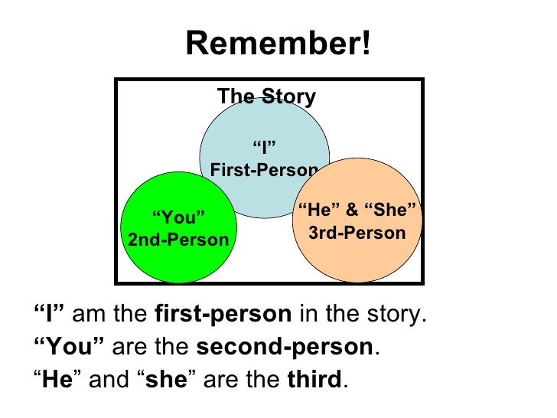

**A good narrative should consist of:**

1. **To attract the reader’s attention**



1. **Introduction:** You set the scene (people, time and place in an interesting way to catch the reader attention and make him /her to continue reading your story.
2. **Main body:** Consisting of two or more paragraphs in which you develop your story.
3. **Conclusion:** In which you can refer to people’s feelings, comments and reactions. The more unpredictable your conclusion is, the longer lasting the impression it will make on the reader.



**Points to consider:**   
1. You should never start writing your story before you have decided on a plot.

2. Use various adjectives and describe feelings and actions.

3. Be careful with tenses you choose.  
You can use **past continuous** to set the scene, **Past simple** to describe the main events, **Past perfect** to give the background of the story.

4. Description of people, places, objects, or events and descriptive techniques can be used in a narrative when you want to emphasise specific parts of your narrative.

**Techniques to begin your story:**

* + **Describing weather, people, surrounding, etc. using the senses.**
  + **Using direct speech.**
  + **Asking a question which expects no answer.**
  + **Creating mystery or suspense**

**Example;**

**“One Hundred Dollars”**

**Leonard James is a homeless man. For him, life is always hard. He is always hungry. His shoes have holes in them. He needs a haircut. His clothes are old and dirty.**

**“What I would do with one hundred dollars!” Leonard says.**

**This is a game he likes to play with himself to take his mind off things.**

**He is walking down the street on a Thursday night. The winter air is cold on his face. “If I had one hundred dollars, I could buy new socks,” he says.**

**He continues to walk down the street. “If I had one hundred dollars, I could get a haircut,” he says. He continues to walk down the street. “If I had one hundred dollars, I could buy new pants,” he says.**

**He continues to walk down the street. “If I had one hundred dollars, I could get a hamburger,” he says.**

**His stomach rumbles at the thought. “If I had….” Leonard looks down at the sidewalk. He cannot believe what he sees! Someone has lost his wallet. Leonard picks it up.**

**Inside are five twenty-dollar bills. “One hundred dollars!” Leonard says. He is very excited. “Now I can buy everything I want!” Then Leonard begins to think. “But this is not my money,” he says. Leonard goes to the police station.**

**He gives a police officer the wallet and money. “Thank you,” says the police officer. “You are a very honest man.” Leonard smiles. He turns around and begins to leave the police station. “Hold on,” the police officer says. He reaches in his own pocket and gives Leonard ten dollars. “Get yourself something to eat.**