**Study Sheet 2|** Lower Secondary

Stage (6-8)

1st Semester | 2023-2024

|  |  |
| --- | --- |
| **Subject:** ICT | **Chapter:** 3 |
| **Objectives:**   * Use the commands input, print and int, identify variables correctly. | |

**Python-Program #1**

Write a python program to input a name and then print “Hello” followed by the name that the used will input.

Inputs: Name

**Start**

**Input Name**

**Print “Hello”, Name**

**End**

Output : Hello *Name*

**Python**

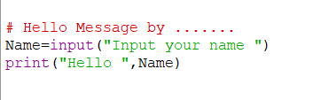

**Flowchart**

**Python-Program #2**

**Start**

**input**

**Num1 Num2**

**Print Total**

**Total=Num1+Num2**

**End**

Write a python program to add and print the total of two numbers.

Inputs: Num1, Num2

Process: Total=Num1+Num2

Output: Total

**Python**

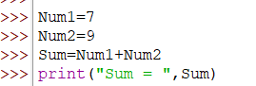

**Flowchart**

**Python-Program #3**

Write a python program to calculate and print the average of three numbers.

**Start**

**input**

**A,B,C**

**Print “Average =”, Average**

**Average=(A+B+C)/3**

**End**

Inputs: A, B, C

Process: Average=(A+B+C)/3

Output: Average = 7.66

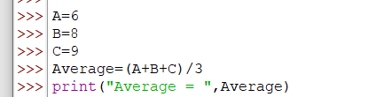

**Flowchart**

**Get Input**

In this part the Python program asks the user to input values for variables.

To get user input in Python we use the command **input**.

Examples:

The user must input his name and the computer will save it in the variable name

* name = input (“what is your name? “)

String variable

The user must input a number and the computer will save it in the variable length as a number.

* length = int (input (“input length”)

Numeric variable

**int – it’s an abbreviation of integer which convert the text into a number.**

**Python-Program #4**

Write a python program to calculate and print the Total and Multiplication of two numbers input by the user.

**Start**

**input**

**N1 N2**

**Print Sum,Mul**

**Sum=N1+N2**

**End**

**Mul=N1*N2**

Inputs: N1, N2

Process: Sum=N1+N2 / Mul=N1*N2

Output: Sum, Mul.

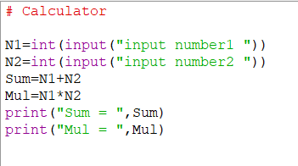

**Python-Program #4**

Write a python program to input the length and width of a rectangle and then calculate and print the area of the rectangle.

L – Length / W – Width / A – Area A = L*W

**Start**

**Input L, W**

**Print “Area =”, Area**

**Area = L*W**

**End**

Inputs: L, W

Process: Area = L * W

Output: print Area

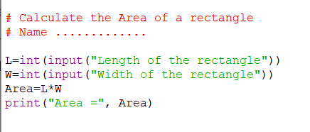

**Error messages**

Programmers sometimes make mistakes. A simple typing error can stop your program working. Text color can help you to find errors before you run the program.

But sometimes errors remain when you run the program. That is OK. Python will find the mistake. It will stop the program and show you an error message.

**Python’s error message will help you to work out what the error is.**

|  |  |
| --- | --- |
| **Wrong statements** | **Correct statement** |
| print(hello) | print(“hello”) |
| Print(“Smart”) | print(“Smart”) |
| A= Int(A) | A=int(A) |