**Writing Study Sheet** **|** Lower Secondary

Stage (6-8)

1st Semester | 2023-2024

|  |  |
| --- | --- |
| **Subject:** English | **Unit:** 2 |
| **Objectives:**   * To realize how to write a newspaper report.   **Name:** __________________________________________  **Grade 6CS: Section:** C, D, E, F, G | |

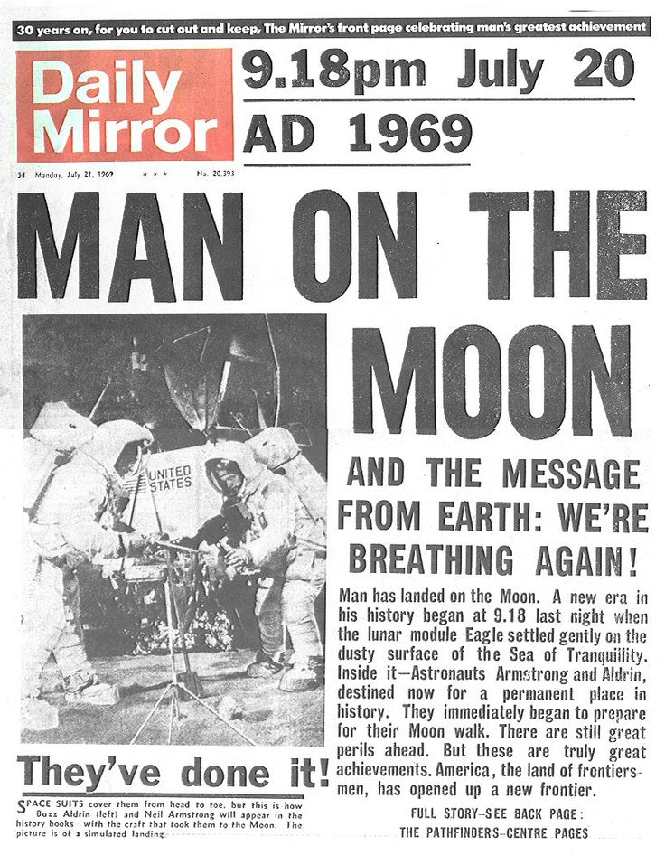

* The key elements of a News Report are:
  1. **Headline**



* + - Catches your attention
    - Sums up the story
  1. **Byline**
     + Writer’s name
     + Writer’s Specialty, e.g. sports, food, crime, current events
  2. **Lead**

4.

* The opening section
* Gives most important information
* Should answer most of the 5W's
  1. **Body**
     + Supplies detail
     + Most important details come first
     + Simple true statements
  2. **Quotation**
     + What someone actually said
     + Adds accuracy
     + Adds “at the scene” feeling



**Task:**

Write a **news report** based on the headline and picture below.

* You will have to make up the facts and information by answering some

or all of the following questions: Who? What? Where? When? Why? How?

* You must relate your newspaper report to **both** the headline **and** the picture.

**Purpose and**

**Audience:** to report on an event for the readers of a newspaper

**Length:**

The lined space provided for your written work indicates the approximate length of the writing expected.

**Before you submit your work:**

* **Read your news report.**
* **Answer the following questions as you read through the report!**

|  |  |  |
| --- | --- | --- |
| **YES** | **NO** | **Is the report related to the headline?** |
| **YES** | **NO** | **Are all 5 W’s present?** |
| **YES** | **NO** | **Is enough detail used?** |
| **YES** | **NO** | **Is there a quotation used?** |
| **YES** | **NO** | **Did you use third person narration?** |
| **YES** | **NO** | **Did you use proper spelling and grammar?** |
| **YES** | **NO** | **Is there a byline?** |
| **YES** | **NO** | **Is there a good lead paragraph?** |

* **Practice:**

Write a newspaper report according to the provided topic “Donation Day at NOS”

**Donation Day at NOS**



**_______________________________________________________________________________________________________________________________________________________________________________________________________________________________________________________________**

**_____________________________________________________________________________________________________________________________________________________________________________________________________________________________________________________________________________________________________________________________________________________________________________________________________________________________________________________________________________________________________________________________________________________________________________________________________________________________________________________________________________________________________________________________________________________________________________________________________________________________________________________________________________________________________________________________________________________________________________________________________________________________________________________________________________________________________________________________________________________________________________________________________________________________________________________________________________________________________________________________________________________________________________________________________________________________________________________________________________________________________________________________________________________________________________________________________________________________________________________________________________________________________________________________________________________________________________________________________________________________________________________________________________________________________________________________________________________________________________________________________________________________________________________________________**

|  |  |
| --- | --- |
| **CRITERION** | **MARKS** |
| **Creation of texts** | **/5** |
| **Vocabulary and Language** | **/3** |
| **Grammar and Punctuation** | **/7** |
| **Structure of texts** | **/7** |
| **Word Structure [Spelling] and the use of wide variety of words** | **/3** |
| **Total** | **/25** |