**Study Sheet -1** **|** Lower Secondary

Stage (6-8)

1st Semester | 2023-2024

|  |  |
| --- | --- |
| **Subject:** ICT | **Chapter:** 3  (Programming Language) List in Python |
| Grade: 8  Objectives:   * How to store a series of items as a list. * How to add, delete and edit items in the list. * Sort, length, remove, | |

**List syntax:**

**Name_of_list= [element1, element2, ……….]**

Example:

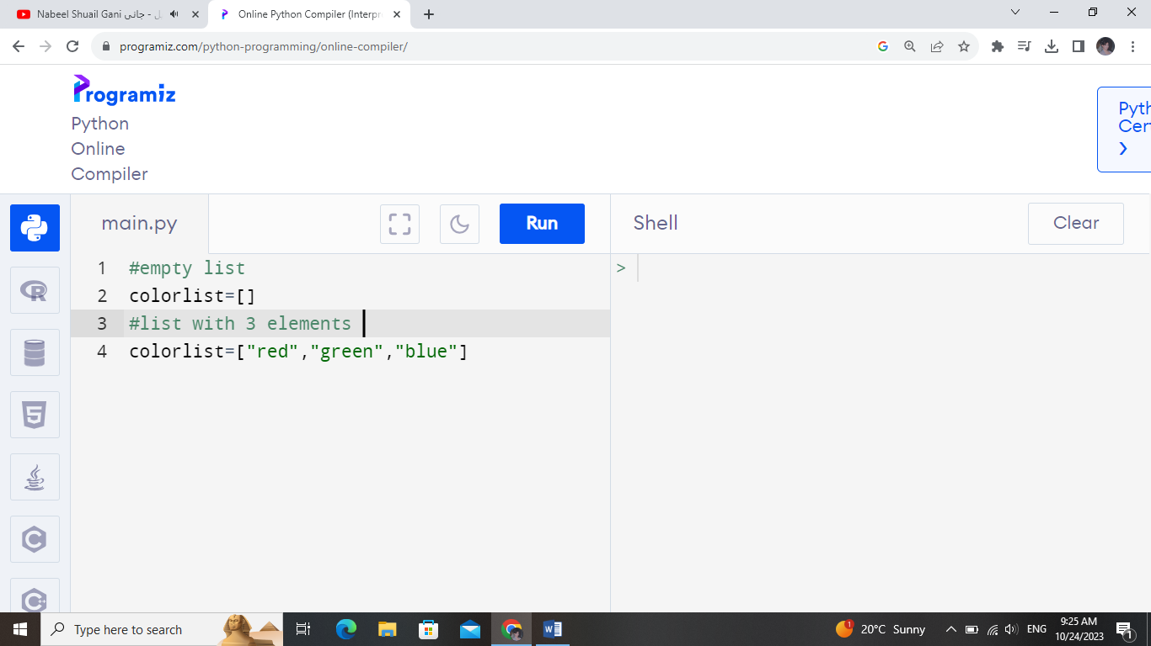

**The append () method adds an item to the end of the list.**

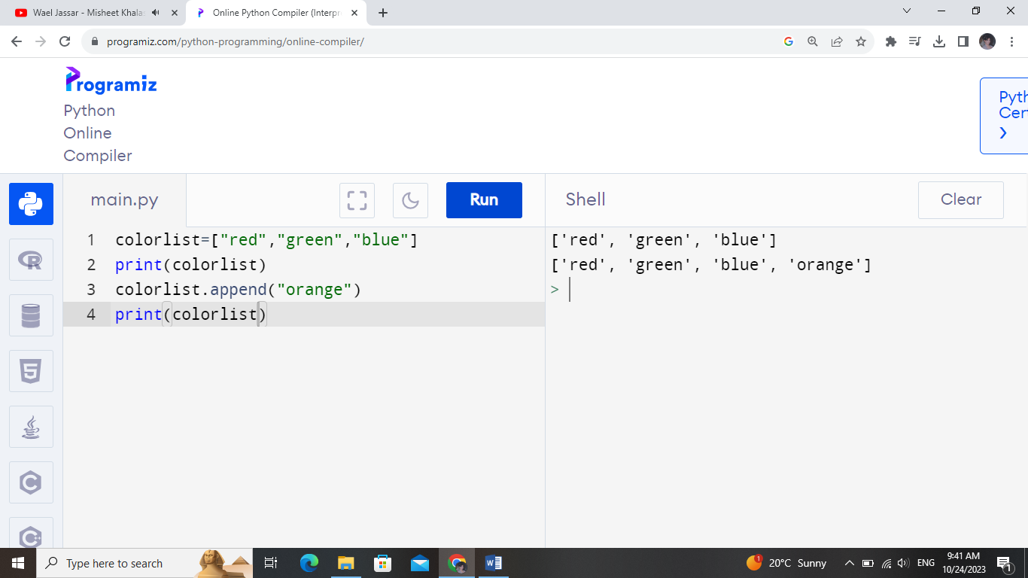

**Get input from the user and add the value to the list**

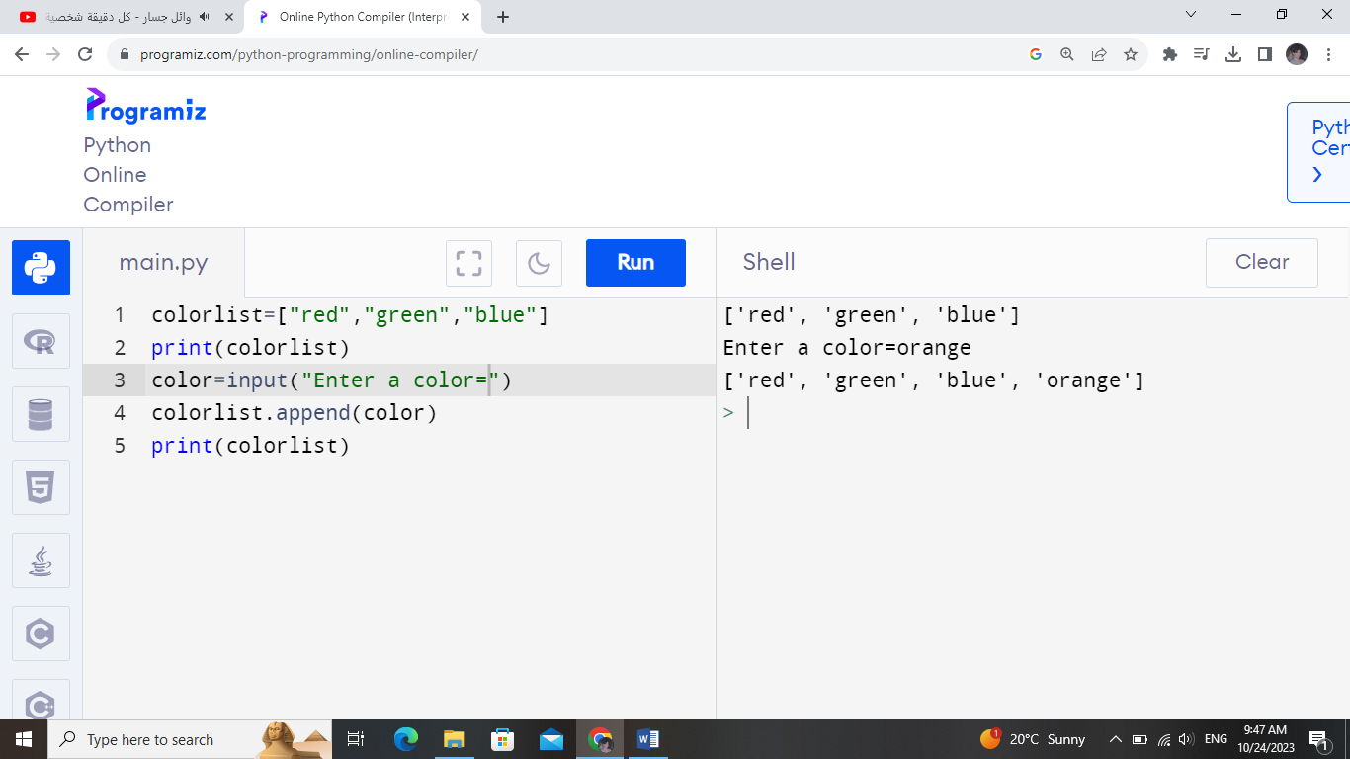

**Index Number: is the position of the element in the list.**

|  |  |  |  |  |  |
| --- | --- | --- | --- | --- | --- |
| **Element** | Element 1 | Element 2 | Element 3 | Element 4 | Element 5 |
| **Index** | 0 | 1 | 2 | 3 | 4 |

**For example, to print the first element**

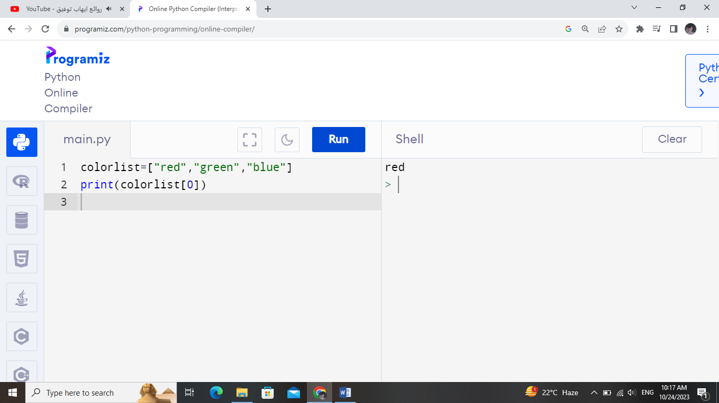

**Edit an element:**

**Change the last element in the list:**

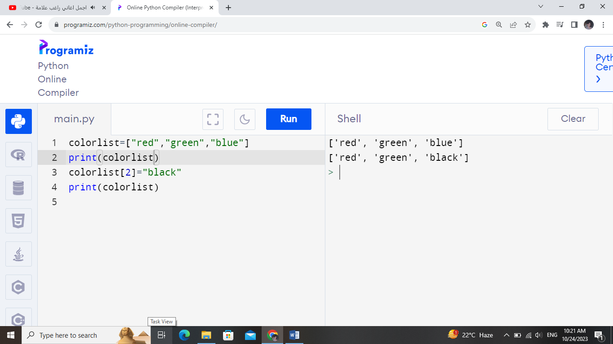

**Delete an element (using its index):**

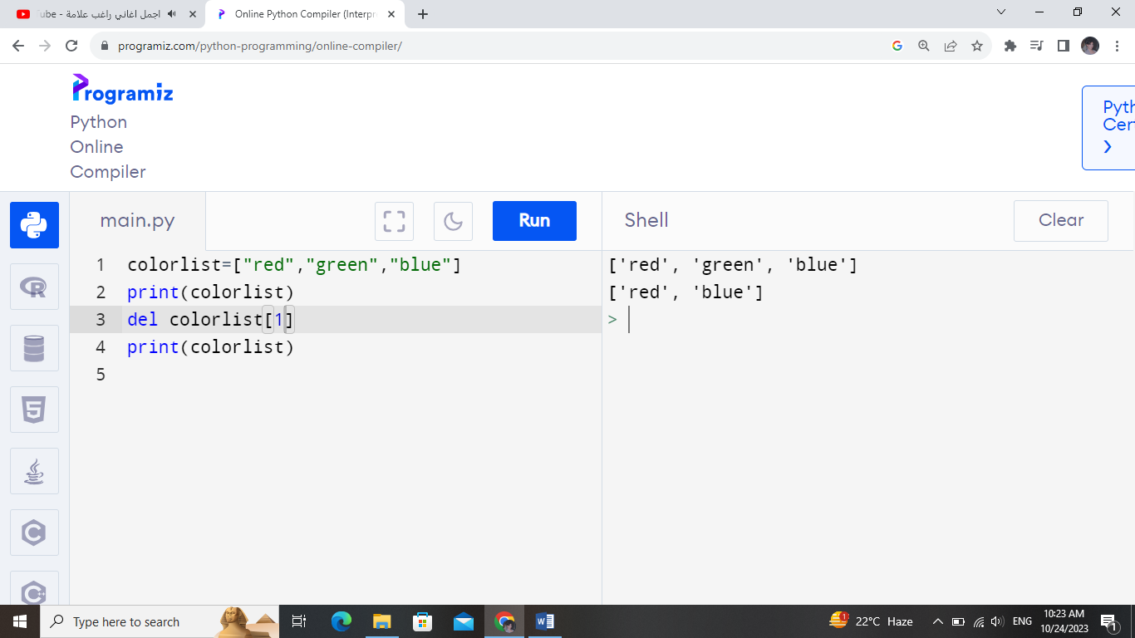

**Delete an element (using its value):**

**The remove () method removes the first matching element (which is passed as an argument) from the list.**

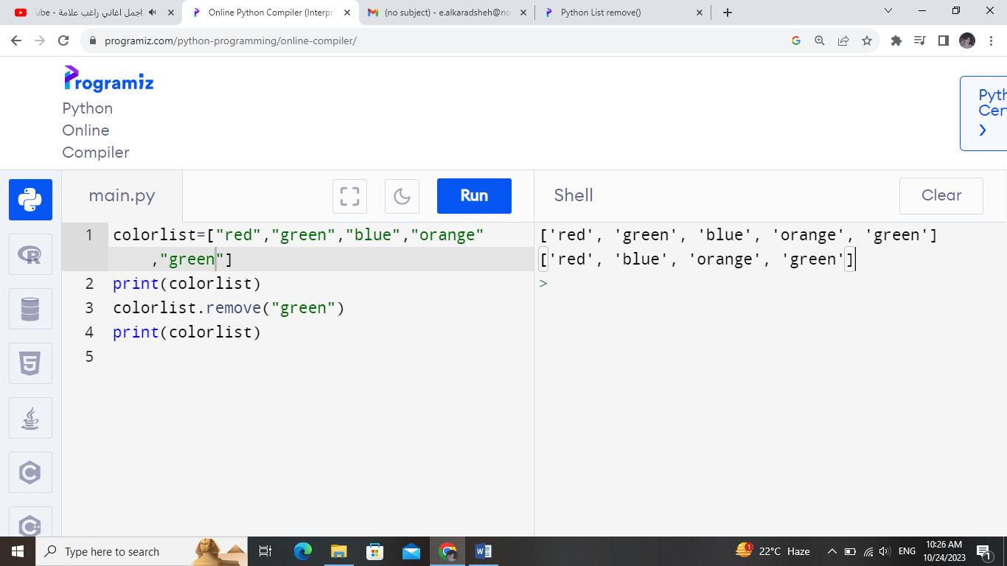

**Note:   
If you enter a number exceeding the index of the last element, it is an error**

**This type of error is called an out-of-bounds error.** 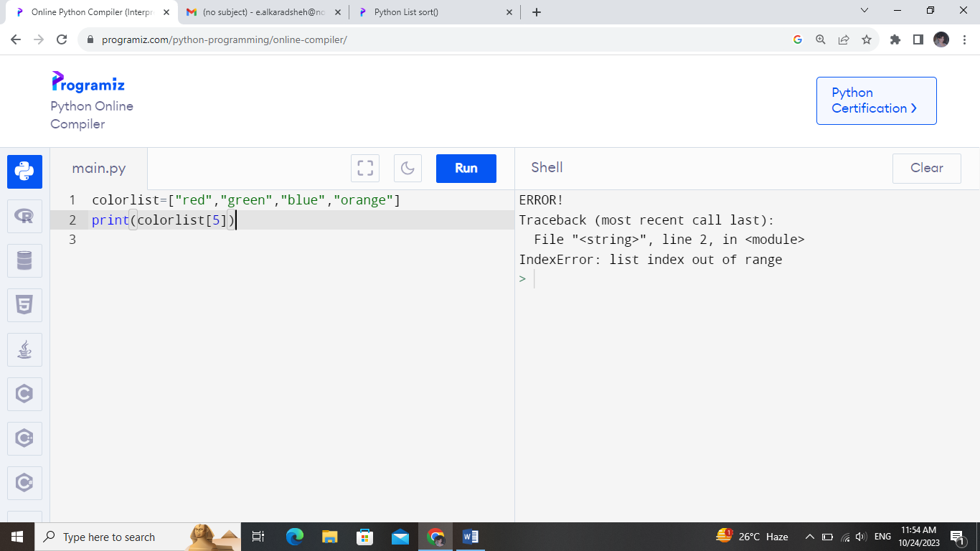

**The len() method tells the length of a string or a list.**

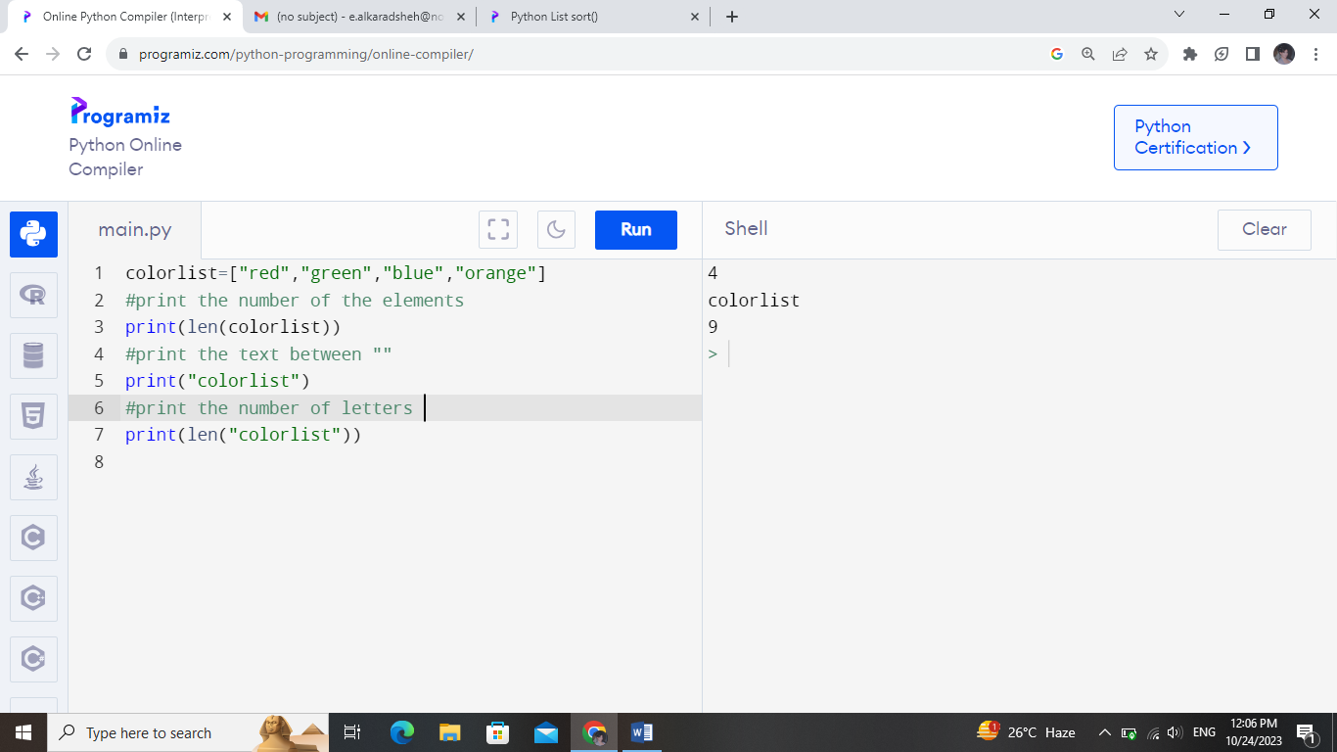

**The sort () method sorts the items of a list in ascending or descending order.**

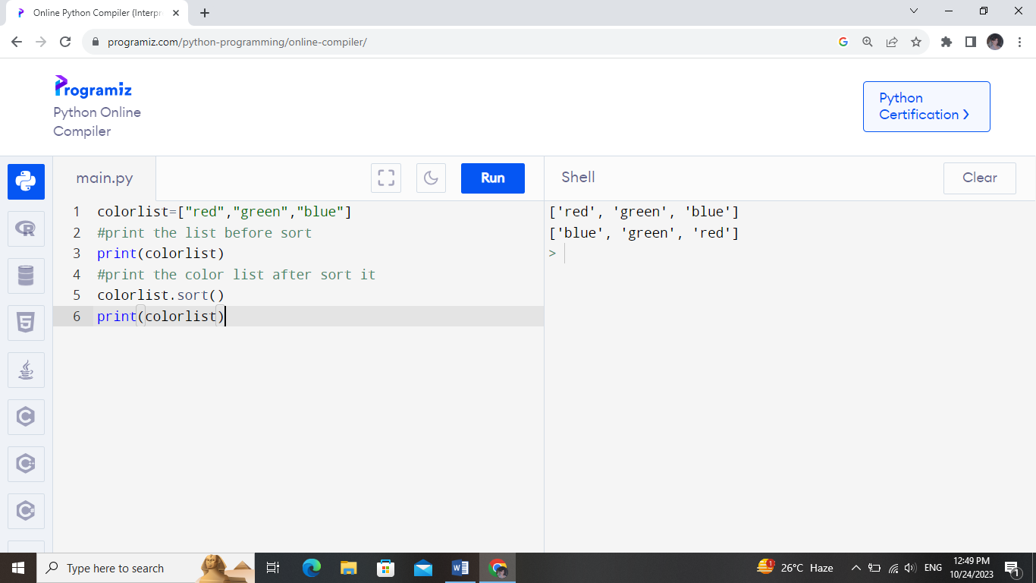

**Also, sort the numbers**

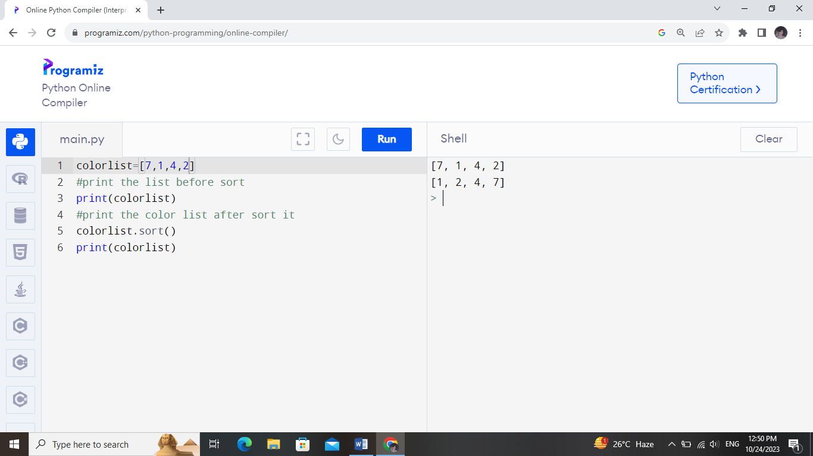

**The count () method returns the number of times the specified element appears in the list.**

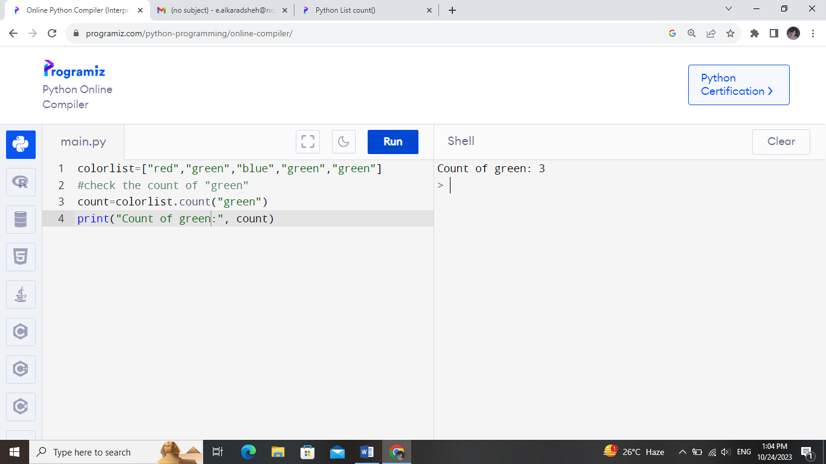

**The reverse () method reverses the elements of the list.**

