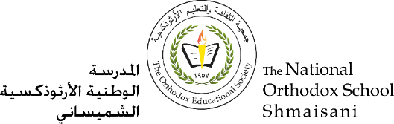

**The Primary Stage (4-5)**

**First Semester 2022-2023**

**Name** : **Subject** : Sharks/ Key

**Date : / / Class : Grade 4 CP (All Sections)**

**_____________________________________________________________**

**Objective/s:** To read a text and answer related questions

To revise concept covered for the second month assessment.

1. Name 2 species of sharks?

Great white shark and hammerhead shark.

1. Which countries have had the most shark attacks?

Australia, South Africa, America and Brazil.

1. How small is the smallest shark?

One of the smallest sharks is the dwarf lantern shark, which is usually only around 17cm in length.

1. Do all species of sharks attack humans? Explain your answer.

No- some types of sharks can be deadly, but only 12 species have been involved in human attacks.

1. Why have some humans hunted sharks and what has this led to?

Humans are very harmful to sharks as they illegally hunt them for their meat, organs and skin. This has led to the great white shark becoming an endangered species.

1. What is special about a shark’s teeth?

Sharks have many rows of replacement teeth, which grow on the inside of their jaws and move forward when needed.

1. What are baby sharks able to do straight away and why?

Baby sharks are born already able to take care of themselves. They have to swim away fast as some mothers try to eat their own pups and their own siblings can even attack them.

1. Tick (√ ) two boxes that you know are true from the passage. ( /2 marks)
2. They are more than 500 species of sharks.

√

1. A group of sharks is called a pup

√

1. The largest shark in the world can measure up to 14 metres long
2. Sharks can smell the blood in the water from 500 metres away.
3. Mention two features of a non-chronological report.

Third person.

Present tense.

Written in formal style

Gives factual information.

1. What is the purpose of the subheadings?

Subheadings are used in order to organise and find information more easily.

1. Refer to the extract and answer the following:
2. Find a word in the third paragraph that means “ **at risk of extinction**” endangered
3. Find a word in the fourth paragraph that means “ **a brother or sister**” sibling