

**Our value: Self – belief and hard work will always earn you success**

**Past Continuous**

Grade 6(A + B)

Name: _______________ Date: / /

Objectives: To review the past continuous tense.

To practise using the past continuous.

The past continuous (also called past progressive) is a [verb tense](https://www.englishpage.com/verbpage/verbtenseintro.html) which is used to show that an ongoing past action was happening at a specific moment of interruption, or that two ongoing actions were happening at the same time.

**Past Continuous Forms**

|  |  |  |
| --- | --- | --- |
| Positive | Negative | Question |
| I **was singing**. | I **was not singing**. | **Was** I **singing**? |
| You **were singing** | You **were not singing**. | **Were** you **singing**? |
| We **were singing**. | We **were not singing**. | **Were** we **singing**? |
| They **were singing**. | They **were not singing**. | **Were** they **singing**? |
| He **was singing**. | He **was not singing**. | **Was** he **singing**? |
| She **was singing**. | She **was not singing**. | **Was** she **singing**? |
| It **was singing**. | It **was not singing**. | **Was** it **singing**? |

**Past Continuous Uses**

**USE 1 Interrupted Action in the Past**

past continuous interrupted action

Use the past continuous to indicate that a longer action in the past was interrupted. The interruption is usually a shorter action in the simple past. Remember this can be a real interruption or just an interruption in time.

Examples:

* I **was watching** TV when she called.
* When the phone rang, she **was writing** a letter.
* While we **were having** the picnic, it started to rain.
* What **were** you **doing** when the earthquake started?
* I **was listening** to my iPod, so I didn't hear the fire alarm.
* You **were not listening** to me when I told you to turn the oven off.
* While John **was sleeping** last night, someone stole his car.
* Sammy **was waiting** for us when we got off the plane.
* While I **was writing** the email, the computer suddenly went off.
* A: What **were** you **doing** when you broke your leg?  
  B: I **was snowboarding**.

**USE 2 An action that was happening at a specific time in the past.**

past continuous specific time

Examples:

* Last night at 6 PM, I **was eating** dinner.
* At midnight, we **were** still **driving** through the desert.
* Yesterday at this time, I **was sitting** at my desk at work.

**USE 3 Parallel Actions ( two actions that were happening at the same time in the past)**

past continuous parallel actions

When you use the past continuous with two actions in the same sentence, it expresses the idea that both actions were happening at the same time. The actions are parallel.

Examples:

* I **was studying** while he **was making** dinner.
* While Ellen **was reading**, Tim **was watching** television.
* **Were** you **listening** while he **was talking**?
* I **wasn't paying** attention while I **was writing** the letter, so I made several mistakes.
* What **were** you **doing** while you **were waiting**?
* Thomas **wasn't working**, and I **wasn't working** either.
* They **were eating** dinner, **discussing** their plans, and **having** a good time.

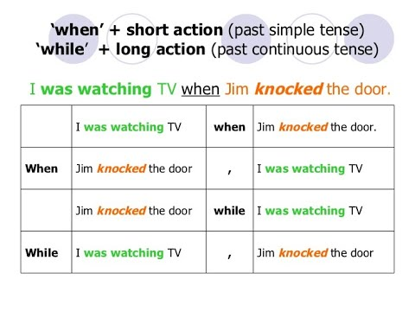

#### **Practice**

#### **Put the verbs into the correct past forms (past continuous or past simple).**

1. When I phoned my friends, they **(play)**were playing monopoly.
2. Yesterday at six I **(prepare)** was preparing dinner.
3. The kids **(play)** were playing in the garden when it suddenly began to rain.
4. I **(practice)** was practicing the guitar when he came home.
5. We **(not / cycle)**weren’t cycling all day.
6. While Alan **(work)** was working in his room, his friends **(swim)were swimming** in the pool.
7. I tried to tell them the truth but they **(not / listen)** weren’t listening.
8. What **(you / do)** did you do yesterday?
9. Most of the time we **(sit)** were sitting in the park.
10. I **(listen)** was listening to the radio while my sister (watch) was watching TV.
11. When I arrived, they **(play)** were playing cards.
12. We **(study)** were studying English yesterday at 4:00 pm.

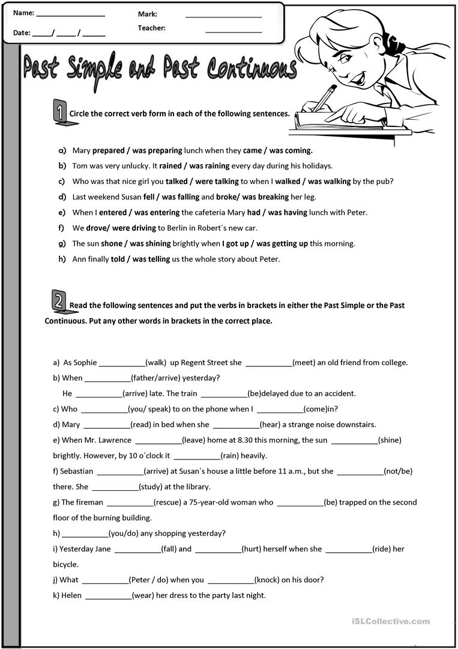

Teacher: Mirna Nawaf Al-Sahawneh.

Coordinator’s Signature: --------------------------------------