|  |  |  |
| --- | --- | --- |
|  | **The King Hussein** |  |
|  |  |
|  | **Cancer Center** |  |

The King Hussein Cancer Center (KHCC) is Jordan’s only comprehensive cancer treatment centre. It treats both adult and paediatric patients. As the population of the country increases, more and more families will rely on the hospital for cancer treatment. Patients come not only from Jordan but also from other countries in the region, as they are attracted by its excellent reputation, lower costs, and cultural and language similarities.



In order to cope with the increase in demand for treatment, the KHCC has begun an expansion programme. Building started in 2011 CE. The hospital will have more than doubled its capacity by 2016 CE, increasing space for new cancer cases from 3,500 per year to 9,000.

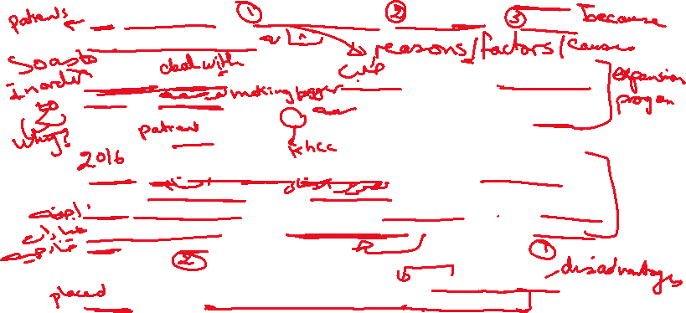

By then, they will have added 182 extra beds, along with bigger units for different departments, including radiotherapy. New adult and paediatric wards will have opened. Additionally, they will have built a special ten-floor outpatients’ building, with an education centre which will include teaching rooms and a library.

Many cancer patients live far away from Amman, **where** the KHCC is located, and the journey to and from the hospital is often difficult. For this reason, there are plans to extend cancer care facilities to other parts of Jordan. In the near future, King Abdullah University Hospital in Irbid hopes to set up radiotherapy machines, so that cancer patients from northern Jordan will not have to go to Amman for radiotherapy treatment



|  |  |  |
| --- | --- | --- |
|  |  |  |
|  |  |
|  |  |  |