** Past Continuous tense**

**Our value: Self – belief and hard work will always earn you success**

**Name ………………… Grade (7)**

|  |
| --- |
| **Objectives**  1.To review the form and the uses of the past continuous tense.  2. To use the tense in sentences. |

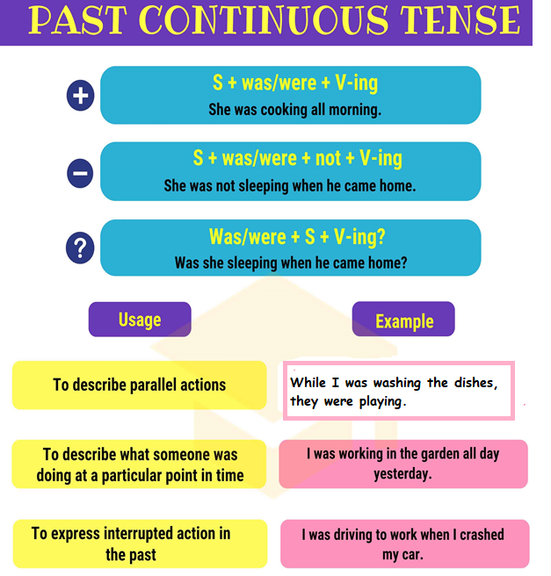

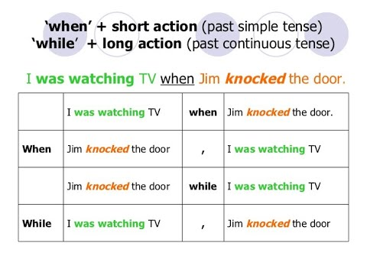

**A) Choose the correct verbs to make the sentences in the past continuous tense.**

1. The boy ————————— at 8 o’clock yesterday.

a. is sleeping

b. was sleeping

c. were sleeping

2. I ———————– when the lights went out.

a. was reading

b. were reading

c. am reading

3. She ———————– the clothes at 3 o’clock last week.

a. is washing

b. was washing

c. were washing

4. I ————————- dinner when the visitors -----------------.

a. am cooking / was arriving

b. was cooking/ arrived

c. were cooking / arrived

5. Julia ————————- her homework at 8 pm last night.

a. did

b. was doing

c. were doing

6. James ————————– the car when I called him.

a. was repairing

b. were repairing

c. is repairing

7. Janet ————————- for the play at 4 o’clock yesterday.

a. were rehearsing

b. is rehearsing

c. was rehearsing

8. Sophia ————————– for the bus when I saw her.

a. was waiting

b. has waiting

c. were waiting

9. The birds ————————– while I was having my coffee.

a. was singing

b. were singing

c. have singing

10. The boys ———————— their English lesson while they were playing in the class.

a. was learning

b. were learning

c. are learning

**B) Use the past continuous tense to finish these sentences using the verbs in brackets and write the use under each sentence.**

1. She was getting dressed when I came home. (**get**)

Use: interrupted action

2. Was he searching for his purse at three o’clock yesterday? (**search**)

Use: An action that was happening at a specific time in the past

3. The cat was chasing the mouse when it broke the vase. (**chase**)

Use: interrupted action

4. It wasn’t raining while I was cutting the branches. (**not/rain**)

Use: parallel actions

5. The wind was blowing fiercely while we were walking. (**blow**)

Use: parallel actions

6. The dogs were barking at midnight. (**bark**)

Use: An action that was happening at a specific time in the past

**C) Write the question and the negative form of the following sentences.**

1. Suzan was cheating in the exam.

N: Suzan wasn’t cheating in the exam.

Q: Was Suzan cheating in the exam?

2. The students were waiting for the bus.

N: The students weren’t waiting for the bus.

Q: Were the students waiting for the bus?

|  |
| --- |
| **D) Put the verbs between brackets into the correct past simple or past continuous form.** |
| 1) I was sitting **(sit)** in a café when you called **(call).** |  |
| 2) When you arrived **(arrive)** at the party, who was **(be**) there? |  |
| 3) Susie was watching **(watch)** a film when she heard **(hear)** the noise. |  |
| 4) Yesterday I went **(go)** to the library, next I had **(have)** a swim, later I met **(meet)** Julie for coffee. |  |
| 5) We were playing **(play)** tennis when John hurt **(hurt)** his ankle. |  |
| 6) What were they doing **(they/do)** at 10pm last night - it was really noisy? |  |
| 7) He was taking **(take)** a shower when the telephone rang **(ring).** |  |
| 8) He was **(be)** in the shower when the telephone rang **(ring).** |  |
| 9) When I walked **(walk)** into the room, everyone was working **(work).** |  |
| 10) It was **(be)** a day last September. The sun was shining **(shine)** and the birds were singing **(sing).**  E) Use the following verbs in one sentence using the past simple and the past continuous and a suitable conjunction.  1. Eat / do : While he was eating his sandwich, I was doing my homework.  2. Go / watch : When the light went off, they were watching a movie. |  |

Teacher: Mirna Nawaf Al-Sahawneh.

Coordinator’s Signature: --------------------------------------