**Study Sheet 3**

**Answer key |** Lower Secondary

Stage (6-8)

1st Semester | 2023-2024

|  |  |
| --- | --- |
| **Subject:** ICT | **Chapter:** 3 |
| **Objectives:**   * How to apply Python skills to solve a problem | |

**Perimeter=2*(L+W)**

**Area=L*W**

1. **Write a program to calculate the Area and perimeter of a rectangle**

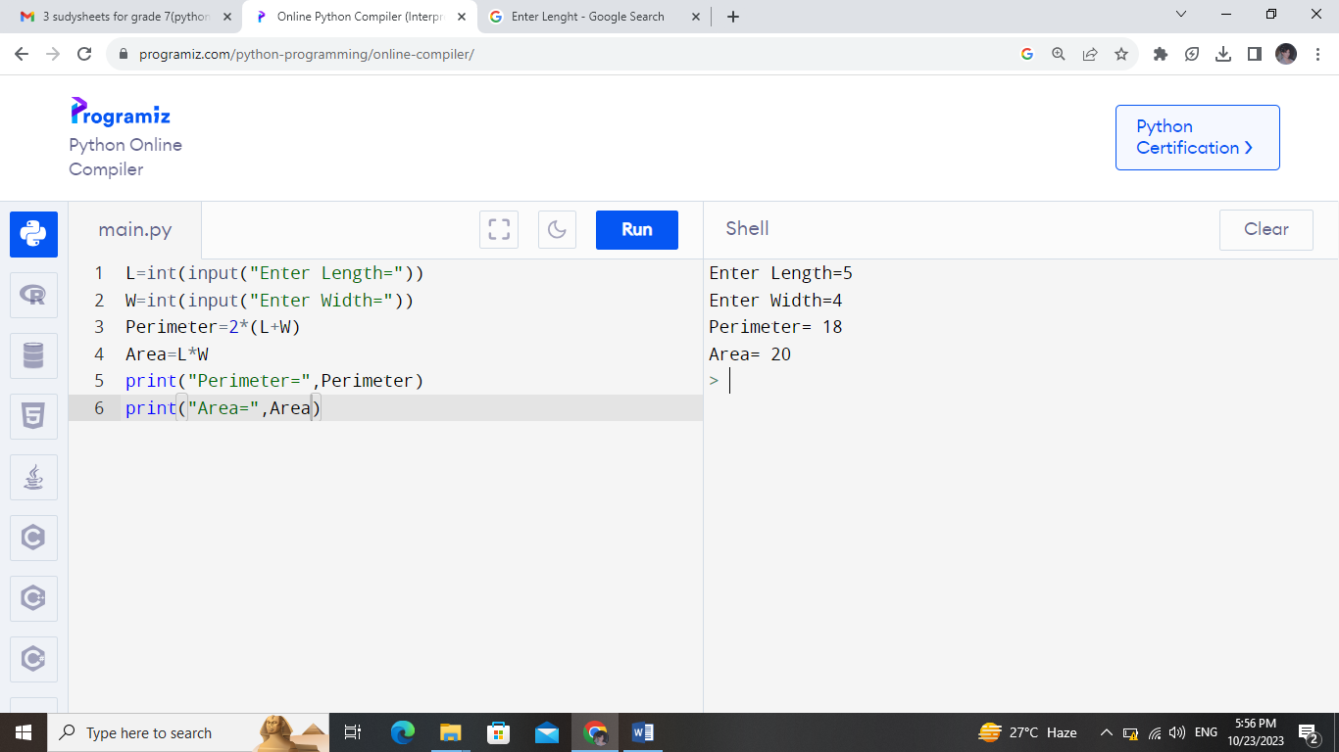

**BMI=W/(H*H)**

1. **Write a program to calculate the BMI (Body Mass Index).**

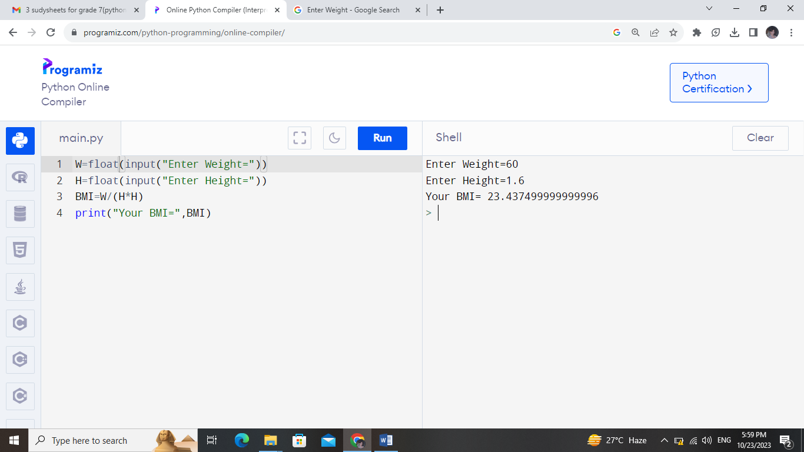

1. **Write a program to convert from Celsius to Fahrenheit degree and to Kelvin**

**k=c+273.15**

**f=1.8*c+32**

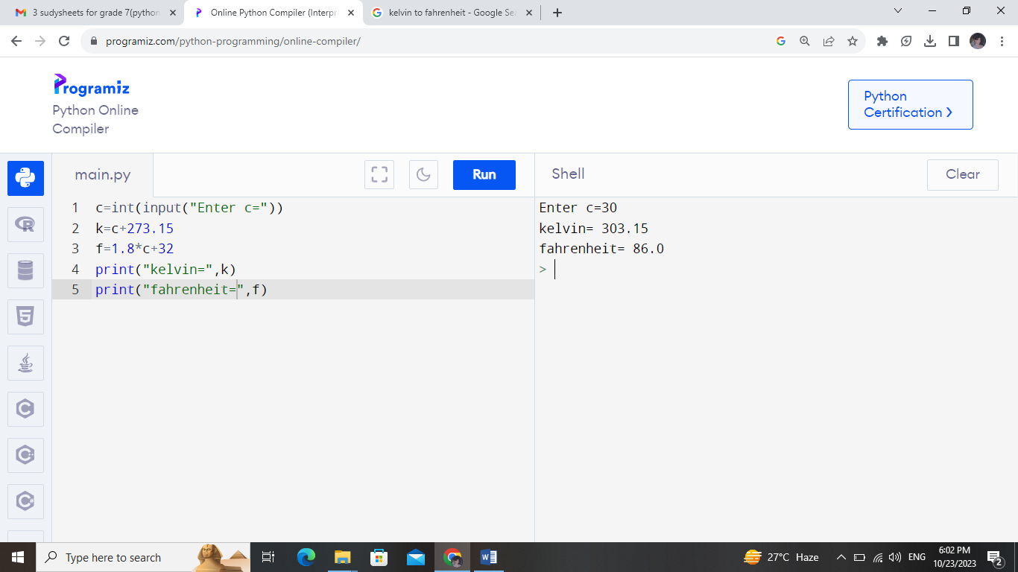

**Sum=a+b**

**Sub=a-b**

**Mul=a*b**

**Div=a/b**

1. **Write a program to create a simple calculator (input 2 numbers and calculate the results).**

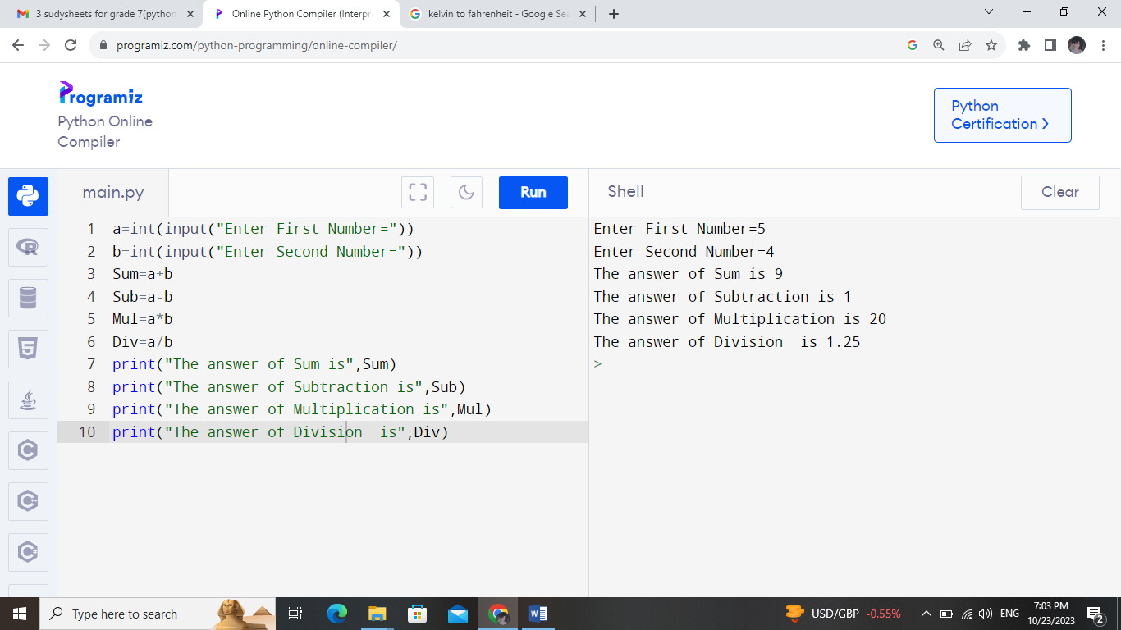

**P=a+b+c**

**Area=1/2*h*b**

1. **Write a program to calculate the area and the perimeter of the triangle**

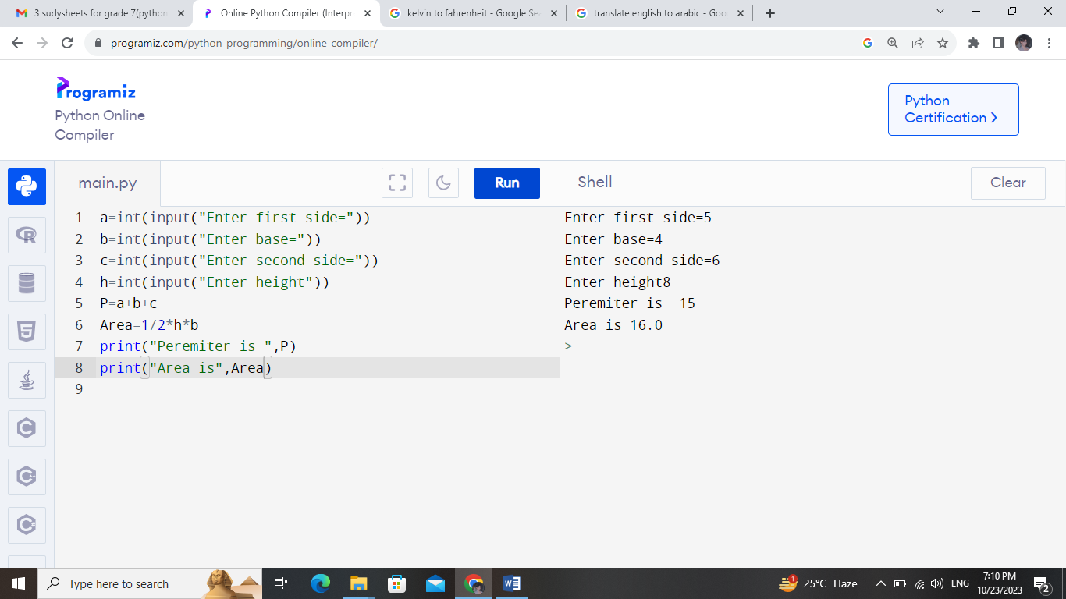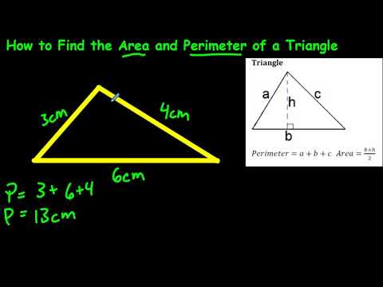

1. **Write a program to calculate the area of a circle**

**Area =3.14 *r2**

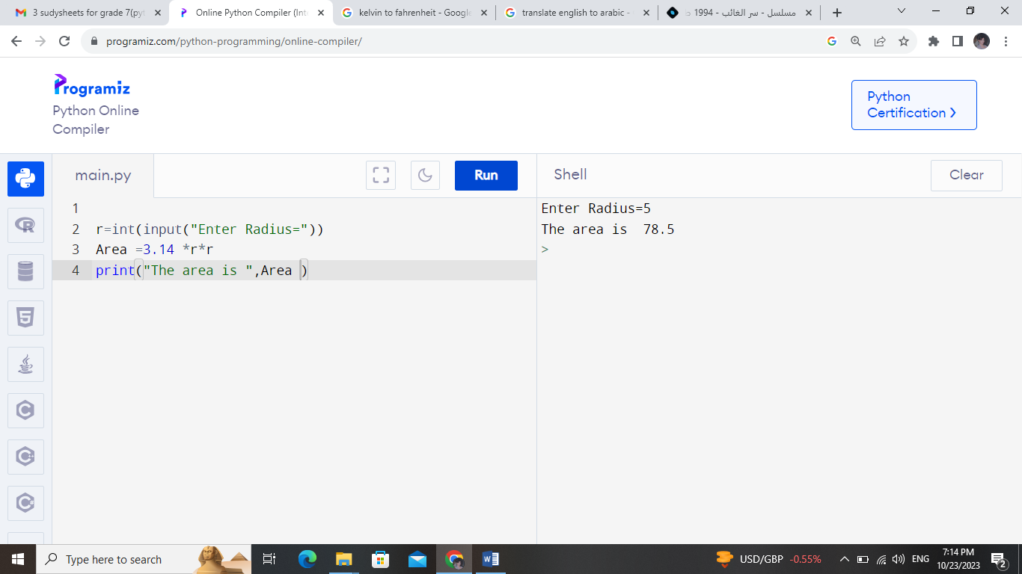

**R**2 🡺 R2**

**Example 32 🡺 3**2 = 9**

**Note: Resolve Question 2 using the indices (power) operator**

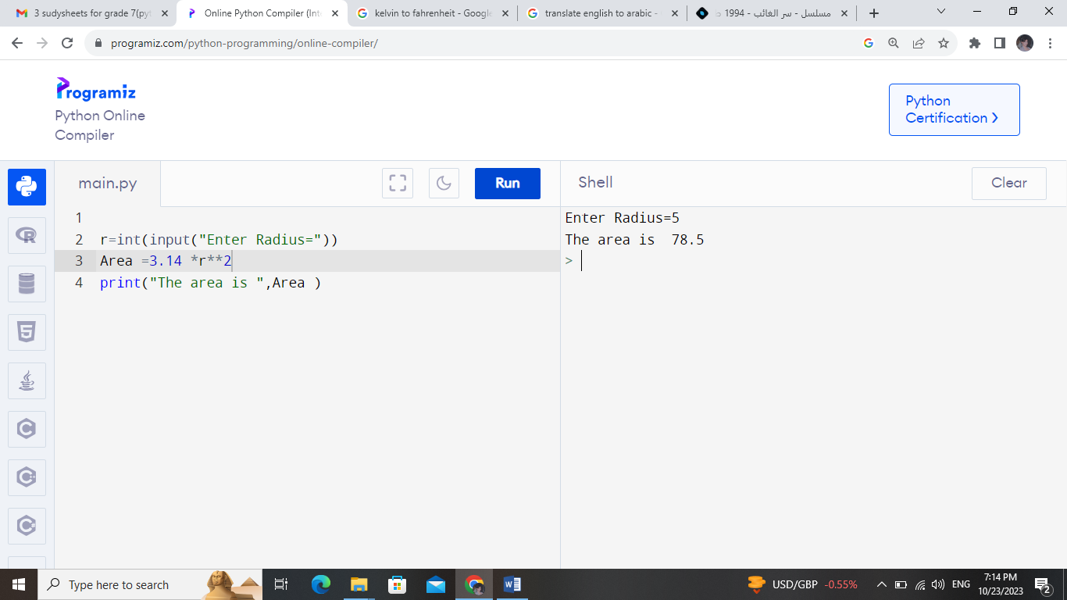**OR**

1. **Write a program that:**
   1. **Input your name.**
   2. **Print your name.**
   3. **Input your birthyear**
   4. **Calculate and print your age.**

