**Study Sheet -1(Answer key)**

**|** Lower Secondary

Stage (6-8)

1st Semester | 2023-2024

|  |  |
| --- | --- |
| **Subject:** ICT | **Chapter:** 3 (programming language) |
| **Objectives:**   * How to use the Python programming language for input and output. | |

**Variable:**

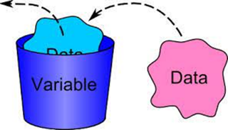Python variables are simply containers for storing data values. Python has no command for declaring a variable, so you create one the moment you first assign a value to it.

**Variable name must:**

* Start with a letter or the underscore character
* Be one word only - no spaces
* Not contain special characters like (+-$@/...) d) underscore and letters are allowed
* Variable names are case-sensitive (age, Age and AGE are three different variables)

**Data types:**

* **Text:** is stored as string data type.
* **Integer:** Whole numbers are stored as integer data type.
* **Float:** Real Numbers (with decimal points) are stored as float data type.

**Examples:**

* Sum=10 🡺 integer
* Name=“Naya” 🡺 String
* Average=90.5 🡺 float

**Question#1: Circle the correct variable names:**

* 1G Not correct 🡺 start with number
* Emp_Name=” Dana” Correct
* Num1=5 Correct
* H*1=90 Not Correct🡺contain special character
* Girlname=RamaNot correct 🡺”Rama” string

**Question #2: Find the output for each of the following:**

1. 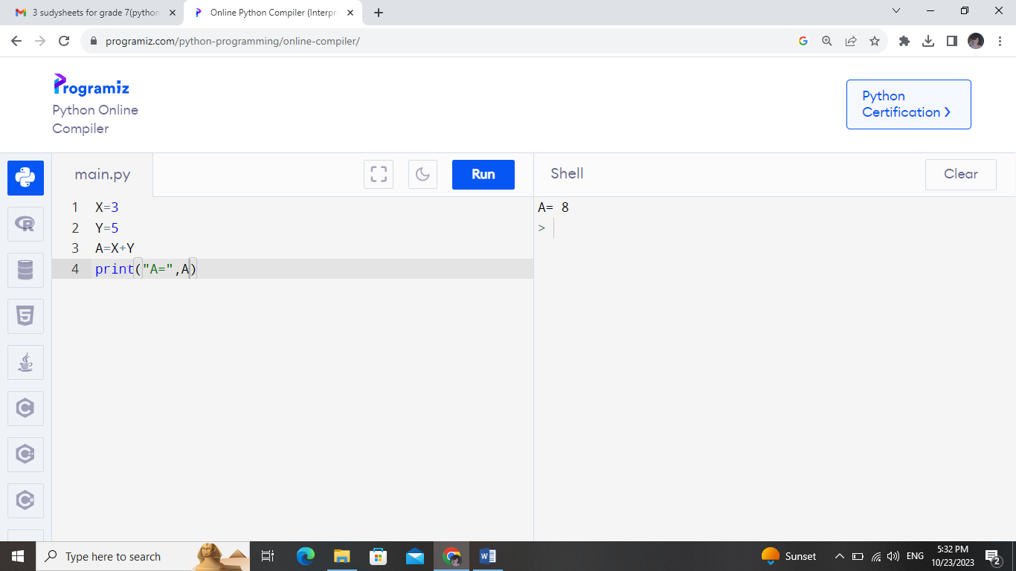
2. 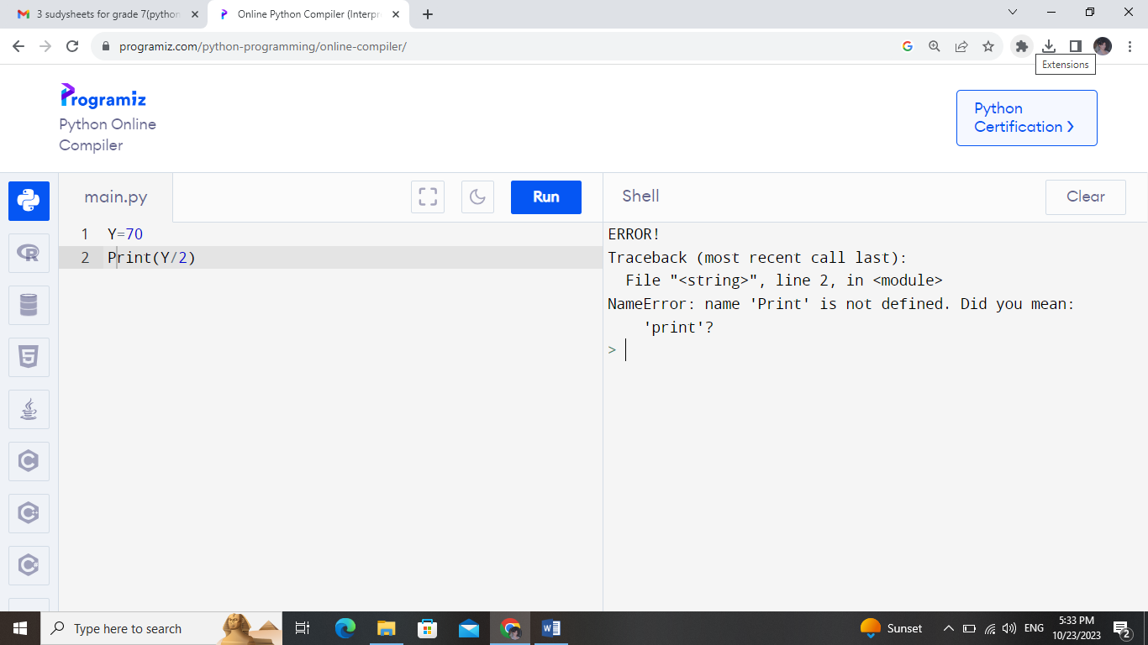
3. 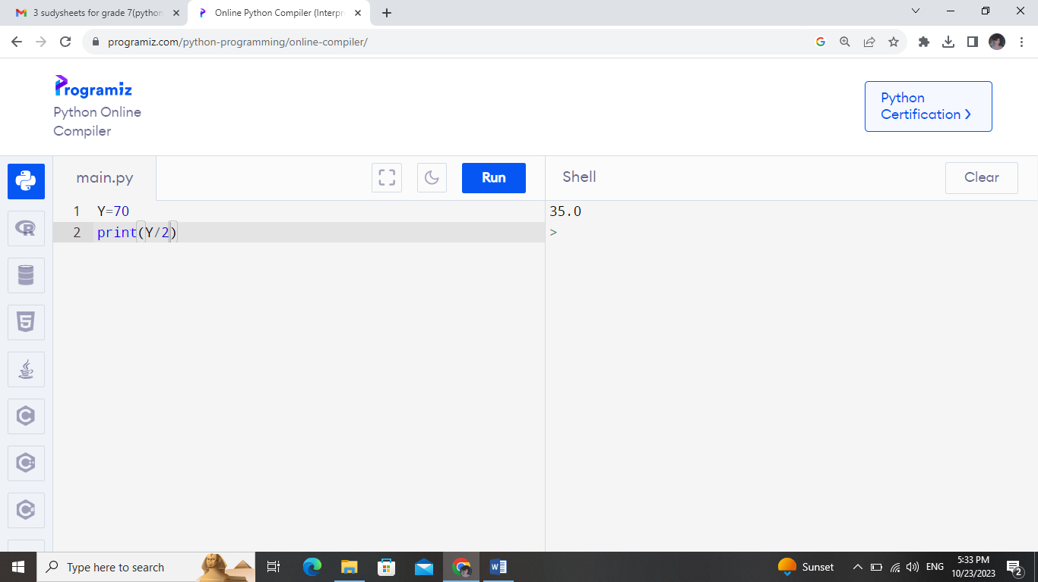
4. 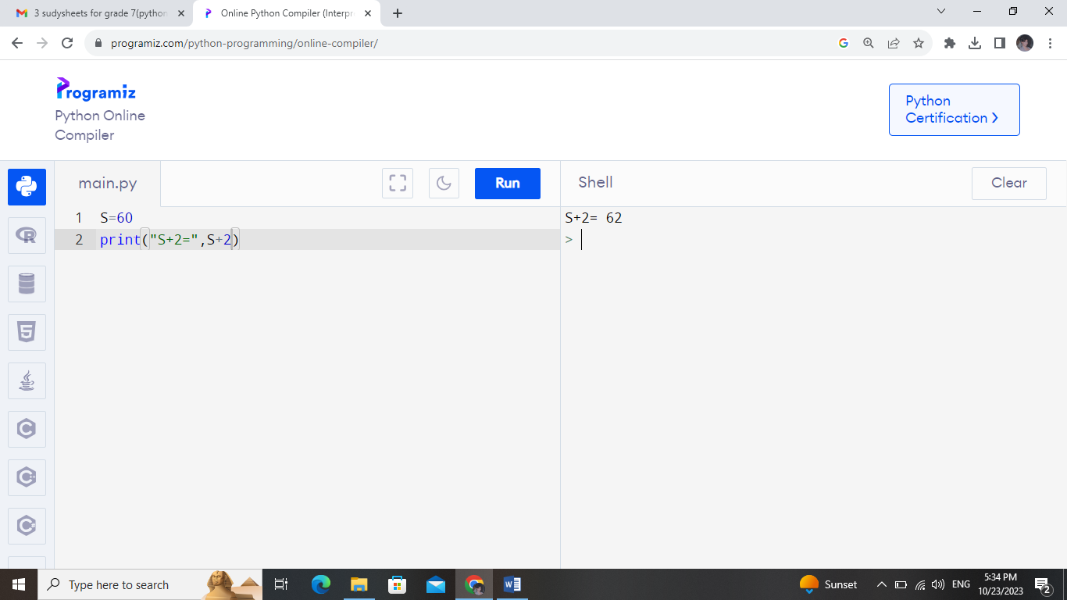
5. 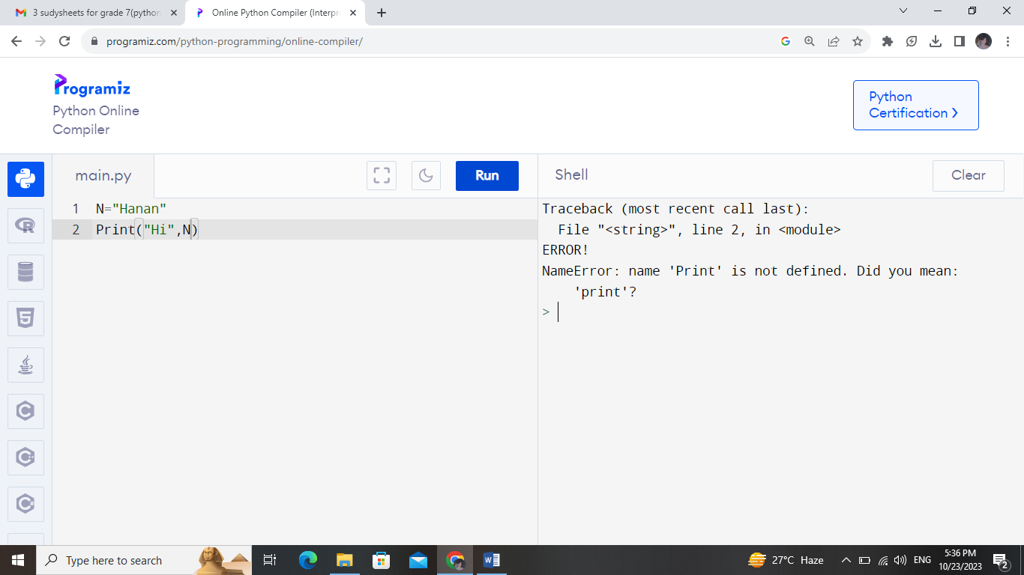
6. 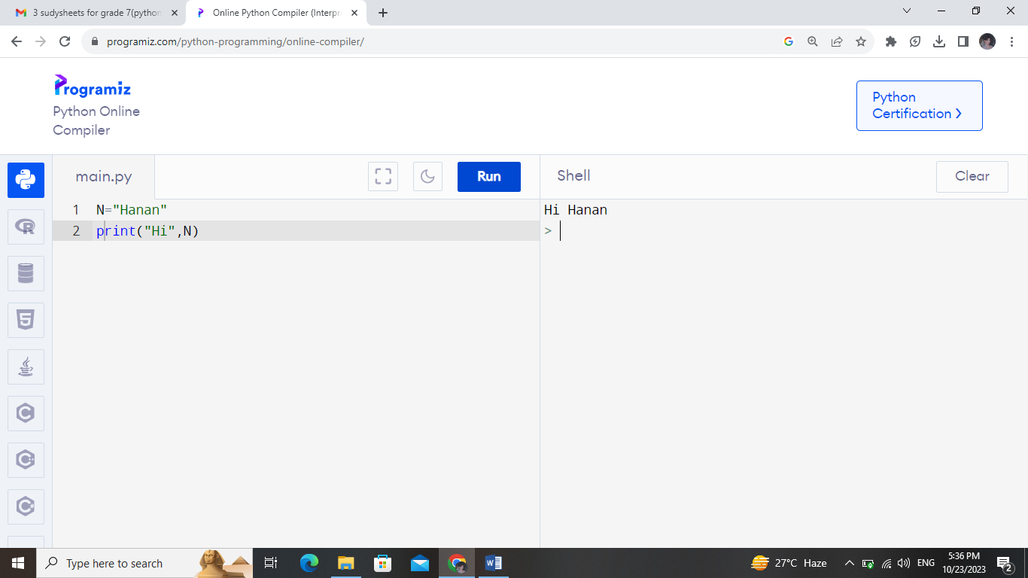
7. 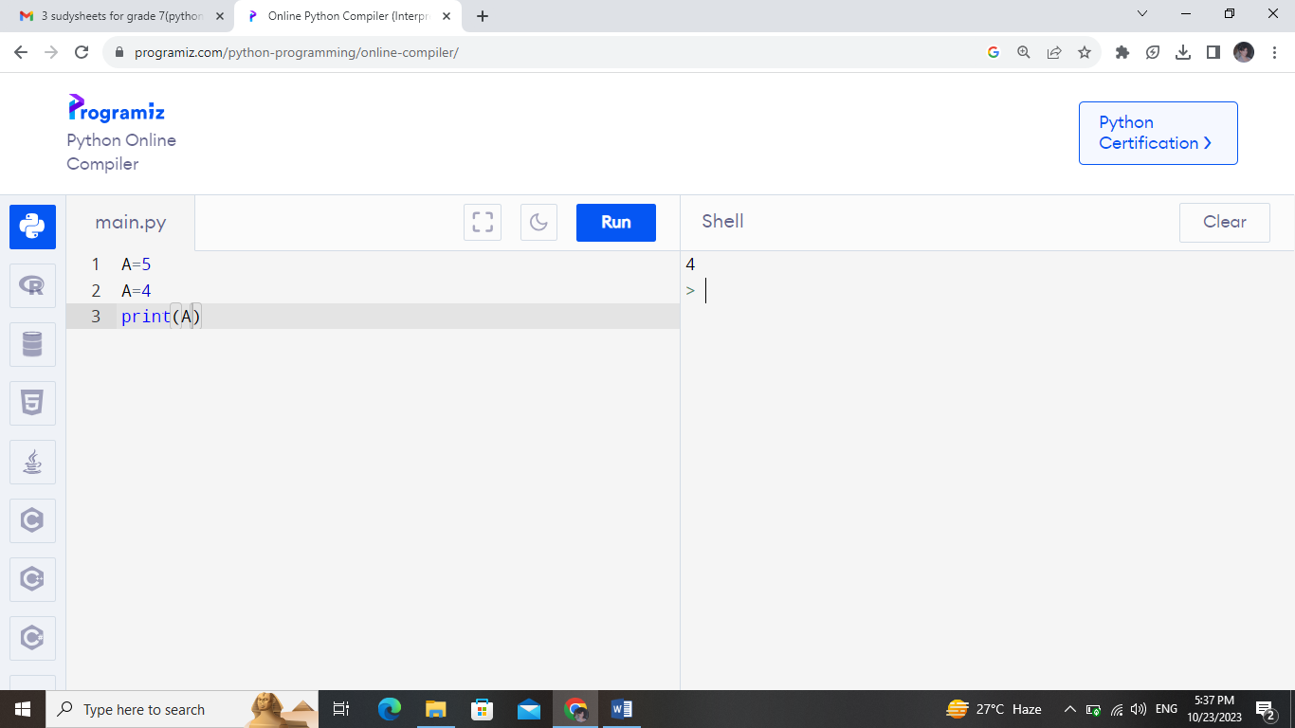
8. 