
Grammar Worksheet ( 4)
Grade 2
Name: ------------ Date: / /2023
________________________________________________ Objective: To use subjective and objective pronouns.
A pronoun is a word that takes the place of a noun.
*Sally saw Ramez yesterday.
She saw him yesterday.
*Ramez saw Sally yesterday.
He saw her yesterday.
***Subjective pronouns come before the verb.
***Objective pronouns come after the verb.

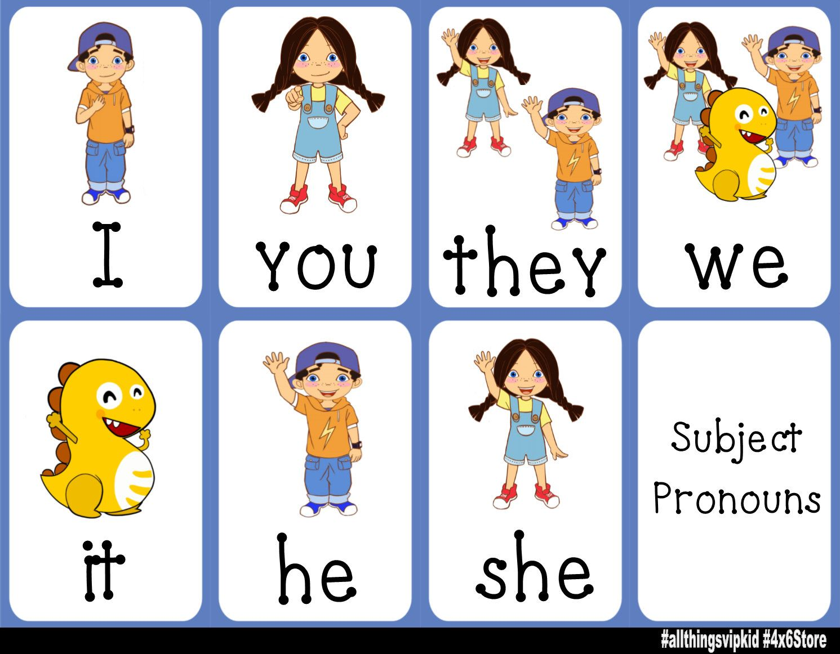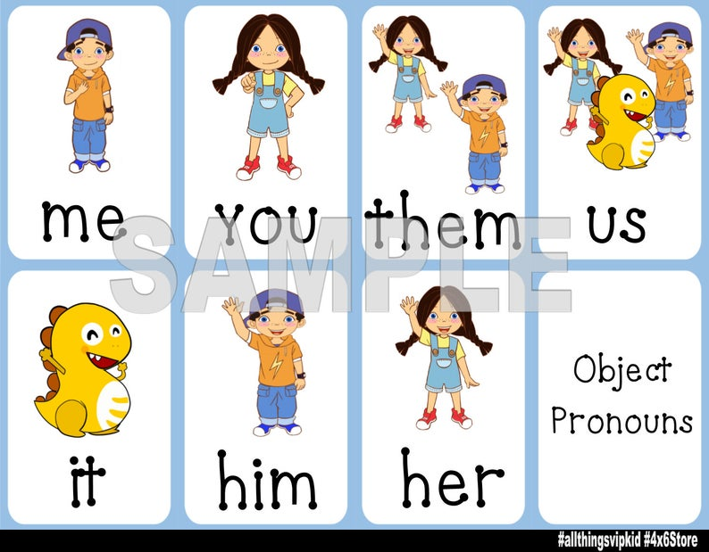

Subjective pronoun | Objective pronoun
I | me
You | you
He | him
She | her
It | it
We | us
They | them

Q1)Use one of the words in the box to replace the words given.
She He They You We It I

Words | Pronouns
My brother | He
Ayla | She
Peter and I | We
Dog | It
Carrots | They
MY Dad | He
Helen and Merry | They

Q2) Choose the correct pronouns.
- ______ would like a treehouse.
I her him
- Will you help ______ with the worksheet?
me She They
- _______ buys new toys every week.
She him them
- Wow! Look at the elephant! ______ is very big.
We It Him
Q3) Match the subject pronoun with object pronoun.
- She a. Us
- I b. Me
- We c. Her
- They d. Him
- It e. It
- He f. Them
Q4) Replace the nouns with the correct pronouns (subject and object).
- Tia gave Natali a pink pen.
She gave her a pink pen
- Sami and Karam played with Laith.
They played with him
T.Raneem Haddad Coordinator’s Signature:

