
Grammar Worksheet (3)
Grade 2
Name: Date: / 10/2023 ______________________________________________
Objective: To identify and use object pronouns.
*A pronoun is a word that takes the place of a noun.
*Object pronouns are those pronouns that come after the action in a sentence.

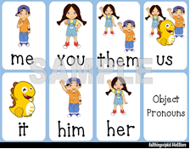
1)Circle the object pronouns in each sentence.
1. Can you give me a pen ?
2. Grace is my best friend. I love her.
3. I give my book to him.
4.She is playing with them.
5.The teacher asks us a question.
6.Adam has a kite. He can fly it.
2) Circle the correct words.

1-He is dancing. Look at __________.
her him me
2-We don’t know the road. Please help ______.
They her us
3- My mom is singing. Listen to________.
her me them
4- I am playing football. Would you please play with ____?
her him me

3) Use the following Object pronouns in sentences of your own.
Him:
Them:
Me :

T. Raneem Haddad Coordinator’s Signature:

