
Tolerance is the power of life.
Meaning Worksheet ( 1 )
Grade 2
Name: Date: /9/2023
Objectives: To identify the meaning of new words.
To practice using the new words in sentences.
1)Study the words below:
word | Meaning
animals | 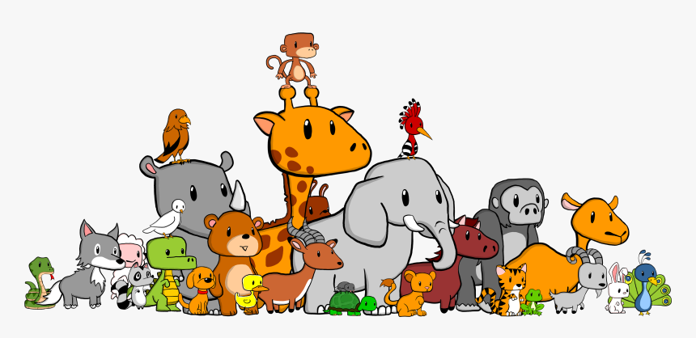
fur | 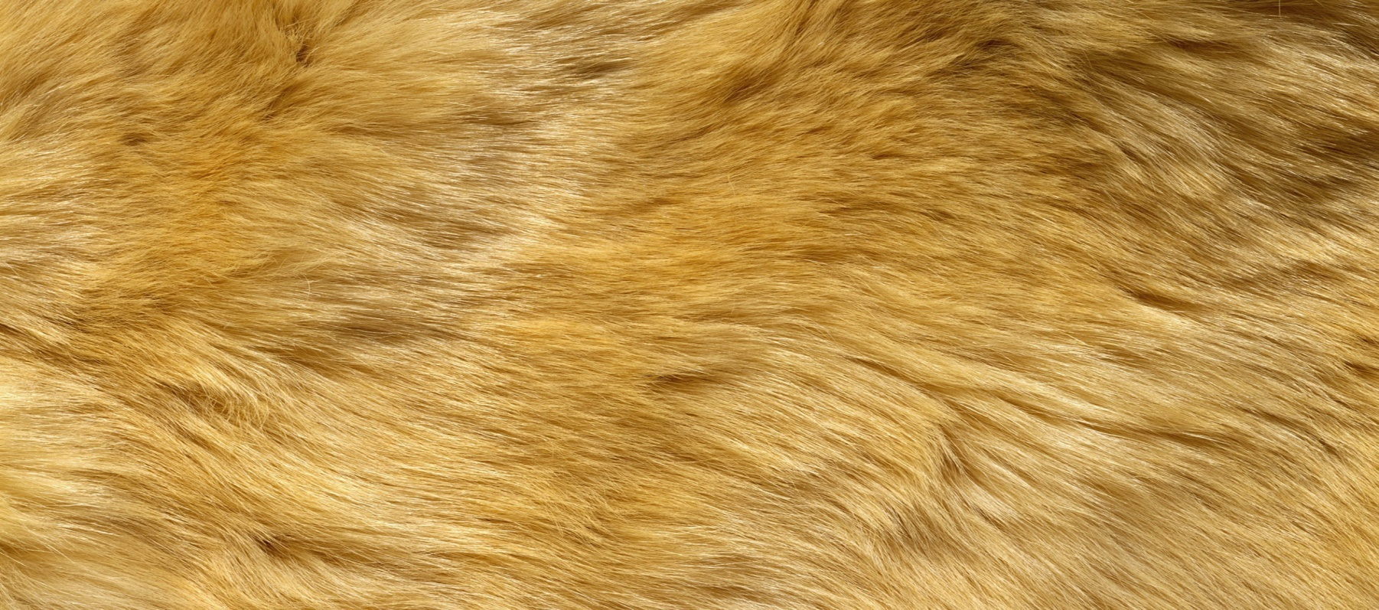
wings | 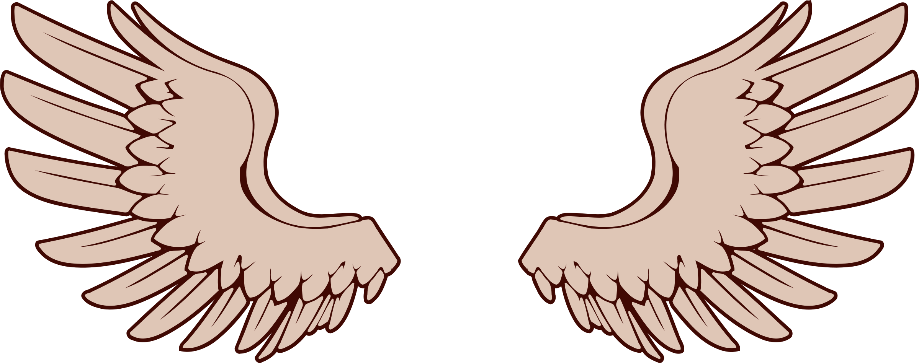
feathers | 
gills | 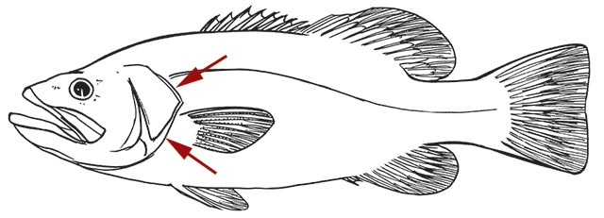
scales | 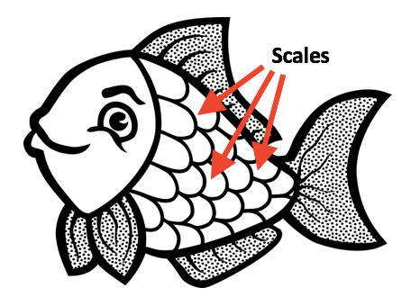
eggs | 
amphibians | 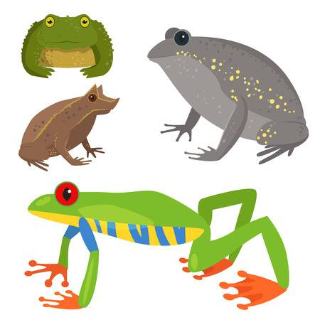
skin | 
mammals | 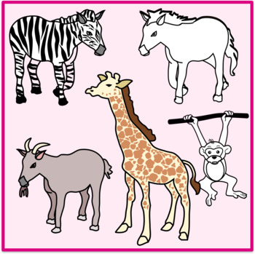
same | 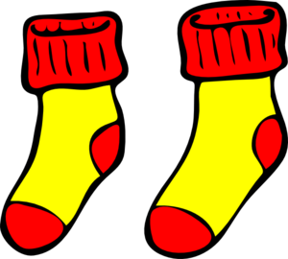
different | 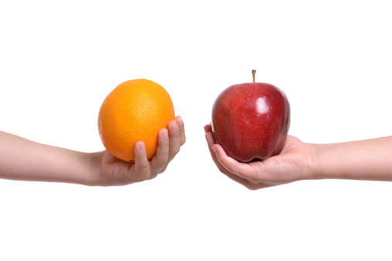
2) Circle the correct word:

eggs - animals– amphibians
gills - scales - mammals
same - fish- animals

- Fill in the blanks with the correct word:
Amphibians different wings gills

- All birds have two wings.
- Amphibians can live on land and in water.
- Fish breathe through gills.
- Oranges are differentfrom apples.

- Look and write the words.
body ears eyes head legs mouth feathers

1.ears 2eyes
3mouth 4.head
5.body 6.legs

T. Raneem Haddad Coordinator’s Signature

