
Grammar Worksheet (4)
Grade 2
Name: ------------ Date: / 10 /2023
_________________________________________________
Objective: To join two nouns to make compound words .
Compound words are two words put together to make a new word.
Butter + fly =butterfly
Basket + ball =basketball

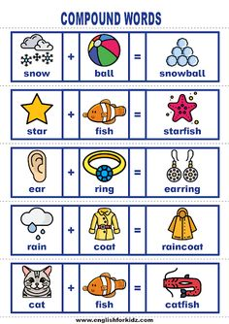

- Join two words to make one compound word.
- foot + ball = football
- rain + bow = rainbow
- bed +room = bedroom
- lady +bird = ladybird
5.snow + man =snowman
6. butter +fly = buttrtfly
- Write the second word of the compound word.
- Homework
- Bathroom
- Starfish

T.Raneem Haddad Coordinator’s Signature:

