
Grammar Worksheet (1)
Grade 2
Name: Date: / 10 /2023 ________________________________________________
Objective: To replace nouns with the correct subject pronouns.

1) Write the correct subject pronoun :( he, she, it, they)

A farmer farmer


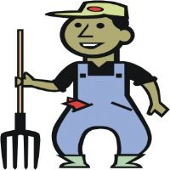

A book

Gloves




A girl

Adog

Players


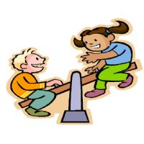

Kids

A boy

A rose

2) Replace the underlined words with the correct subject pronouns.

1-This ball is small. ___________ is small.

2-My mom is tall . _____________is tall.
3-My father is a farmer. …… ___________ is a farmer.

T. Raneem Haddad Coordinator’s Signature:

