
Grammar Worksheet (4)
Grade 2
Name: ------------ Date: / 10 /2023
_________________________________________________
Objective: To join two nouns to make compound words .
Compound words are two words put together to make a new word.
Butter + fly =butterfly
Basket + ball =basketball

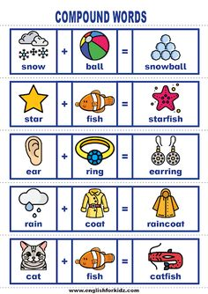

- Join two words to make one compound word.
- foot + ball =
- rain + bow =
- bed +room =
- lady +bird =
5.snow + man =
6. butter +fly =
- Write the second word of the compound word.
- Home--------
- Bath---------
- Star--------

T.Raneem Haddad Coordinator’s Signature:

