

My cousin Rachel ch.2

(News From Italy)

Grade 7 ( A + B )

Name: Date : / /

Enjoy reading the chapter and answer the following questions.

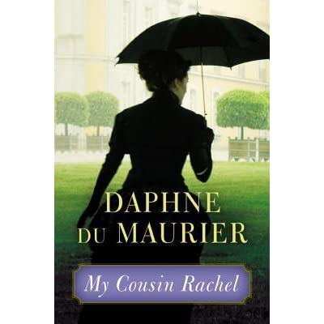

1. What did the doctors advise Ambrose to do?

They advised him to go abroad every winter to a drier country.

1. Where did Ambrose go?

He went to Italy.

1. Why didn’t Ambrose want Philip to go with him to Italy?

Because someone must look after the estate.

1. Whom did Ambrose meet in Italy?

His cousin Rachel.

1. Why was Philip angry and unhappy?

Because Ambrose got married.

1. Who is Nick Kendall?

He is Philip’s godfather. He is a lawyer.

1. Why was Philip worried after receiving Ambrose’s letter?

Because he wasn’t feeling good; he had headaches.

1. How did Ambrose’s father die?

He died of a tumour of the brain.

9. Who is Seecombe?

He is the head servant.

10. Did Philip go to Italy?

Yes, he did.

Teacher: Mirna Nawaf Al-Sahawneh.

Coordinator’s Signature: -------------------