|  |  |  |  |
| --- | --- | --- | --- |
| **Informative Writing** **|** Lower Secondary  Stage (6-8)  **1st Semester | 2023-2024** | | | |
| **Name:** | __________________________ **Grade: _______________________** | | |
| **Date:** | __________________________ | | |
| **Subject:** English Language | |  |
| **Objectives:**   * **To understand the elements of informative writing.** * **To produce an informative essay.** | | |

**What is informative writing?**

Informative writing is writing with the purpose to inform and educate others on a certain topic. It informs the reader by presenting **straightforward information** about a **specific topic**. Typically, these essays will answer one of the five WH questions: who, what, where, when, and why. Of course, they can also answer HOW, indicating how to do something. Unlike other forms of writing, informative writing does not aim to change the reader’s opinion or move the reader to take action;  informative essays are purely objective [pieces of writing.](https://www.grammarly.com/essay-writing) Illustrations, charts, diagrams and maps are useful visuals to reinforce data within informative writing.

**Examples of informational texts:**

* biographies
* reports
* essays
* newspapers
* magazines
* textbooks
* instruction manuals

**Parts of an informative essay:**

**Introduction:**

Your informative essay starts with an introduction paragraph. This paragraph includes your **thesis statement, which is a concise summary of your essay’s focus.** In a persuasive or argumentative essay, the thesis statement is typically the author’s position, which the author then supports and defends in the body paragraphs. **In an informative essay, it’s a sentence that clearly states what the essay will cover.**

In addition to your thesis statement, your introduction paragraph should **include the points** you will discuss in your body paragraphs, as well as an **interesting statement to**[**hook**](https://www.grammarly.com/blog/how-to-write-a-hook/) your reader’s interest. This can be an important statistic, a surprising fact, or an engaging anecdote that makes the reader want to learn more.

**Body:**

The body should be several paragraphs divided into subtopics that support the main topic and specifically, the thesis statement. There should be a heading for each of these subtopics. The body includes specific factual details about each subtopic and also includes features like quotes, statistics, keywords, diagrams, maps, and charts. These help to explain the topic to the reader.

**Conclusion:**

In the conclusion section, summarize your essay in a few sentences. Think of this as a recap of the points you made in your body paragraphs. Somewhere within this recap, reiterate your thesis statement. You don’t need to restate it in the exact same words you used in your introduction, but you should remind the reader of your essay’s primary focus.

**Structures of informative writing:**

**Descriptive**: The topic is described in great detail.

**Compare/contrast**: Similarities and differences about the topic are discussed.

**Problem/solution**: The reader is informed about a problem that exists and a plan to solve it is presented.

**Cause/effect**: The relationship between events or things is discussed and one is the result of the other.

**Definition**: a difficult term or concept is explained by breaking it down into sections.

**Classification**: A topic is broken up into different categories.

**Chronological**: The prefix ‘chrono’ means time, and ‘logical’ means order. This form follows time order. Many historical events are written in time order.

## **7 steps for writing an informative essay**

### 1 Select topic

If you aren’t assigned a topic, you’ll need to choose your own. Choose a topic you can sufficiently explain in approximately [five paragraphs](https://www.grammarly.com/blog/five-paragraph-essay/).

Once you’ve chosen a general topic, narrow it down to the specific subject you’ll cover in your essay. This process, known as brainstorming, often involves some preliminary research.

### 2 Research

The next step is to thoroughly research your topic. During this phase, choose credible sources you can cite in your work.

### 3 Create an outline

After you’ve conducted your research and determined which sources you’ll use in your essay, write an [essay outline](https://www.grammarly.com/blog/essay-outline/). An essay outline is a bare-bones “skeleton” version of your essay that briefly mentions what you’ll discuss in each paragraph.

### 4 Write

Following your outline’s [structure](https://www.grammarly.com/blog/essay-structure/), write your essay. At this stage, don’t stress about getting the tone just right or maintaining perfect flow between paragraphs; these are things you’ll refine during the revision stage. Focus on getting words on the page that craft an easy-to-follow look at your topic. Your tone should be objective, informative, and without literary devices.

### 5 Edit

Once you’re finished writing your first draft, take a break. Revisit it again, ideally a day later, and read it carefully. Take note of how effectively your sources support the points you make, how your writing flows from one paragraph to the next, and how well you explain your topic overall. Then rewrite any parts that can be made stronger. By the time you’re finished rewriting these, you’ll have your second draft.

### 6 Proofread

You’re not done yet! After you’ve finished revising your work, read it again to check for any spelling or grammatical mistakes. It’s also helpful to double-check the facts you cite at this stage to ensure they’re all accurate.

### 7 Document citations

The last part of writing an informative essay is writing a [citations](https://www.grammarly.com/citations) page. Because an informative essay includes statistics, facts, and other pieces of objective data, you need to credit the sources you consulted to find this data. How you format your citations page depends on whether your essay is written in [MLA](https://www.grammarly.com/blog/mla-format/)8

**Sample Essay:**

**Why Are Honey Bees Important?**

Did you know it takes about twelve honey bees, working their entire lives to make one teaspoon of honey? **Honey bees are important part of the ecosystem and our everyday life.** Not only are they responsible for producing honey, they also play a large role in pollination of plants and flowers. **This article with explain why they are important, what honey bees do, and how they make honey.**

**Why honey?**

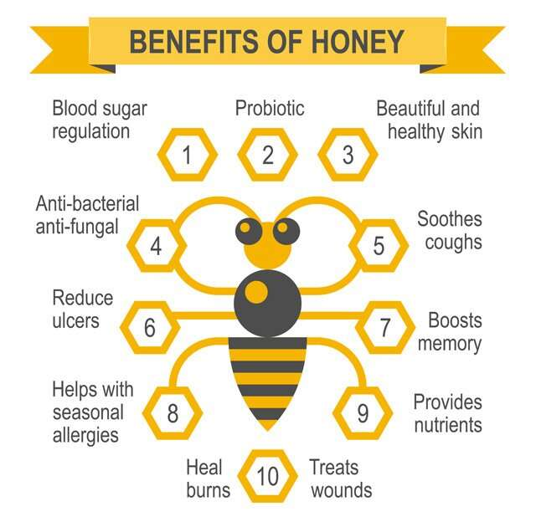 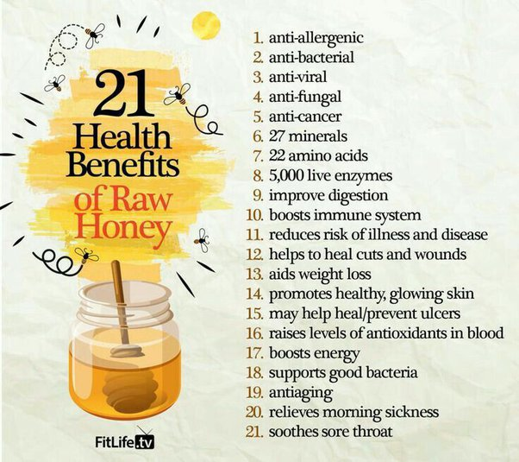

Humans have been using honey for years, dating back to 2000 BC. The way honey is made has not changed over the years; however, the way we use it has changed significantly. Not too long ago, honey was used for many medicinal purposes. For example, up until the first part of the 20th century, using honey for wounds dressings was part of everyday care. Although we no longer depend on honey for medicinal reasons, many people still choose to use it for home remedies. After all, it is natural!

**Pollination**

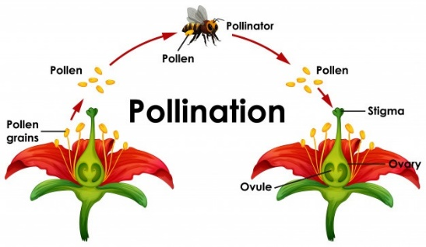

Honey is just one thing honey bees are able to produce for us. Honey bees are pollinators. Pollinators need us, and we need them. Without honey bees, our agriculture would suffer; therefore, so would we. We depend on pollinating animals for countless fruits, vegetables, and nuts, as well as half the world’s oils, fibers, and raw materials. The process also helps prevent soil erosion and increases carbon sequestration, which filters our air.

**How honey is made**

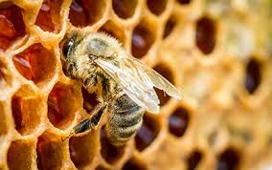

How does a bee make honey? First, worker bees collect a substance called nectar by sucking it out of flowers and carrying it in a special sac called a honey stomach. Next, worker bees go to the beehive and pass the nectar to house bees. This process causes the nectar to have too much water to store for the winter. The next step is to dehydrate the honey. Bees do this in two ways: by spreading it across the honeycombs and by fanning it with their wings. Once the honey is dehydrated, it is time to store it. The honey is placed into honeycomb cells and then capped with beeswax to keep it fresh.

In conclusion, honey bees are an important part of our world. This information helps us understand the importance of honey, how honey bees work, and the honey-making process. Remember, honey bees are a key component to our agriculture needs. You can help save the bees by avoiding pesticides or planting a tree in your own backyard.

________________________________

**Identifying informative elements**

**The topic is introduced:** Honey bees are an important part of the ecosystem and our everyday life.

**The subtopics are mentioned:** this article will explain why they are important, what honey bees do, and how they make honey.

**Body 1:** why honey

**Body 2:** pollination

**Body 3:** how honey is made

**Transition words:** not only, however, although, in fact, first, next, the next step, in conclusion

**Keywords:** honey bees, pollination, medicinal, nectar, honey, beeswax

**Variety of sentences:**

Did you know it takes about twelve honey bees, working their entire lives to make one teaspoon of honey?

Not too long ago, honey was used for many medicinal purposes.

Although we no longer depend on honey for medicinal reasons, many people still choose to use it for home remedies.

Remember, honey bees are a key component to our agriculture needs.

**Conclusion:**

**Topic**: honey bees are an important part of our world.

**Summary of subtopics**: This information helps us understand the importance of honey, how honey bees work, and the honey-making process.

https://rockinresources.com/2021/09/what-is-informative-writing-2.html

**Suggested Topics:**

**Choose** one of the topics below. **Research information** you may use for your essay. Use the organizer (the following pages) to help you write your essay.

## **‘How-To’ Informative Essay Topics**

* How to start a recycling program
* How to plant a garden
* How to make and care for a compost pile
* How to use social media responsibly
* How to manage time effectively
* How to save money and manage finances responsibly
* How to manage homework stress.

## **Social Studies Informative Essay Topics**

* Describe the life of a world leader.
* How has the role of women in the workplace changed in the last hundred years?
* Describe a time period in history.
* The history and significance of famous landmarks (e.g. the Eiffel Tower, the Great Wall of China)
* Explore the causes of a specific war or armed conflict in history.
* Give an overview of the history of any country or city.
* Describe the evolution of fashion throughout history.
* Learning financial security must be taught in schools.
* Why learning history is important.
* The role of children in politics.
* The role of volunteering and community service for students.
* The role of team projects at schools.
* The importance of pet shelters.
* The culture and traditions of a people.

## **Science Informative Essay Topics**

* Describe a science experiment, including the hypothesis, process, and conclusion.
* Explain what it means to lead a healthy lifestyle.
* Obesity and the importance of a healthy diet.
* How do plants convert sunlight into energy?
* What is the difference between a crocodile and an alligator?
* Describe the life cycle of any animal.
* What are the benefits of recycling?
* Describe the life of a prominent scientist/inventor.
* Describe any disease, including its symptoms and treatments.
* Why do leaves change color in the fall?
* Describe a specific ecosystem, including the plants and animals that live there.
* The role of water in our lives.
* The reasons why smoking is bad.

## **Pop Culture Informative Essay Topics**

* Describe the history of video games.
* The pros and cons of playing video games.
* Why TV shows for teens is not always a good influence.
* Playing sports as a middle-school student.
* Describe the process of making a movie or TV show.
* Tell the story of any band, including its founding, successes and challenges, and breakup (if applicable).
* Describe the life of a famous artist.
* Explore the history of the Olympics.
* Explain the history of the internet.
* The benefits and drawbacks of using ride-sharing services like Uber or Careem.
* The benefits and drawbacks of technology in the classroom

**Informative / Explanatory**

**Writing**

**Organizer**



