**Worksheet** **|** Lower Secondary

Stage (6-8)

1st Semester | 2023-2024

|  |  |
| --- | --- |
| **Subject:** Biology | **Chapter:** The carbon cycle |
| **Objectives:** Describe the carbon cycle in nature  **Name:** | |

**Question One:**

The diagram below shows the carbon cycle. Label the empty boxes with the correct process:

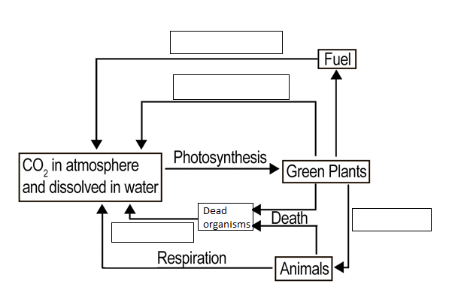

Decomposition

Respiration

Combustion

Feeding

**Question Two:**

Use the words below to fill in the blanks.

Each word may be used more than once.

Organisms dioxide carbon fungi decomposers respiration

The carbon cycle involves the cycling of carbon between the environment and organisms. photosynthesis and respiration are the key processes involved in the cycle. Also decomposition which involves microorganisms called decomposers is important to digest waste and dead organisms. These microorganisms are bacteria and fungi. These decomposers carry out respiration, which converts carbon compounds in dead and waste material back to carbon dioxide in the air.