c

**Fiche de travail N :(3 )**

Nom : _________________ Classe : (1A+B) Date : _______________

**Objectif savoir les personnages du livre**

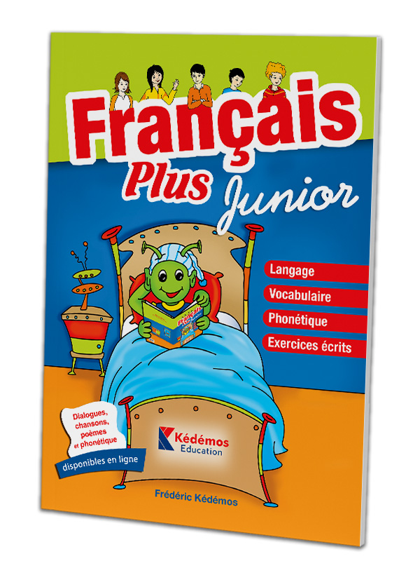

**2/ Ecris**

|  |
| --- |
| **C’est Papa/ C’est maman / C’est Alice/ C’est Fouad**  **C’est Bouli / C’est Stéphanie / C’est Alice / C’est Mounir** |

|  |  |
| --- | --- |
| ***s\\asa*** | ***___________________*** |
| ***Aa*** | ***Aaaaaa*** |
|  | ***__________________________________*** |
|  | ***________________________________*** |
|  | ***_________________________________*** |
|  | ***____________________________________*** |
|  | ***_____________________________________*** |
|  |  |
|  |  |
|  |  |
|  |  |
|  |  |
|  |  |
|  |  |
|  |  |
|  |  |
|  |  |
|  |  |
|  |  |
|  |  |
|  |  |
|  |  |
|  |  |
|  |  |
|  |  |
|  |  |
|  |  |
|  |  |
|  |  |
|  |  |
| ***A*** |  |
|  |  |
|  | ***A*** |
| ***A*** | ***A*** |
|  |  |
|  |  |
|  |  |
|  |  |
|  |  |
| ***A*** | ***A*** |
| ***A*** |  |
| ***A*** | ***A*** |
| ***Aa*** |  |
|  |  |
|  |  |
|  |  |
|  |  |
|  |  |
|  |  |
|  |  |
|  |  |
|  |  |
|  |  |
|  |  |
|  |  |
|  |  |
|  |  |
|  |  |
|  |  |
|  |  |
|  |  |
|  |  |
|  |  |
|  |  |
|  |  |
|  |  |
|  |  |
|  |  |
|  |  |
|  |  |
|  |  |
|  |  |
|  |  |
|  |  |
|  |  |
|  |  |
|  |  |
|  |  |
|  |  |
|  |  |
|  |  |
|  |  |
|  |  |
|  |  |
|  |  |
|  |  |
|  |  |
|  |  |
|  |  |
|  |  |
|  |  |
|  |  |
|  |  |
|  |  |
|  |  |
|  |  |
|  |  |
|  |  |
|  |  |
|  |  |
|  |  |
|  |  |
|  |  |
|  |  |
|  |  |
|  |  |
|  |  |
|  |  |
|  |  |
|  |  |
|  |  |
|  |  |
|  |  |
|  |  |
|  |  |
|  |  |
|  |  |
|  |  |
|  |  |
|  |  |
|  |  |
|  |  |
|  |  |
|  |  |
|  |  |
|  |  |
|  |  |
|  |  |
|  |  |
|  |  |
|  |  |
|  |  |
|  |  |
|  |  |
|  |  |
|  |  |
|  |  |
|  |  |
|  |  |
|  |  |
|  |  |
|  |  |
|  |  |
|  |  |
|  |  |
|  |  |
|  |  |
|  |  |
|  |  |
|  |  |
|  |  |
|  |  |
|  |  |
|  |  |
|  |  |
|  |  |
|  |  |
|  |  |
|  |  |
|  |  |
|  |  |
|  |  |
|  |  |
|  |  |
|  |  |
|  |  |
|  |  |
|  |  |
|  |  |
|  |  |
|  |  |
|  |  |
|  |  |
|  |  |
|  |  |
|  |  |
|  |  |
|  |  |
|  |  |
|  |  |
|  |  |
|  | ***``````````````````````````````````````````````````````````````*** |
| ***`*** | ***4ed=x*** |
|  |  |

**2- Copie les mots suivants**

1. **Papa ______________ , __________________, ______________**

**B – Bouli _______________, __________________,_______________**

1. **Maman _______________. _______________.______________**
2. **Alice ________________, _________________. ______________**
3. **Fouad _________________. _______________. ______________**
4. **Mounir _______________. _________________.______________**
5. **Stéphanie __________________. ______________________**

**3- Ecris le nom convenable**

1. 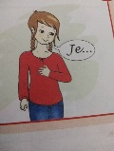 **___________est avec _____________*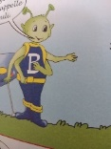***
2. ***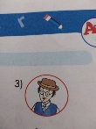*___________et ______________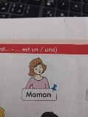 sont à la maison .**
3. ***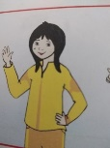*________________ et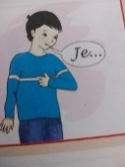 _____________ sont avec**

**________________*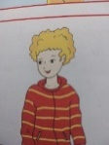***

**4- Colorie les mots suivants**

**Papa Mounir Fouad**

**Bouli Alice Stéphanie Maman**