

**Science Worksheet /The Structure of flower**

Grade: 5(A+B)

Name: Date: / /2023

**Structure of a flower**

1- Label the parts of the male part of the flower.

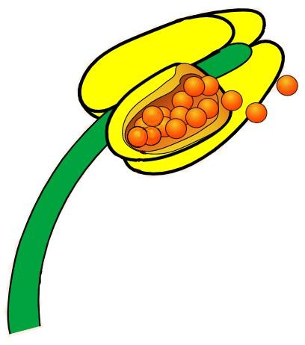

2- Label the parts of the female part of the flower.

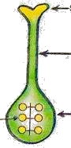

3. What is the name of the female part of the flower? ____________________

4. What is the name of the male part of the flower?

________________________

5- Which part of the flower is responsible for:

- producing pollens. ___________

- Supporting the anther. __________

- attracting insects. ____________

- surrounding the bud. ___________

_____________________