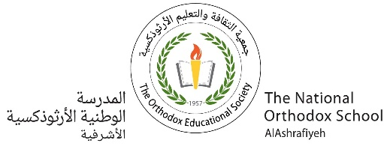

The National Orthodox School

Science Study sheet #1

Name: Grade: 5(A+B)

Date: /9/ 2023

**Structure of a flower**

**Flowering plants**

* Flower is the reproduction organ عضو التكاثر of a plant.
* Flowers have male and female organs.

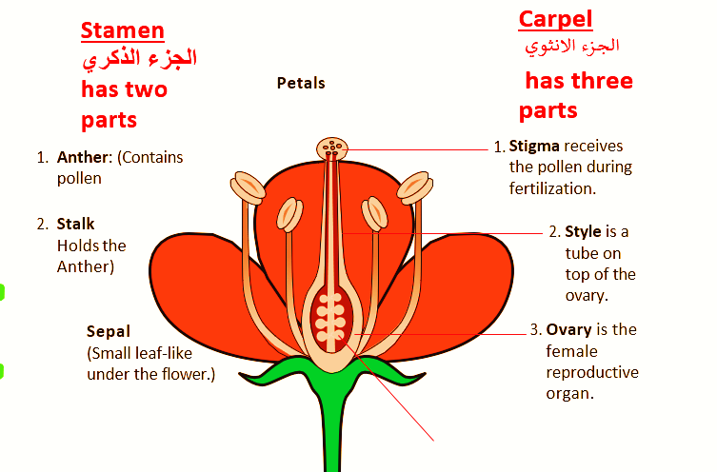

**Ovary**: It produces ovules

ovules

Parts of flower and their functions:

|  |  |  |
| --- | --- | --- |
| 1 | **Petal** | Brightly colored leaves with scent to attract insects. |
| 2 | **Sepal** | Protects the flower while it is bud. |
| 3 | **carpel** | The **female reproductive part** of the flower, made up of **stigma, style, and ovary.** |
| 4 | **stigma** | Sticky part that receive pollens. |
| 5 | **style** | Links the stigma to ovary. |
| 6 | **ovary** | Produce ovules, which develop into seeds. |
| 7 | **stamen** | The **male reproductive part** of the flower,  made up of **anther and stalk.** |
| 8 | **anther** | Contains pollens. |
| 9 | **stalk** | Supports the anther. |

**Pollination التلقيح**: is the transfer of pollens from the anther to the stigma.

* **Ways of pollination**:

1- wind 2- insects 3- water 4-birds