**Revision Sheet #1 Answer Key** **|** Lower Secondary

Stage (6-8)

1st Semester | 2023-2024

|  |  |
| --- | --- |
| **Subject:** Science/ Chemistry | **Chapter:** 4 |
| **Objectives:**   * Understand that the periodic table is a way to sort elements. * Identify different groups in the periodic table. * Describe Acids, Bases and Alkalis. | |

**1 – Name the structure below and then answer the following questions about it.**

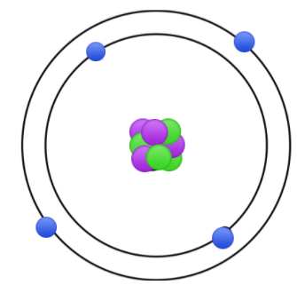

This is a/an _**atom**___

It is the smallest unit of matter that forms ___**elements**_____

1. Referring to the periodic table, give the name of the element that the above structure represents. **Berelium**
2. In which group will you find this element? **Group 2**

1. What type of element is it? **Metal**

1. Name two other elements that you find in the same group.

**Magnesium – Calcium – Barium – Radium**

1. When this element reacts with Oxygen it forms an oxide that is used in nuclear reactors. Write down the chemical formula for this compound.

**BeO**

1. Referring to the periodic table, draw the basic units for **Na** and **Cl**.

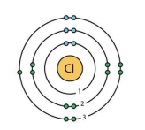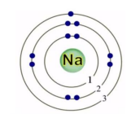

Sodium Chlorine

**2- Choose the correct answer.**

A solution with a pH 8.6 indicates

1. a strong acid
2. a weak acid
3. a strong alkali
4. a weak alkali

An indicator turns into dark red when added to an acidic solution. This means that this solution is

1. diluted b- alkaline

c- neutral d- corrosive

When a very strong alkali reacts with the universal indicator it will change into

1. dark red b- blue

c- green d- dark purple

When Hydrochloric Acid reacts with Potassium Hydroxide the salt will be

1. Sodium Chloride b- Potassium Chloride

c- Potassium Oxide d- Potassium Chloride

When Sulphuric Acid (H2SO4) reacts with Sodium Hydroxide (NaOH) the products are

1. **H2O + NaOH** b- **H2O + Na2SO4**

c- **H2O + Na Cl** d- **H2O + Na2O**

Which of the following is an alkali?

1. water b- orange juice

c- dishwashing detergent d- vinegar

Choose the correct statement

1. Only acids conduct electricity
2. Only alkalis conduct electricity
3. Acids and alkalis don’t conduct electricity
4. Acids and alkalis conduct electricity

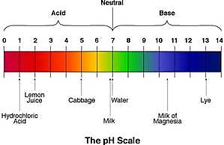

According to the pH range given in the image, which substance is more acidic than lemon juice?

1. HCl
2. Milk
3. Water
4. Lye

Which of the following is not a base?

1. NaOH b- NH4OH c- HNO3 d- Ca(OH)2

**3 – Estimate the pH for the following substances.**

|  |  |
| --- | --- |
|  | **Estimated pH** |
| Baking soda |  |
| Lemon juice |  |
| Hand soap |  |
| Water |  |
| Bleach |  |
| Corrosive acid |  |