**Revision Sheet** **|** The Secondary Stage of (6-8)

1st Semester | 2023-2024

|  |  |
| --- | --- |
| **Subject:** English | **Chapter:** 1 |
| **Objectives:** | |

**What is an embedded clause?**

An embedded clause is essentially a [dependent clause](https://lemongrad.com/dependent-clause/) – noun, relative, or adverb – that is part of another clause.

-Most scientists believe that Tiger shark went extinct nearly two million years ago. [Noun clause]

-Tiger shark, which was a giant version of modern-day great white shark, went extinct nearly two million years ago.

-Most scientists believe that Tiger shark, which was a giant version of modern-day great white shark, went extinct nearly two million years ago.

**Embedded clause is one of the two ways to expand a sentence**

Let’s take an example to understand how embedded clauses can expand a sentence.

- Tiger shark went extinct nearly two million years ago.

* Tiger shark, which was a giant version of modern-day great white shark, went extinct nearly two million years ago.
* Tiger shark , which was a giant version of modern-day great white shark, went extinct nearly two million years ago because its prey base migrated to colder regions.

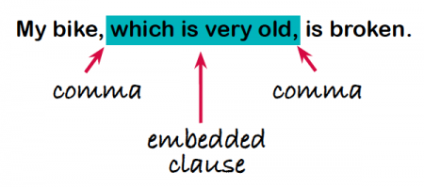

*Commas are usually (but not always) used to separate the clause that has been embedded from the main clause

. 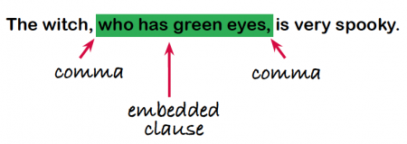  
If you removed the embedded clause the main clause would stand alone as a complete sentence. However, the embedded clause is reliant on the main clause so it does not make sense on its own (it's a [subordinate clause](https://www.theschoolrun.com/what-is-a-clause)).

**An embedded clause usually begins using the words which, who, with, that, whose or where and relates to the noun or pronoun in the main clause.   
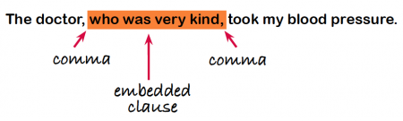  
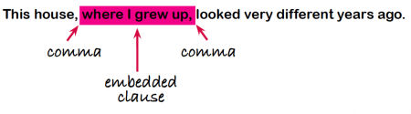

Who 🡪 people

Which 🡪 things/objects/animals

When 🡪 time

That 🡪 instead of who or which

Whose 🡪 belongings and possessions

**Practice: Place brackets around each subordinate clause.**

1. Deta shook hands with her companion and stood still while Barbara approached the tiny, dark-brown mountain hut, which lay in a hollow a few steps away from the path.

2. I prophesy that you will learn it in a very short time, as a great many other children do that are like you and not like Peter.

3. The people in the village called to her now more than they had on her way up because they all were wondering where she had left the child.

4. Clara was looking forward to this visit, and told Heidi so much about her dear grandmama that Heidi also began to call her by that name, to Miss Rottenmeier's disapproval, who thought that the child was not entitled to this intimacy.

**Use the correct relative pronouns to complete the sentences:**

**Who / Which/ That / Whose / Whom**

Top of Form

1. Economics is a subject that I've never understood.

Bottom of Form

Top of Form

1. I want a mobile phone that takes good photos.

Bottom of Form

Top of Form

1. I work in that big yellow building which you can see over there.

Bottom of Form

Top of Form

1. Lee Harvey Oswald is the man who shot John F Kennedy.

Bottom of Form

Top of Form

1. Meryl Streep is the famous person whom, I'd most like to meet.

Bottom of Form

Top of Form

1. What's the name of the lady who is wearing the blue dress?

Bottom of Form

Top of Form

1. You need a coat that will keep you warm this winter.

Bottom of Form

Top of Form

1. You're the most beautiful person that I've ever seen.
2. I have an uncle who lives in California.
3. This is Mr and Mrs Andrews, whose children I teach.
4. The man whom I marry will have to be someone really special.
5. Unfortunately, my new boss is someone whom I really dislike.

Bottom of Form