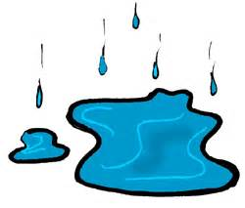

**Puddle**

………………………………………………………………………………………………………………………………………………………………

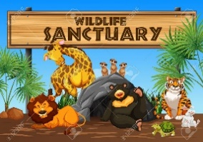

**Sanctuary**

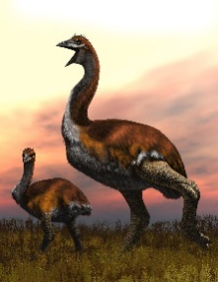

**Elephant bird**

………………………………………………………………………………………………………………………………………………………………

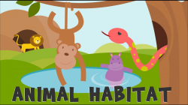

**Habitat**

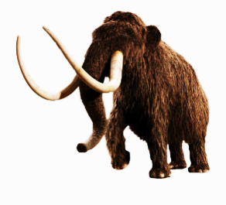

**Woolly mammoth**

………………………………………………………………………………………………………………………………………………………………

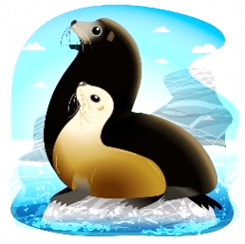

**Sea wolf**

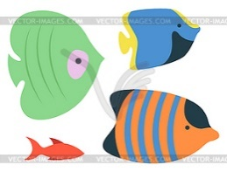

**Species**

………………………………………………………………………………………………………………………………………………………………

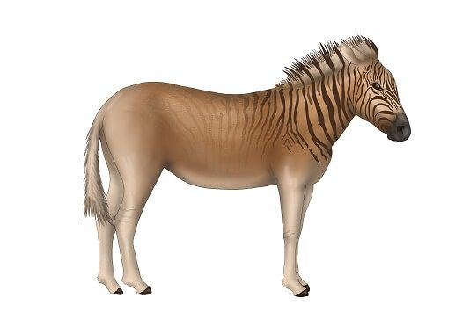

**Quagga**

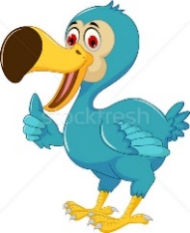

**Dodo**

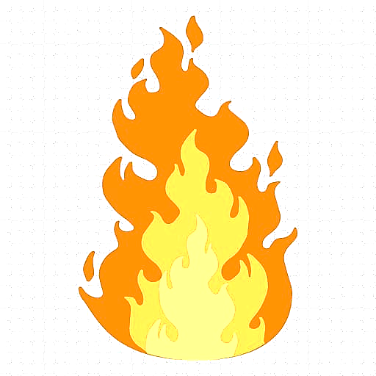………………………………………………………………………………………………………………………………………………………………

**Fiery**



**Miserable**

………………………………………………………………………………………………………………………………………………………………

**Sleepy**

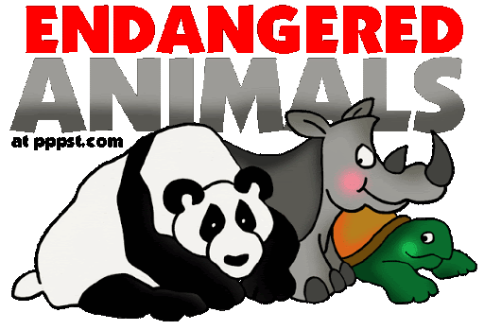

**Endangered**

………………………………………………………………………………………………………………………………………………………………

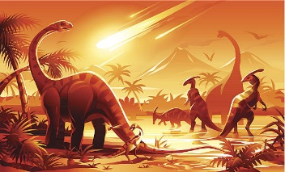

**Extinct**



**Peer**

………………………………………………………………………………………………………………………………………………………………

**Stumble**



**Emerge**

………………………………………………………………………………………………………………………………………………………………

**Gush**



**Swish**

………………………………………………………………………………………………………………………………………………………………



**Exploit**

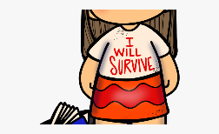

**Survive**