  **Writing Task**

**Our value: Self – belief and hard work will always earn you success**

Name: _____________ Date: / /

Grade (6)

You are going to do a writing task about the **Golden Gate Bridge**. It’s going to be in two paragraphs according to the following plan:

Paragraph 1 _ Golden Gate Bridge/ red / suspension bridge/ steel / located / San Francisco / USA / connects San Francisco to Main county/ six lanes / walkways on either side / a visitor center and a gift shop

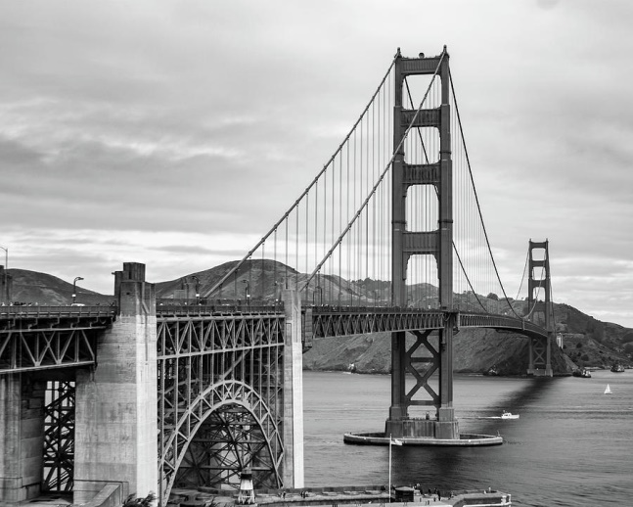Paragraph 2__ construction started January 5th,1937 / opened to public 1939/ length 2,737 meters/ width 27,5 meters / height 227 meters / 45 million vehicles cross a year.

Remember

# Use the present tense

# Link your sentences accurately

# Indent the paragraphs

# Punctuate correctly

Golden Gate bridge is a red suspension bridge. It’s built up of steel. It is located in San Francisco, USA. It connects San Francisco to the Main county. It has six lanes and walkways on either side. If you have the chance to visit it, you will find a visitor center and a gift shop.

The bridge’s construction started on January 5th,1937. It was opened to public in 1939. It’s 2,737 meters long, 27,5 meters wide and 227 meters high. 45 million vehicles cross the bridge each year.