**Grammar Study Sheet** **|** The Secondary Stage of (6-8)

1st Semester | 2023-2024

|  |  |
| --- | --- |
| **Subject:** Types of Sentences | **Unit 1:** Spine-Chilling Suspense |
| **Objectives:**   * To identify simple sentences, compound and complex sentences.   **Name: ___________________________**  **Grade 6CS: All Sections** | |

**Types of Sentences**

Sentences can be categorized into three main types based on their structure and complexity. Understanding these types will help you become a better writer and communicator.

**1. Simple Sentences:**

**Structure:**

Consist of a single independent clause (a group of words that can stand alone as a complete sentence).

**Example:**

* She loves to read books.

**2. Compound Sentences:**

**Structure:**

Composed of two or more independent clauses joined by a coordinating conjunction (FANBOYS: for, and, nor, but, or, yet, so) or a semicolon.

**Example:**

* He wanted to go to the park, but it started raining.
* She studied for her test; however, she still felt unprepared.

**3. Complex Sentences:**

**Structure:**

Composed of an independent clause (main clause) and one or more dependent clauses (subordinate clauses).

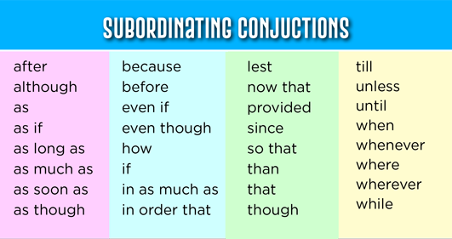

**Example:**

* After I finish my homework (dependent clause), I'll go to the park (independent clause).
* Because it was raining (dependent clause), they decided to stay indoors (independent clause).
* **Additional Information:**
* Simple sentences are the most basic type of sentence and often express a single idea or action.
* Compound sentences combine two or more related ideas or actions.
* Complex sentences show a relationship between a main idea and a supporting idea.
* **Answer the following exercises:**
* **Exercise 1: Identifying Sentence Types**

**Determine the type of each sentence and write "S" for Simple, "C" for Compound, or "CX" for Complex.**

* The sun rises in the morning.

Simple sentence (S)

* I wanted to visit the museum, but it was closed.

Compound sentence (C)

* Although she was tired, she stayed up late to finish her project.

Complex sentence (CX)

* Are you coming to the party?

Simple Sentence (S)

* What a wonderful surprise!

Simple Sentence (S)

* Please pass me the salt.

Simple Sentence (S)

* He studied hard, so he aced the exam.

Compound sentence (C)

* After the storm passed, we went outside to play.

Complex sentence (CX)

* **Exercise 2: Create Sentences**

**Create one sentence of each type (simple, compound, complex) based on the prompts provided.**

**(Students answers may vary)**

* **Simple Sentence:** Describe your favorite hobby in a single sentence.

I love playing football.

* **Compound Sentence:** Combine two activities you enjoy using a coordinating conjunction (FANBOYS).

My favorite activities are playing outdoors **and** swimming in the sea.

* **Complex Sentence:** Write a sentence about a time when you had to make a difficult decision.

**When** I was studying , I didn’t go out to play with my friends.

* **Exercise 3: Sentence Combining**
* **Combine the pairs of simple sentences into compound sentences using a coordinating conjunction (FANBOYS).**
* She loves to swim. She enjoys surfing.

She loves to swim **and** she enjoys surfing.

* He can play the piano. He can also play the guitar.

He can play the piano **and** he can also play the guitar.

* They visited the zoo. They saw lions and tigers.

They visited the zoo **so** they saw lions and tigers.

* I like pizza. I prefer pasta.

I like pizza **but** I prefer pasta.

* **Exercise 4: Complex Sentences**
* **Combine the pairs of simple sentences into complex sentences by adding a dependent clause.**
* I finished my homework. I went to bed early.

**When** I finished my homework, I went to bed early.

* She woke up late. She missed the bus.

She missed the bus **because** she woke up late.

* He practiced basketball. He wanted to improve his skills.

**Because** he wanted to improve his skills, he practiced basketball.

* We planted flowers. We hoped they would bloom in spring.

We planted flowers, **so that/because** we hoped they would bloom in spring.