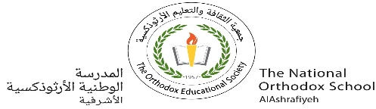

The National Orthodox School

Science Worksheet #1

Living Things

Name : Grade: 1

Date:

**Opposite words**

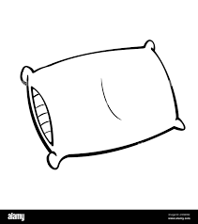Draw a line to match the word on the left to its opposite.



Hot soft

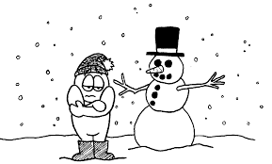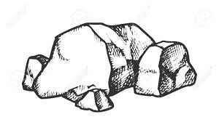

Hard cold

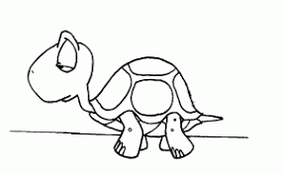

Strong slow

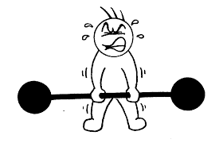



Small weak

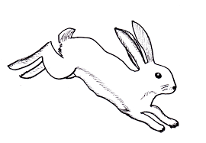

Fast big

# Write down the opposite of each words on the left. Choose from the words below

# .

|  |  |
| --- | --- |
| Adjective | opposite |
| Big |  |
| Soft |  |
| Strong |  |
| Hot |  |
| Slow |  |

cold / fast / small / weak / hard