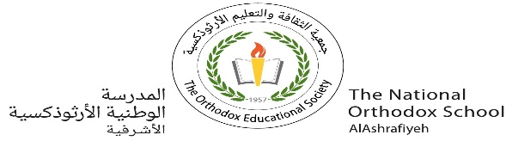

The National Orthodox School

Science Worksheet #1

Name: Grade: 3

Date: / /2023

***Living things***

1) Answer the following questions.

* **Give two examples of living things**.

1. …a baby………………… 2-………a cat………………

* **Give two examples of non-living things**.

1. ………sun…………… 2-………table………………

2) **Fill in the blanks with the correct words:**

1. All plants and _________ are living things. (animals/wood)
2. Ants, birds, and snakes are_________ things.

(living /nonliving ).

1. The taking in of oxygen inside the body is called_________

(growing / breathing).

4. Which of the following can move on its **own**? _________

(money/ monkey).

3)**Write True or false**

1- All living things grow and develop. _T______

2- Chair is a living thing. __F_____

3-Plants don’t make their own food. .__F_____

4- Plants breathe through stomata. .__T_____

5-Fish breathe through gills. .__T_____

6- Living things grow old and die. __T_____

*Teacher: Diala alazrai*