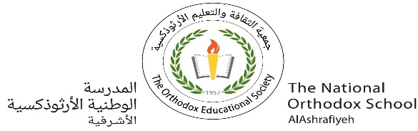

**Value*: You always gain by giving love..***

The National Orthodox School

Science Study sheet #1

Name: Grade: 6(A+B)

Date:

**تركيب الخلية Structure of a cell**

- All living things are made up of cells.

- A cell is the smallest part of a living thing that can carry out life’s activities.

## **What’s in a cell?**

Inside cells are various مختلفة structures that are specialized) (متخصصةto carry out a particular function. **Both animal and plant cells have these components:**

* **Cell membrane (الغشاء الخلوي)** –A thin outer layer, it controls the exchange of material between the cell and its surroundings.
* **Nucleus)**  (النواة–. A large round part. It **contains DNA (**the genetic information) **المعلومات الوراثية) ) and it controls how the cell works** .(It is the brain of the cell)
* **Cytoplasm) (السيتوبلازم** – this is a jelly-like. It holds the inner parts of the cell.
* **Mitochondria( الميتوكندريا)**  –It provides energy for the cell.
* **Vacuole( (الفجوة-** Some animal cells may contain many smallvacuoles.

## **What parts do plant cells have that animal cells do not??**

## Plant cells have all the parts in the list above, plus a few extra structures:

## **Cell wall (الجدار الخلوي)**- It is a hard-outer layer of the plant cell. It is made of **cellulose**. It protects the cell and gives its shape.

## **Vacuole** - It stores water and wastes.

## **A labelled cross-section of both a plant and animal cellChloroplasts** (البلاستيدات الخضراء) - Contain chlorophyll that uses energy from sunlight to make food.

## **Difference between plant cell and animal cell**

* Animal cells do not have a cell wall or chloroplasts but plant cells do.
* Animal cells are round and irregularغير منتظمة in shape but plant cells are rectangular and have a fixed shape.شكل ثابت
* Animal cells have one or more small vacuoles but plant cells have only one big vacuole.