***Animal cells***

Label the picture of the animal cell. Use the words below to help:

**cytoplasm nucleus cell membrane mitochondria**

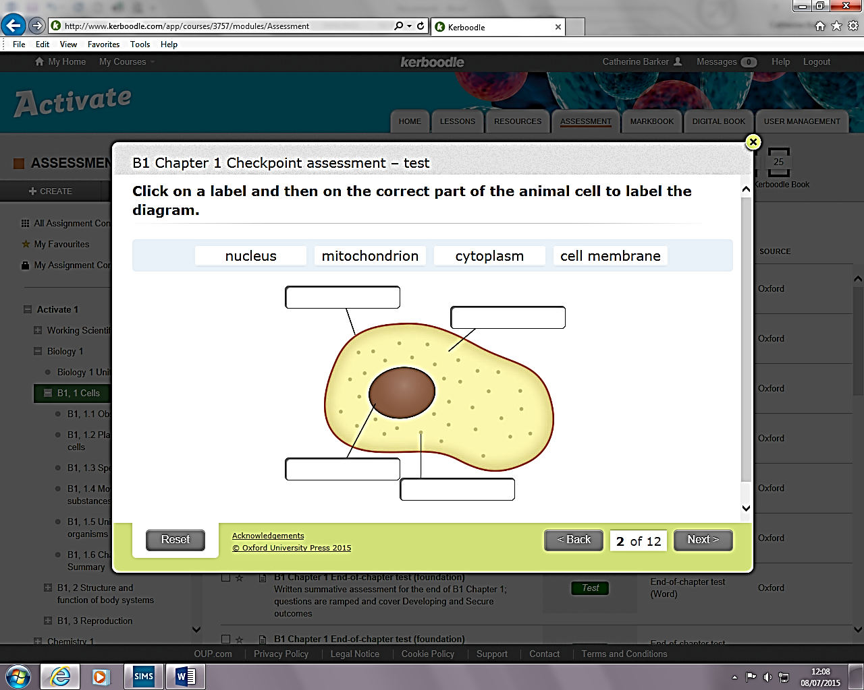

***Plant cells***

Label the picture of the plant cell. Use the words below to help:

**cytoplasm nucleus cell membrane mitochondria**

**chloroplast**  **cell wall vacuole**