

**Worksheet** **|** The Secondary Stage of (6-8)

1st Semester | 2023-2024

|  |  |
| --- | --- |
| **Subject:** Biology  Name : Date : | **Chapter:** Photosynthesis |
| **Objectives:**   * **Understand the process of photosynthesis and be able to answer questions .** | |

**Part 1 : Leaf structure**

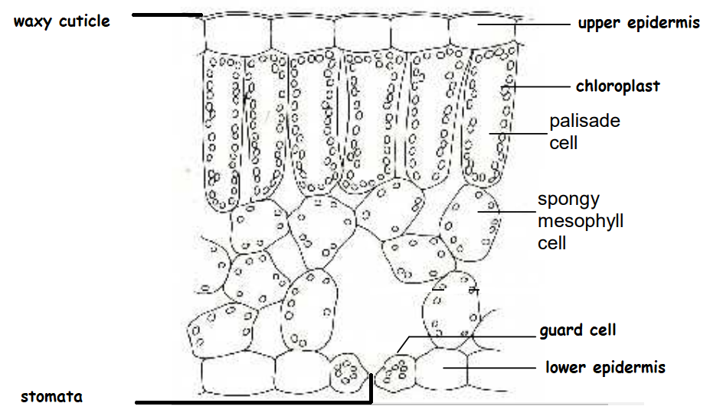

**Part 2 :**

1. **Testing for starch in leaves :**

*Objective : to detect the presence of starch in leaves*

Iodine solution is used to test leaves for the presence of starch , before we start we must have a de-starched plant.

**De -starching a plant**

A plant can be ‘de-starched’ by leaving it in the dark for 2 to 3 days , **in dark the plant uses all the starch by respiration** .

**Steps :**

1. Heat a plant leaf in boiling water for 30 seconds to soften the cell wall .
2. Then heat it in boiling [**ethanol**](http://www.bbc.co.uk/education/guides/zq239j6/revision/6#glossary-zmfpgk7) for a few minutes (this removes most of its colour)
3. Wash with water and spread onto a white tile.
4. Add iodine solution from a dropping pipette.

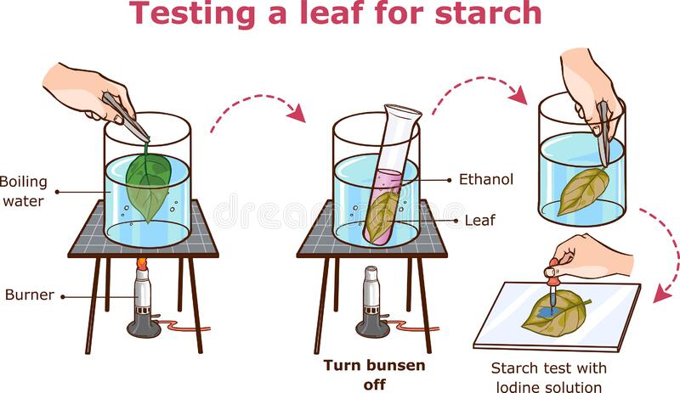

**After a few minutes, the parts of the leaf that contain starch turn blue-black.**

**Note :** Ethanol is heated using a hot water bath because it boils at 78°C,this is safer than using a Bunsen burner because ethanol is [**flammable**](http://www.bbc.co.uk/education/guides/zq239j6/revision/6#glossary-z38pcdm).

* **Leaves**  have green parts (where the cells contain chlorophyll) and white parts (where there is no chlorophyll).

Only the parts that were green become blue-black with iodine solution, showing the importance of chlorophyll in photosynthesis.

1. **Production of Oxygen in photosynthesis :**

*Objective : to observe the production of oxygen bubbles using underwater plants .*

**Steps :**   
  
1. Place water plant in a beaker containing pond water.  
  
2 . Cover the plant with short stemmed funnel.  
  
3. Invert the test tube full of water and cover the stem of the funnel.  
  
4. While placing the test tube, ensure that the level of the water in beaker is above the level of stem of funnel.  
  
5. Expose the apparatus to the sunlight.  
  
6. After few hours, gas bubbles will form and collect in the test tube.  
  
7. Test the gas in the test tube.  
  
8. A **glowing splinter** bursts into the flame shows the presence of oxygen.  
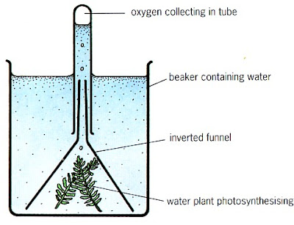

***Question : describe the effect of increasing the light intensity on the number of bubbles produced during photosynthesis .***

…………………………………………………………………………………………………………………..

**c. Investigating the need for carbon dioxide in photosynthesis**

1. De- starch 2 plants (this step was done for you)
2. Tie a clear bag containing soda lime, around the plant.
3. Tie a clear bag containing sodium hydrogen carbonate around the other plant.
4. Place the plants in bright light for several hours.
5. 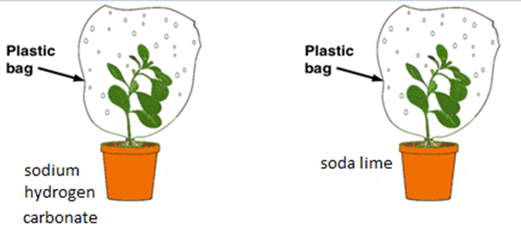Test the leaves of both plants for starch using iodine

***Check your understanding :***

**Question 1:**

Describe the steps 2 and 4 to detect the presence of starch in leaves :

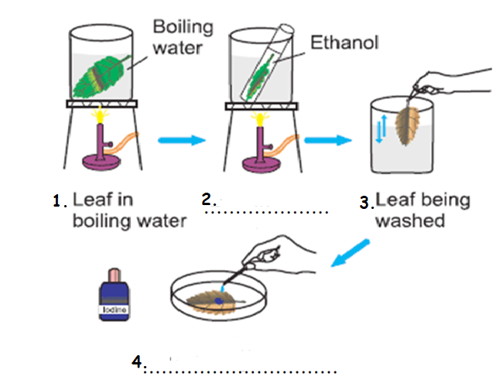

**Question 2 :**

Carbon dioxide is needed for photosynthesis

Use the diagram below to answer the following questions .

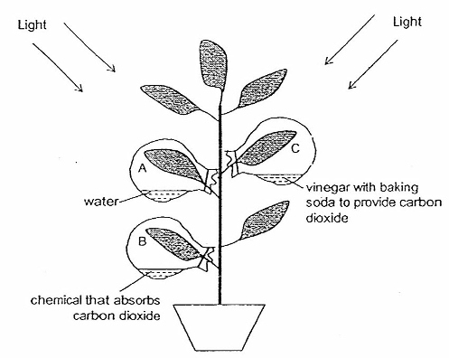

1. Vinegar with baking soda is used to produce ________.
2. Leaves can make photosynthesis because _________________________________________.
3. In photosynthesis plants need __________ ,carbon dioxide and produce starch , _________ with the presence of light.
4. Which leaf A,B or C will turn blue black when iodine is added.

**Question 3 :**

1. The figure below shows a cross section in a leaf .

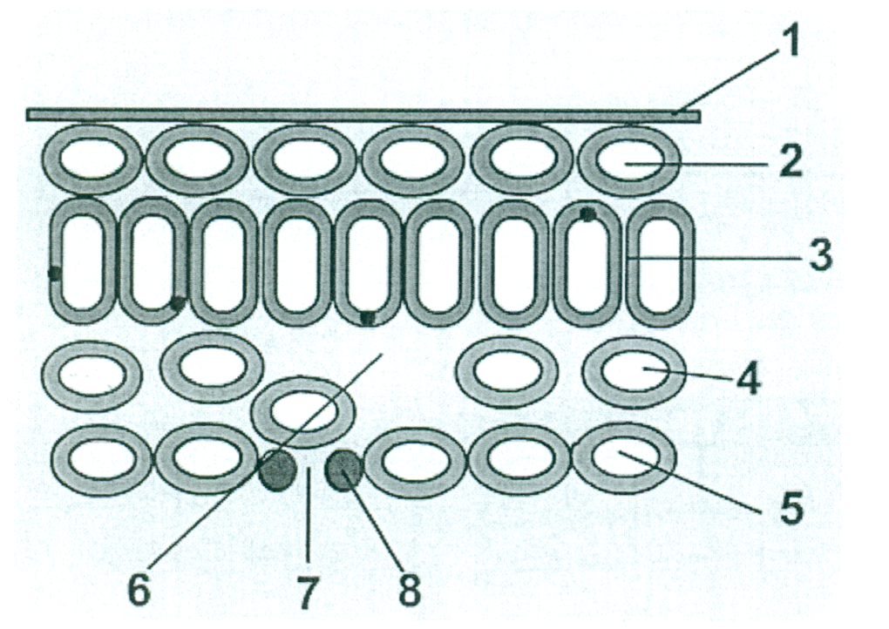

* Name the following parts :

2: .............................................

4: .............................................

8: .............................................

* What is the function of part 3 ? ...............................................................
* Photosynthesis is an important process in plants .

1. Write the word equation of photosynthesis.

..............................................................................................

**Question 4:**

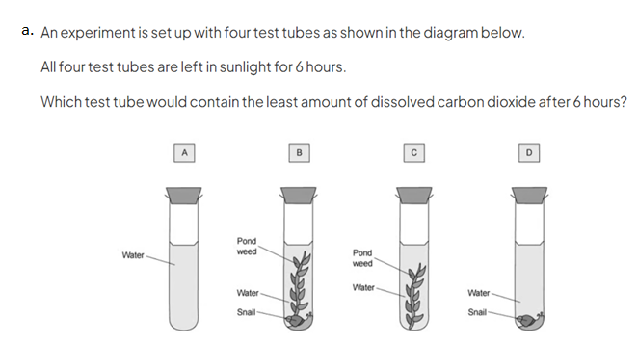Circle the correct answer :

