

Grammar worksheet (1)

Adjectives with -ed and -ing

Grade ( 3 )

Name: Date: / /2023

**Adjectives could be color , size, shape and numbers feeling.**

|  |
| --- |
| **Objectives:**  1. To be able to identify adjectives in sentences.  2.To differentiate between adjectives ending in -ed and -ing.  3.To practice using adjectives ending in -ed and -ing **.** |

**Example:**

*The **blue** whale is very **large**.

* We have **three** **circle** tables in my home.

**Q1) Circle the adjectives among the following words.**

**Sun long giraffe sad red**

**yellow happy school big triangle**

**green sport large small Suzi**

**one sea circle sit tall**

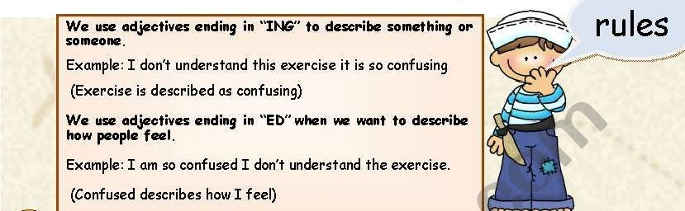

**Examples**:

1. You look really **tired** . why don’t you go to bed ?

( describing what he feels)

1. His exam results were really **disappointing** .

( describing the results (thing ) )

1. I was really **surprised** that I won the competition.
2. This book is **boring** I don’t like it. If I read it I get **bored.**

**Q2) Circle the correct adjective according to the sentence.**

1. Holidays are **exciting / excited** .
2. The festival was **amazed/ amazing.**
3. I was **interested / interesting** in this book .
4. Flying is **frightening / frightened** .
5. Sweeping the floor is **tired / tiring.**
6. The last lesson was **bored / boring** .

**Q3) Order the words to make correct sentences .**

1. I / interested / in / am / soccer / game.

**________________________________________.**

1. The / wasn’t / festival / exciting .

**_______________________________________.**

**Q4) Complete the sentences with a correct adjective .**

1. My English class is so **_______________.( interest)**
2. Rainy days make me feel **______________.(depress)**
3. My teacher is **_______________** by the studentsbecause they are **______________.( annoy )**
4. I was **____________** when I heard the news**.(shock)**
5. Grammar is ____________.(**confuse)**

**Q5) Write 2 sentences about something you like ( use adjectives with –ed , -ing) .**

**1.________________________________________.**

**2.________________________________________.**

Teacher : Raneem Haddad

Coordinator’s Signature: ___________.