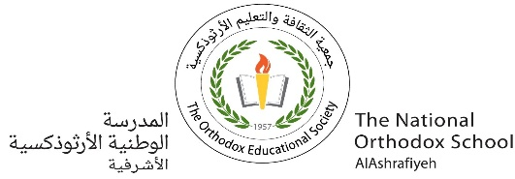 Meaning Worksheet ( 1 )

Having Fun

Grade (3)

Name: Date: /9/2023

|  |
| --- |
| **Objectives:**  1. To identify the meaning of the new words.  2. To identify the synonym of the new words.  3. To use the new words in meaningful sentences. |

|  |  |  |
| --- | --- | --- |
| **Nouns** | **Meaning** | **Synonym** |
| **Festival** | A number of special events such as shows in one place.  **Example:**  I am going to the Jarash festival next Friday . | Celebration. |
| **Folk dance** | A type of dance that the people of a particular country have been doing for a long time .  **Example**:  Rama participates in the Jordanian folk dance in the school. | Social dancing / traditional dancing . |
| **Wedding** | A time when two people get married.  **Example**:  This is the most amazing wedding party. | Marriage. |
| **Family reunion** | A meeting of people from the same family.  **Example**:  There was a family reunion party and my cousin was there. | Gathering |
| **Fair** | A place outside where you can ride on a big machine and play games.  **Example**:  I like going to the fair with my friends. |  |
| **Race** | A competition to see who is the fastest to do something.  **Example:**  Suzi wins the race. | A competition. |

|  |  |  |
| --- | --- | --- |
| **Team** | A group of people who play a game together against another group.  **Example:**  They are the worst team in baseball. | A group / crew |
| **Winner** | A person or an animal that wins a game.  **Example:**  Jack is the winner of the school champion. | A hero / a victor. |
| **Score** | The number of points that you get in a game.  **Example:**  Our team gets the high score in the competition. | Result / Mark. |
| **Player** | A person who plays a game or a musical instrument. | Sportsman. |
| **Athlete** | A person who participates in sports or other physical activities.  **Example**:  The **athlete** has got powerful muscles. | Player |
| **Costumes** | Clothes  **Example**:  Dani wore a pirate **costume** on Halloween. | Clothes. |

|  |  |  |
| --- | --- | --- |
| **Adjective** | **Meaning** | **Synonym** |
| **Delicious** | Having a pleasing taste or smell.  **Example:**  The apple pie is **delicious**. | Tasty |
| **Exciting** | Being very happy  **Example**:    I've got some very **exciting** news for you. | Being happy |
| **Special** | Unique  **Example**:  We're going to a **special** restaurant to celebrate. | Unique |
| **Popular** | Famous  **Example**:  Folk dance is **popular** around the world. | Famous |

**Q1) Order these words to make meaningful sentences.**

1. am/ dance/ I/ very/ not/ folk / of / fond.

I am not very fond of folk dance.

2. hope / be / I / to/ player / piano / a.

I hope to be a piano player.

3. Chinese / Year /New / is / most /the/ important /festival / China /in .

Chinese New Year is the most important festival in China.

**Q2) Match each word with its synonym.**

1. Wedding a. traditional dancing
2. Score b. Result
3. Race c. group
4. Team d. marriage
5. Folk dance e. competition

|  |
| --- |
| 1.----d-----2.----b-----3.-----e---4.----c----5.----a---- |

**Q3) Unscramble the alphabets to make a word.**

1. s / F/ e / t / l / v / a/i. Festival
2. d / W/ n / e / d / i / g . Wedding
3. r / F/ i / a. Fair
4. e / c / o / s / r.

Score

**Q4) Complete the sentences using the words in the box.**

|  |
| --- |
| race festivals winner player popular |

1. Who won the  **race** ?
2. He is the best player in the team.
3. Diwali is one of the most beautiful festivals of India.
4. Shrimps are a **popular** type of seafood.

**Q3)** **Write the correct word under each picture.**



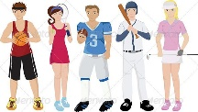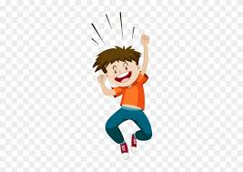

1. 2. 3.

Exciting / Athlete Delicious

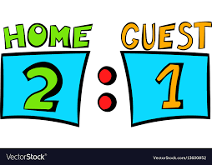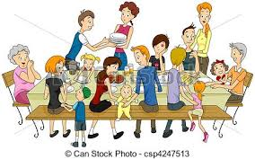

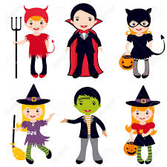

1. 5. 6.

Family reunion Costumes Score

T. Raneem Haddad . Coordinator’s Signature