**Grammar Worksheet** **|** The Secondary Stage of (6-8)

1st Semester | 2023-2024

|  |  |
| --- | --- |
| **Subject:** Present Simple and Continuous | **Grade: 7NAT** |
| **Objectives:**   * To identify present simple and present continuous.   **Name:** _________________________ | |

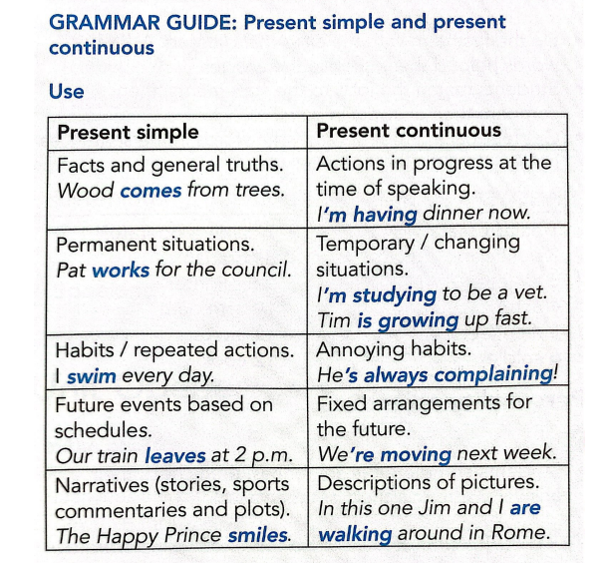

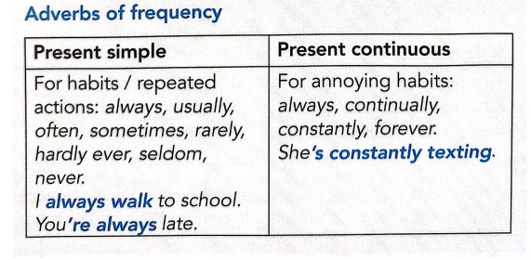

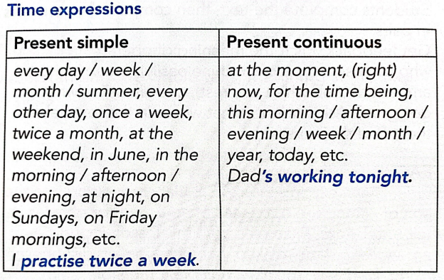

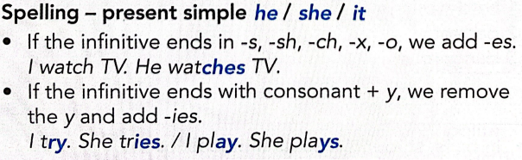

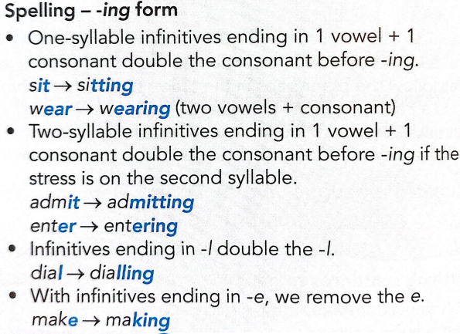

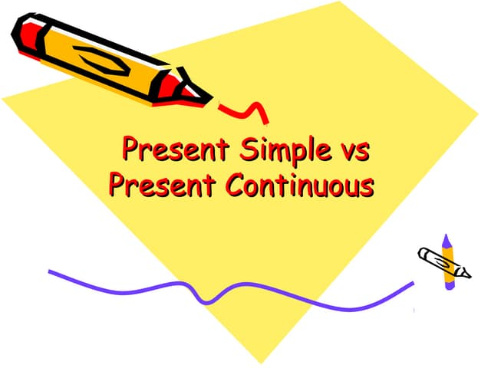

* 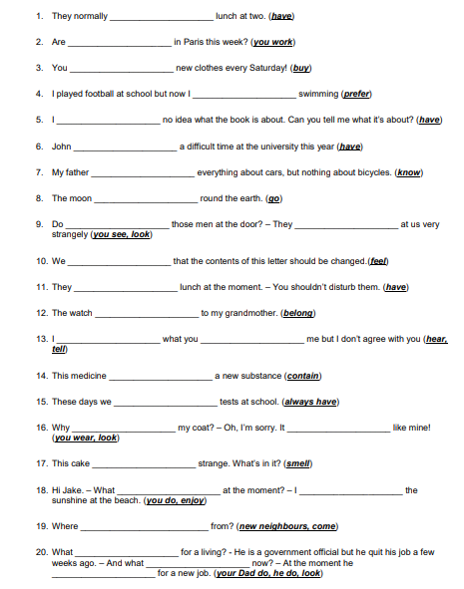**Fill in the blanks with the correct present tense.**