**Study sheet |** The Secondary Stage of (6-8)

1st Semester | 2023-2024

|  |  |
| --- | --- |
| **Subject:** English – 7CS | **Unit one: choice** |
| **Objectives:**   * To study and cover the aspects of writing a persuasive letter | |

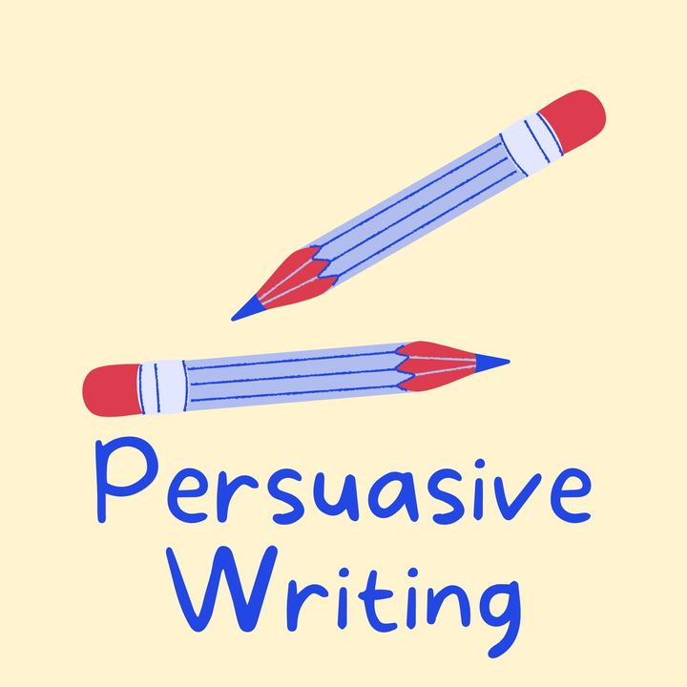

**what is a persuasive letter ?**

Persuasive Letter is a letter written to persuade an organization/s or individual/s towards accepting the writer's (sender’s) issue, interest or perspective. It can be written to any type of organization i.e. school, bank, college, NGO, municipality etc. The individuals can be a director, CEO, government official etc.

**The persuasion can be related to any matter; it can be:**

* A complaint
* A sale
* A petition
* A request or any other matter which requires convincing

**Sample**

Dear Mrs Head Teacher

I hope you don’t mind me writing to you about a possible trip for Y5 to Alton Towers.

Everyone agrees that you are the kindest head teacher that this school has ever had and that you do everything in your power to ensure that Greenfield School is an enjoyable place to learn.

I am sure that you have noticed that Y5 have worked exceptionally hard this year and produced some outstanding work, particularly in literacy. However, they are all now tired and really need something to give them a boost until the end of term. A trip to Alton Towers would be the perfect solution!

In addition, when we returned to school, we would have so much to write about for our next topic, “Theme Parks of England”.

I know that if you agreed to this, I would feel as delighted as the winner of the lottery. A trip to Alton Towers would be the most sparkling, special and spectacular day of my whole life!

To finish: would you love to give your pupils an extra reward for working so hard this term? Then please agree to our request. We would remember it forever!

Thank you very much for reading my letter.

Yours faithfully

S

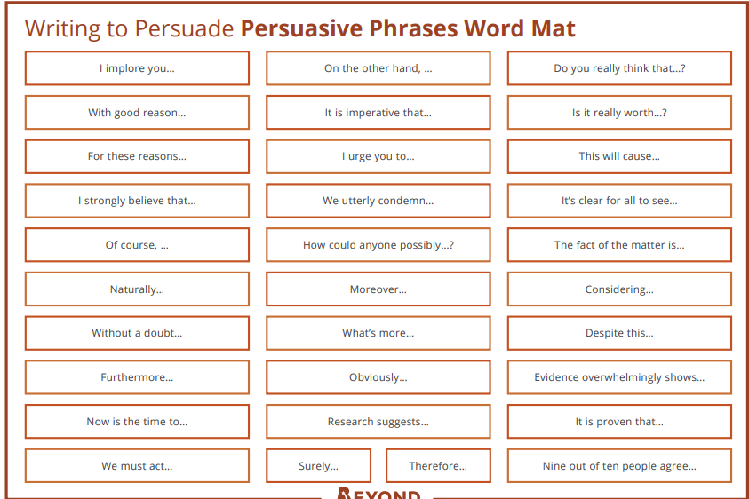

**Formal persuasive letter organizer**

**Greetings**

**____________________________________**

**____________________________________**

**____________________________________**

**Opening statement that provokes and hooks the reader to be interested in your request.**

**___________________________________________________________________________________**

**__________________________________________________________________________________**

**__________________________________________________________________________________**

**__________________________________________________________________________________**

**Body paragraphs that explain your request and the reasons which make your request both logical and up for discussion and approval**.

_________________________________________________________________________________

_________________________________________________________________________________

_________________________________________________________________________________

_________________________________________________________________________________

_________________________________________________________________________________

_________________________________________________________________________________

_________________________________________________________________________________

_________________________________________________________________________________

_________________________________________________________________________________

_________________________________________________________________________________

_________________________________________________________________________________

_________________________________________________________________________________

_________________________________________________________________________________

**Closing statement that leaves your reader with something to think about in order to approve what you have asked for.**

**______________________________________________________________________________**

**______________________________________________________________________________**

**______________________________________________________________________________**

**______________________________________________________________________________**

**Yours sincerely / Faithfully ( state your name)**

**Writing Checklist**

Did you include….?

|  |  |
| --- | --- |
| an opening sentence that hooks the reader and explains why you are writing in the introduction paragraph |  |
| body paragraphs that explain a point each and evidence to support it |  |
| emotive language, such as ‘Everyone would be ecstatic if…’ |  |
| persuasive phrases from the persuasive phrases word mat |  |
| rhetorical questions, such as ‘Are we supposed to just sit back…? |  |
| exaggeration, such as ‘It would be a tragedy if…’ |  |
| flattery, such as ‘I’m sure that you have noticed…’ |  |
| a conclusion that summarizes that main point and reinforces the opinion |  |
| ‘Yours faithfully’ if you don’t know the recipient or ‘Yours sincerely’ if you do know the recipient |  |
| simple, compound and complex sentences |  |
| 180-250 words |  |