**Worksheet 2 -Answer Key**

**Paddle -Script**

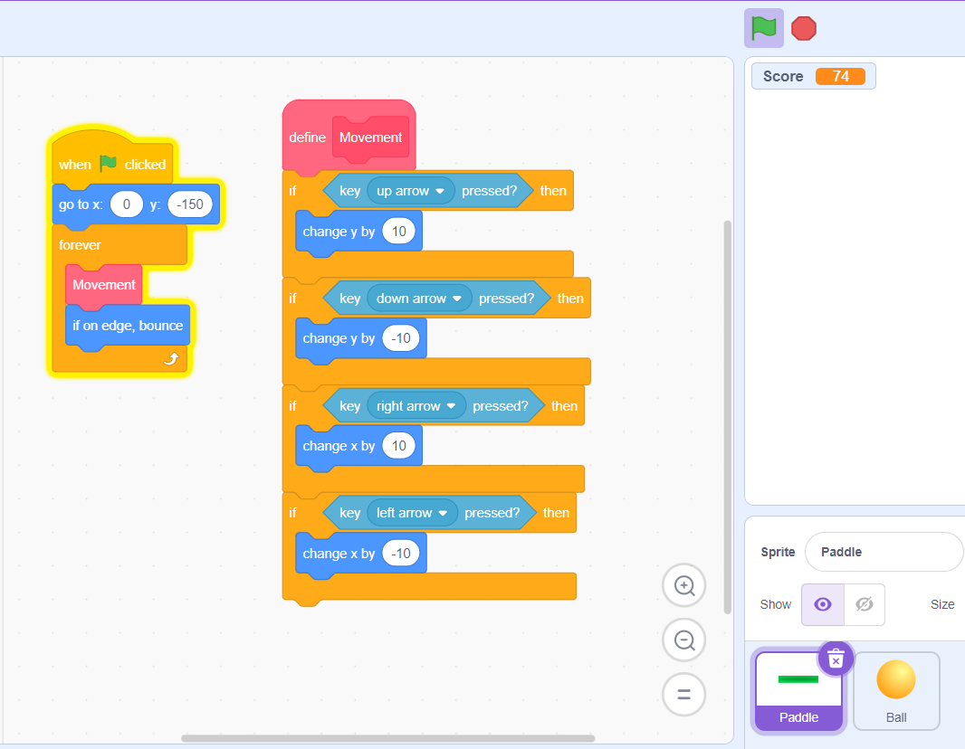

**Ball -Script**

