ورقة عمل (3) محور البراعة البشريّة (الابتكار العلمي والتّكنولوجيا) المرحلة (9-12)

الفصل الدّراسيّ الأوّل 2023/2024

|  |  |
| --- | --- |
| اسم الطّالبـ/ــة: …………………………………………………….. | المــادّة: اللّغة العربيّة |
| التّاريخ: / / | الصف: التّاسع الدّبلوما لشعبة ( ) |
| الأهداف:   * يقدّر الطّالب دور الإنسان على مر العصور . * يستكشف أهميّة الابتكارات وأثرها على كوكب   الأرض وعالمنا الإنساني.   * يبيّن الطّالب أهميّة التّنمية المستدامة في الحياة   الإنسانية. |  |

بعد فهمكم لمحور البراعة البشرية موضوع( الابتكار العلمي والتّكنولوجيا) اختاروا صورة من الصّور التّالية وحلّلوهامن حيث المضمون والرّسالة مراعيين كتابة مقدّمة وخاتمة للتّحليل.

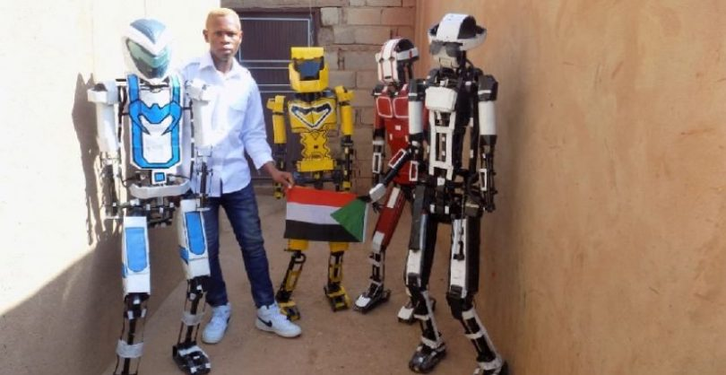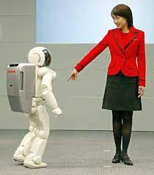

............................................................................................................................................................................................................................................................................................................................................................................................................................................................................................................................................................................................................................................................................................................................................................................................................................................................................................................................................................................................................................................................................................................................................................................................................................................................................................................................................................................................................................................................................................................................................................................................................................................................................................................................................................................................................................................................................................................................................................................................................................................................................................................................................................................................................................................................................................................................................................................................................................................................................................................................................................................................................................................................................................................................................................................................................................................................................................................................................................................................................................................................................................................................................................................................................................................................................................................................................................................................................................................................................................................................................................................................................................................................................................................................................................................................................................................................................................................................................................................................................................................................................................................................................................................................................................................................................................................................................................................................................................................................................................................................................................................................................................................................................................................................................................................................................................................................................................................................................................................................................................................................................................................................................................................................................................................................................................................................................................................................................................................................................................................................................................................................................................................................................................................................................................................................................................................................................................................................................................................................................................................................................................................................................................................................................................................................................................................................................................................................................................................................................................................................................................................................................................................................................................................................................................................................................................................................................................................................................................................................................................................................................................................................................................................................................................................................................................................................................................................................................................................................................................................................................................................................................................................................................................................................................................................................................................................................................................................................................................................................................................................................................................................................................................................................................................................................................................................................................................................

معلمة المادة لينا حدّاد.