**Worksheet #2** **|** The Lower Secondary of Stage (6-8)

1st Semester | 2023-2024

|  |  |
| --- | --- |
| **Subject:** ICT | **Chapter:** 4 |
| **Objectives:**   * Write a program that controls movement for each sprite. * **Using Modules** | |

**The game scenario**

The user can move the **Paddle** using arrows (up- down - right - left) so it can touch the falling ball.

The ball will fall from the top of the stage until it touches the paddle it will hide, and the score will increase by 2.

This game uses **white** backdrop and two sprites: **Ball** and **Paddle.**

1. Create a new project.
2. Name your new project (Ball and Paddle - Add your name)
3. Add a new variable **(Score) for all sprites.**
4. When the green flag clicked set the value of the variable **(Score) to 0.**
5. For this sprite **(Ball)**

Add (When flag clicked)

Set the score variable to 0.

Go to random position.

Set Y to 180.

**Add Forever Loop.**

* Change Y by (-5)
* If the ball touches the paddle then:
  + Hide
  + Change score by 2
  + Go to random position.
  + Set Y to 180.
  + Show
* If Y Position less than -150 then:
  + Hide.
  + Go to random position.
  + Set Y to 180.
  + Show.

1. For the Sprite **(Paddle)**

Create a Module: click on the red “My Blocks” dot. Then click the button “Make a Block”. The new block will store the movement commands.

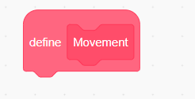Add the following commands to the Module:

* + Move the **Paddle** up when the **Up Arrow** pressed.
  + Move the **Paddle** down when the **Down Arrow** pressed.
  + Move the **Paddle** right when the **Right Arrow** pressed.
  + Move the **Paddle** Left when the **Left Arrow** pressed.

Starts when the green flag clicked.

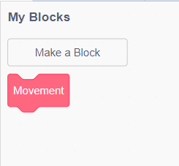 Set X to 0 and Y to -150

Add Forever Loop.

* + Add the movement block.
  + If on edge bounce

1. Save your work.