 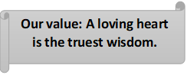

**Present Continuous** **Worksheet No. (4)**

Grade 6(A + B)

Name: Date: / /

Objectives: To review the present continuous tense.

To practise using the present continuous tense.

------------------------------------------------------------------------------------------------------------

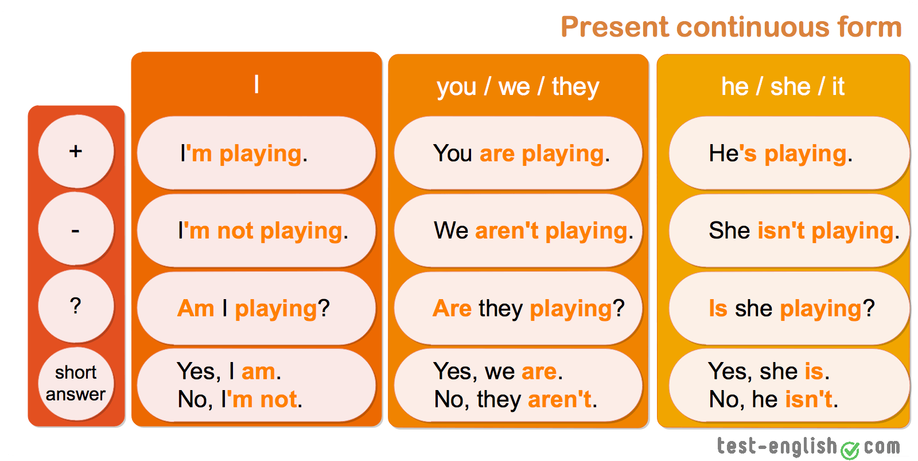

Uses…

* 1. **Now, at the time of speaking.**

http://www.englishpage.com/image/verbs/presentcontinuousnow.gif

* You **are learning** English now.
* You **are not swimming** now.
* **Are** you **sleeping**?
* I **am sitting**.
* I **am not standing**.
* **Is** he **sitting** or **standing**?
* They **are reading** their books.
* They **are not watching** television.
* What **are** you **doing**?
  1. **Around the time of speaking.**

http://www.englishpage.com/image/verbs/presentcontinuouslongnow.gif

* I **am studying** to become a doctor.
* I **am not studying** to become a dentist.
* I **am reading** the book *Tom Sawyer.*
* I **am not reading** any books right now.
* **Are** you **working** on any special projects at work?
* **Aren't** you **teaching** at the university now?
  1. **Near future plan (personal arrangement)**

http://www.englishpage.com/image/verbs/simplefuture.gif

* I **am meeting** some friends after work.
* I **am not going** to the party tonight.
* **Is** he **visiting** his parents next weekend?
* **Isn't** he **coming** with us tonight?
  1. **To express annoyance**

You are always talking in class.

**Key words**

**Now, At present, At this moment, Still, Still now**

**A)Choose the correct answer.**

.    
I _____ football. He ____ video games.

|  |
| --- |
| am playing |
| is playing |
| are playing |

|  |
| --- |
| am playing |
| is playing |
| are playing |

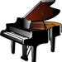   
You ____ the piano. She ____ rugby.

|  |  |  |  |  |  |  |  |
| --- | --- | --- | --- | --- | --- | --- | --- |
| |  |  | | --- | --- | |  | am playing | |  | is playing | |  | are playing | |  |

|  |  |
| --- | --- |
|  | am playing |
|  | is playing |
|  | are playing |

**B) Make the following sentences negative.**

|  |  |
| --- | --- |
| 1. I am thinking. |  |
| 2. You are singing. |  |
| 3. He is eating jelly. |  |
| 4. She is studying hard. |  |
| 5. It is raining now. |  |

**C)Use the underlined words to form questions.**

1. We are travelling by ship.

How are you travelling?

-------------------------------------------------

Top of Form

Bottom of Form

1. 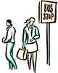We are waiting because the bus is late. Why are we / you waiting?

Top of Form

------------------------------------------------wbhhjbvhjfb

Bottom of Form

1. It's raining hard. [YES/NO] Is it raining hard?

--------------------------------------------------------------

Top of Form

Bottom of Form

1. She's going to work. Where is she going?

----------------------------------------------------------------

1. baconHe's cooking bacon for supper. What is he cooking for supper?

--------------------------------------------------------------

Top of Form

Bottom of Form

1. You're giving her flowers because it's her birthday. Why are you giving her flowers?

Top of Form

-------------------------------------------------------------

Bottom of Form

1. balloonShe is having a party. [YES/NO] Is she having a party?

-----------------  
------------------------------------------------------------

Bottom of Form

1. 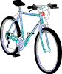He's riding a bike. [WHAT]
2. Bottom of Form

What is he riding?

--------------------------------------------------

**D) Fill in the blanks with the correct tense( simple present or present continuous).**

1. Every Monday, Sally **(drive)** drives her kids to football practice.   
2. Usually, I **(work) work** as a secretary at ABT, but this summer I am studying **(study)** French at a language school in Paris. That is why I am in Paris.   
3. Shhhhh! Be quiet! John **(sleep)** is sleeping.  
4. Don't forget to take your umbrella. It **(rain)** is raining.   
5. I hate living in Seattle because it **(rain, always)** always rains.   
6. I'm sorry I can't hear what you **(say)** are saying because everybody **(talk)** is talking so loudly.   
7. Justin **(write, currently)** is currently writing a book about his adventures in Tibet. I hope he can find a good publisher when he is finished.   
8. Jim: Do you want to come over for dinner tonight?  
Denise: Oh, I'm sorry, I can't. I **(go)** am goingto a movie tonight with some friends.   
9. The business cards **(be, normally)** are normally printed by a company in New York. Their prices **(be)** are expensive, yet the quality of their work is quite good.

10. This delicious chocolate **(be)** is made by a small chocolatier in Zurich, Switzerland.

Coordinator’s Signature: _________________

Teacher: Mirna Nawaf Al-Sahawneh.