 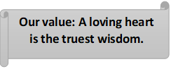

**Grammar Worksheet ( Revision) Grade 7**

**Worksheet No. (5)**

**Name ………………… Date: / /**

**Objectives: To revise the present continuous tense.**

**To practice forming and using the present continuous tense.**

**\*\*Form:**

| **Affirmative** | **Negative** | **Interrogative** |
| --- | --- | --- |
| **I** am going | I am not going | Am I going? |
| **You** are going | You aren't going. | Are you going? |
| **He, she, it**is going | He, she, it isn't going | Is he, she, it going? |
| **We** are going | We aren't going | Are we going? |
| **You** are going | You aren't going | Are you going? |
| **They** are going | They aren't going | Are they going? |

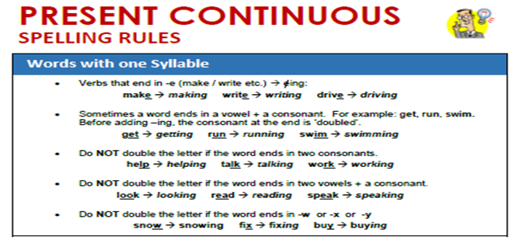

***Verbs end in (ie) change the (ie) into (y) then add (ing)

Die dying

**Present Continuous Uses**

**USE 1: Now**

present continuous now

Use the present continuous with [normal verbs](https://www.englishpage.com/verbpage/types.html) to express the idea that something is happening now, at this very moment. It can also be used to show that something is not happening now.

Examples:

* You **are learning** English now.
* You **are not swimming** now.

**USE 2: Actions that are temporary (around the time of speaking)**

present continuous longer duration

* I **am studying** to become a doctor.
* I **am reading** the book *Tom Sawyer.*
* I **am not reading** any books right now.
* **Are** you **working** on any special projects at work?

### USE 3: Near Future

present continuous near future

Sometimes, speakers use the present continuous to indicate that something will or will not happen in the near future.

Examples:

* I **am meeting** some friends after work.
* I **am not going** to the party tonight.
* **Is** he **visiting** his parents next weekend?
* **Isn't** he **coming** with us tonight?

**\*\*Time Expressions:**

* 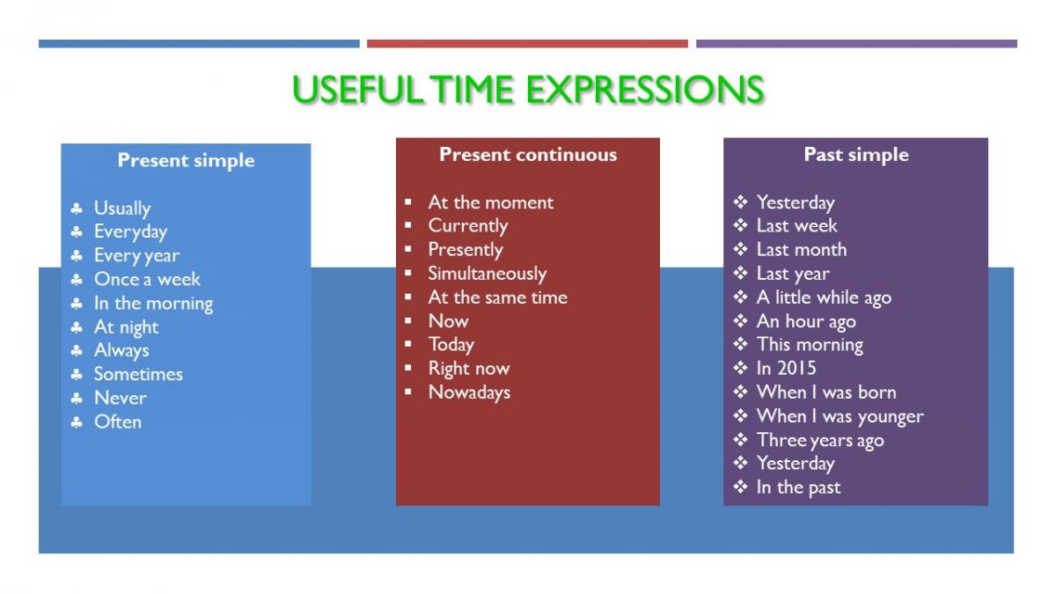

**\*A) Complete the following sentences using Present Continuous Tense. (Capitalize when needed)**

1. My son is talking (**talk**) on the phone right now. (now)

2. Are you sleeping (**you** / **sleep**)? (now)

3. Jason is doing (**do**) his homework at the moment. (now)

4. Tom is working (**work**) on a project nowadays. (around the time of speaking)

5. My kids are playing (**play**) in the garden now. (now)

6. Some people are waiting (**wait**) to talk to you. (now)

7. My wife isn’t cooking (**not/** **cook**) today. (near future)

8. Is Lucas studying (**Lucas** / **study**) for his exam right now? (now)

9. Is Rayan playing (**Ryan** / **play**) the piano now? (now)

10. Lea and I are painting (**paint**) the fences today. (near future)

11. Andrea is helping (**help**) me at present. (around the time of speaking)

12. My children aren’t listening (**not/** **listen**) to the radio now. (now)

13. Selena isn’t drinking (**not/** **drink**) tea now. (now)

14. I am vacuuming (**vacuum**) the carpet right now. (now)

15. My father is watching (**watch**) TV now. (now)

16. What is she eating (**she** / **eat**) right now? (now)

17. Is your dog hiding (**your** **dog** / **hide**) from me? (now)

18. What book are you reading (**you** / **read**) nowadays? (around the time of speaking)

19. Thomas is driving (**drive**) me home now. (now)

20. I am washing (**wash**) my face at the moment. (now)

*B) Complete the sentences with the words between brackets using simple present or present continuous. Write the use under each sentence.

1.Look! She is running **(run)** because she's late for her lesson.

An action that is happening now.

2.Our teacher always gives **(give)** us lots of homework.

Habit

3.We never go **(go)** to the cinema.

Habit

4.What time are you meeting **(you / meet)** Pete tomorrow?

Near future

5.I am not working **(not work)** today. I'm on holiday.

Near future

6.Pete is making **(make)** a project these days.

Around the time of speaking

7.Andrew is not using (not use) his computer at the moment.

An action that is happening now.

8. Does Tony live **(Tony / live)** near the park?

Permanent state

9.Earth moves around. **(move)**

Fact

10.The football match begins at 6:00 p.m. **(begin)**

Time table

Coordinator’s Signature: ______________________