 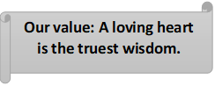

**Grammar Worksheet (Revision)**

**Grade (7)**

**Worksheet No (4)**

**Name ………………… Date: / /**

Objectives: To revise the present simple tense.

To practise forming and using the present simple tense.

The **present tense** is the base form of the verb:

I **work** in London.

But with the third person singular (**she/he/it**), we add an –**s**:

She **works** in London.

**Present simple questions:**

**Do** you **play** the piano?

Where **do** you **live**?

**Does** Jack **play** football?

Where **does** he **come** from?

**Do** Rita and Angela **live** in Manchester?

**\*Verb to be in simple present stands alone without a helper:**

Example: She **is** a clever student.

Negative: She **isn’t** a clever student.

Question: **Is** she a clever student?

We use **do and does** to make questions with the present simple. We use **does** for the **third person singular (she/he/it**) and do for the others.

We use **do** and **does** with question words like **where**, **what** and **when**:

**Where** **do** Angela and Rita **live**?

**What** **does** Angela **do**?

**When** **does** Rita usually **get** up?

**Present simple- negative form**

Look at these sentences:

I like tennis but I ***don't like*** football. (don't = do not)

I **don't live** in London now.

I **don't play** the piano but I play the guitar.

They **don't work** at the weekend.

John **doesn't live** in Manchester. (doesn't = does not)

Angela **doesn't drive** to work. She **goes** by bus.

We use do and does to make negatives with the present simple. We use **doesn't** for the **third person singular (she/he/it)** and **don't** for the others.

We use the present simple to talk about:

1. **Something that is true in the present (permanent):**

I**'m** nineteen years old.

I**'m** a student.

He **lives** in London.

1. **Something that happens regularly in the present ( repeated actions and habits) :**

I **play** football every weekend.

1. **Something that is always true (facts):**

The human body ***co*ntains** 206 bones.

Light **travels** at almost 300,000 kilometers per second.

1. **Schedules and timetables**.

The plane **takes** off at 10 0’clock.

We often use **adverbs of frequency** like **sometimes, always, rarely, often, usually** and **never** with the present simple:

I **sometimes** go to the cinema.

She **never** plays football.

Note: They **are used before main verbs but after verb to be.**

He **always** goes to school.

He is **always** late.

*Spelling rules:

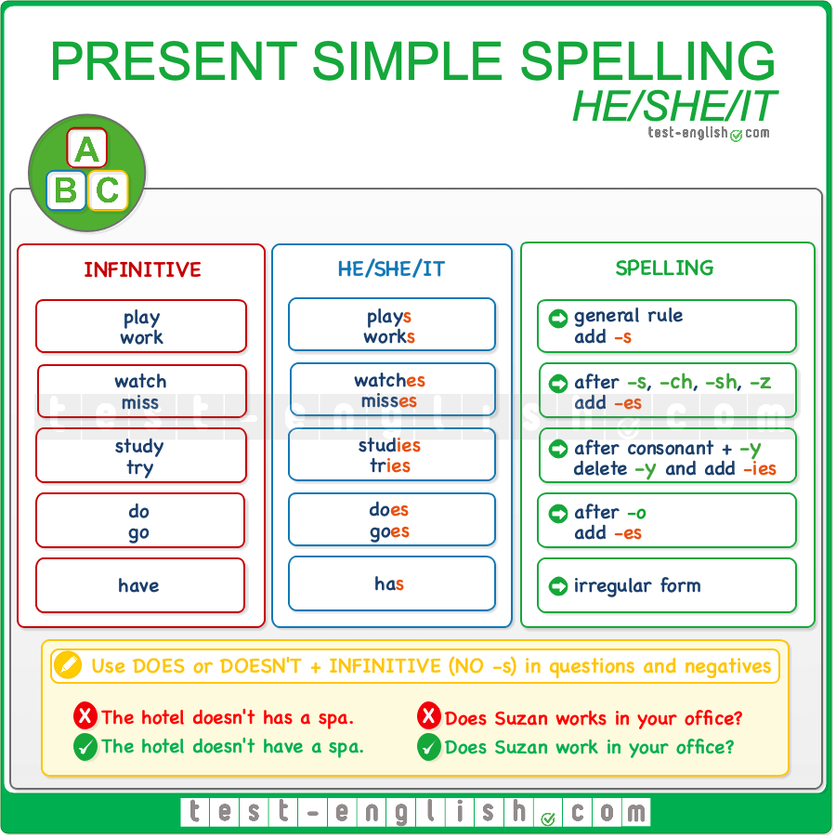

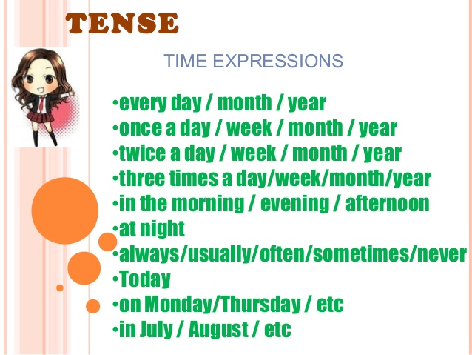

A) Add -s, -es or -ies to the verbs below to form the Present Simple after **he, she** or **it.**

1. stop stops 7. dress dresses

2. watch watches 8. try tries

3. study studies 9. go goes

4. do does 10. catch catches

5. mix mixes 11. enjoy enjoys

6. tie ties 12. lose loses

**B) Complete the sentences with the Present Simple form of the verb in brackets**.

1. Mum washes (**wash**) the car once a week.

2. Children usually like (**like**) ice cream.

3. Do you know (**know**) the way to the lake?

4. He doesn’t visit (**not/** **visit**) his friends every day.

5. Bob studies (**study**) French on Saturdays.

6. Every year Helen goes (**go**) to France.

**C) Write each sentence in the negative. Then write an affirmative sentence using the words in brackets.**

1. You need more spelling practice. (reading)

You don’t need more spelling practice.

You need more reading practice.

2. My dad reads the newspaper every day. (a book)

My dad doesn’t read the newspaper every day.

My dad reads a book every day.

3. I study on Saturdays. (Sundays)

I don’t study on Saturdays.

I study on Sundays.

4.Mark goes to karate lessons. (piano)

Mark doesn’t go on Karate lessons.

Mark goes to piano lessons.

**D) Write questions and answer them about yourself.**

1. your grandma / often / visit you?

Does your grandma often visit you?

Yes, she does. / No, she doesn’t.

2. you / watch / TV / in the evening?

Do you watch TV in the evening?

Yes, I do. / No, I don’t.

3.your dad / play / the guitar?

Does your dad play the guitar?

Yes, he does. / No, he doesn’t.

1. your friends / like / computer games?

Do your friends like computer games?

Yes, they do. / No, they don’t.

**E) Fill in the spaces with the correct form of the verb in simple present tense and write the function.**

Example: **I (play)** play the guitar.

Example: Jessica **(play)** plays the guitar.

1) I **(be)** am sixteen years old. Permanent state

2) Tommy **(live)** lives at 107 Pine Lane. Permanent state

3) Juana (**cook)** cooks dinner for her family. Habit

4) They **(eat)** eat lunch at 12:00. Time table

5) Nina (**take)** takes medicine when she is sick. Habit

6) I (**like)** like chocolate. (Stative verb)

7) He **(drive)** drives a nice car.

8) We **(want)** want to see a movie tonight. (Stative verb)

9) Mr. Anderson **(teach)** teaches chemistry at Hill High School. Permanent state

10) They (**study)** study English at school. Permanent state

11) I **(want**) want to go home now. (Stative verb)

12) Bill and Cilicia (drive) drive to the mountains every year. Routine

13) We **(eat**) eat pasta once a week. Routine

14) It **(snow)** snows here in December. Fact

15) The Math class **(start)** starts at 8 o’clock. Time table

Coordinator’s Signature: _________________