

**Worksheet** **|** Lower Secondary

Stage (6-8)

1st Semester | 2023-2024

|  |  |
| --- | --- |
| **Subject:** Biology | **Chapter:** food webs |
| **Objectives:** | |

* Understand the concept of food webs, including their components.

Animals in an ecosystem form a food web. In the illustration below, use arrows to map out the energy transfer between organisms.

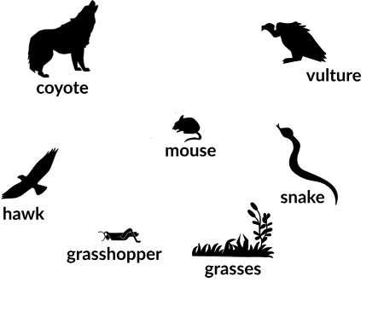

1. Name a producer in the food web above.

__________________________________________

1. Name three consumers in the food web above.

__________________________________________

__________________________________________

__________________________________________

1. What is the difference between food chains and food webs?

_________________________________________________________________________________________________________________________

1. The coyote is a predator to the ________________________.
2. Which animal would have a bigger food supply if the number of grasshoppers decreased?

__________________________

1. Which organism would have the least biomass in this food web? __________________________
2. Snakes are both predators and preys in this food web.
   1. True
   2. False
3. Decomposers are very important for life on Earth.

Explain the role of decomposers in food webs.

__________________________________________________________________________________________________________________________

1. Which trophic level is the hawk?

_____________________________

1. What would happen to the grasshopper’s population if the mice population decreases?

__________________________________________

1. What happens to the energy as we move up from one step to another?

_____________________________________________________________