Nowadays, mobile phones are playing an essential role in our daily lives. Write down an essay /article in which you discuss the advantages and disadvantages of mobile phones. (causes /effects- reasons and results of something)

Mobile phones (short )

(Topic sentence)

Nowadays, mobile phones are playing an essential role in our daily lives. In this essay, I am going to talk about /discuss the advantages as well as the disadvantages of mobile phones.

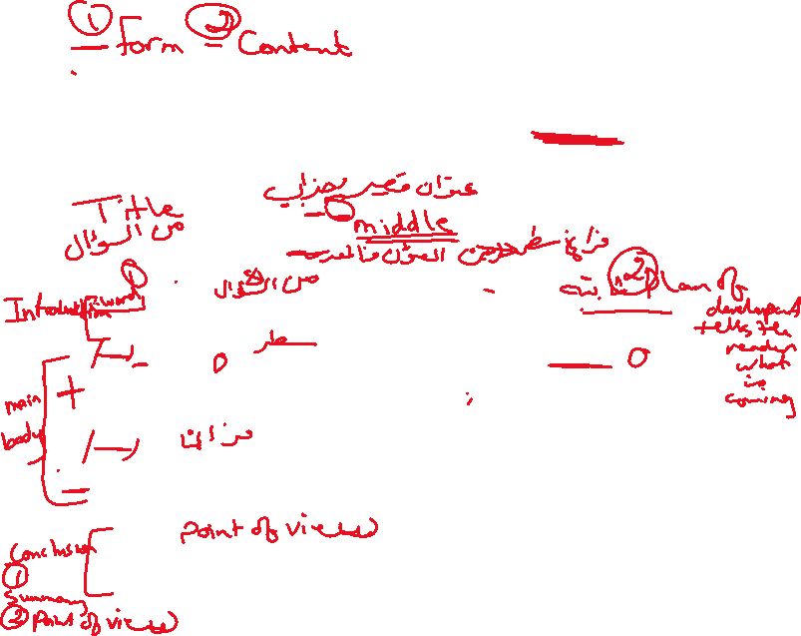

On one hand, there are many advantages of using mobile phones such as being the best and most convenient way of communication with people. In addition, they are great when it comes to entertainment because the new mobile phones that are getting launched nowadays come with great and impressive features/options related to entertainment.

On the other hand, there are many disadvantages of using mobile phones such having bad impacts on studying for students who are addicted to games and chatting. In addition, /Moreover /What is more some recent research proved /showed that mobile phones can cause some serious health problems.



 In my personal point of view/In my opinion I think / I believe that mobile phones are considered to be the greatest invention so far as long as we use them safely /wisely/carefully.

 Free writing

Discursive essay, article ……………… Discussion

Advantages and disadvantages of ………

Pros and cons of ……..

The importance of ……………



The necessity of …….

Suggest solutions- ways…..

Introduction general statement



Thesis statement



Body text ……………………… discussing both sides (topic sentence+ conjunctions)



Conclusion…………. Summary/ your opinion



1. Online distance learning has been spreading among students in Jordan recently. Write an essay discussing the advantages and disadvantages of this method of learning.



1. Healthcare inventions have become more common worldwide. Write an essay describing how those inventions will help people who need them in the future., supporting your ideas with examples.
2. “He who has health has hope and he who has hope has everything. Write a composition about the importance of an excellent healthcare system and how it contributes to a healthy community.

Title



Is it true that _____________________? Have you ever wondered about this? For many people, it is believed this topic sounds very interesting and remarkable to talk /discuss/handle about. Therefore, I intend to write_______________________________ .



Actually, there are a lot of positive points which are clear about this topic. First of all, ___on line learning ____________ is noticeably_______________ and___________________.Secondly, it is _____________________ and ___________________ .



For example, ___________________________.In addition to this, we should never forget that it might be fairly ___________________ and _____________________because _______________________. Finally, being _______________ and __________________ is obviously known. Of course, it has been very great to hear about this.



However, there are some disadvantages that are against____________ . I will start with the fact that it could be __________________ and ________________. Since it is ____________________. Moreover, it is known that it is___________ and __________________. Unexpectedly, it will cause many things, which include _____________________. That is why, we should carefully pay attention when tackling these points.



In the end, it is for those points, which have been considered impartially and comprehensibly this topic deserves to be discussed. In my opinion, __________________ indeed made our life pleasant and convenient although it is impossible to forget its impacts that will certainly influence the way we live.



The advantages and disadvantages of online shopping

Most people now use the Internet on computers, smartphones and tablets to do a variety of tasks from shopping for groceries to all kinds of clothes shopping. Consumers are finding this the easiest way to get what they need, literally at the touch of a button. However, there are numerous and important disadvantages to shopping in this way.

Although using the Internet to shop is usually fairly easy, and there is often greater variety available, it is always a risk because you cannot try on or see in detail the item you wish to buy. In fact, the immediate ‘convenience’ of shopping in this way can end up being an inconvenience if the item is faulty or does not fit, or is just not what the customer wanted. It is true that the prices are better when you shop online, but, while it might be cheaper, there is a distinct disadvantage because you have to wait for the delivery of the purchases. Some people might prefer not to have any personal contact while shopping online, but it can save time in the end since there are always assistants to help with queries you might have during the transaction. In addition to this, there is the issue of Internet payment security; however, recently this has improved a lot.

The Internet has indeed given us a wider choice as consumers, as well as made some aspects of shopping more pleasant and convenient However, it is nearly impossible, in my opinion, to forget the disadvantages we experience from time to time, since these can and do influence the way in which we choose to shop.

