

My cousin Rachel ch.1

(I Begin My Story)

Grade 7 ( A + B )

Name: Date : / /

Enjoy reading the chapter and answer the following questions.

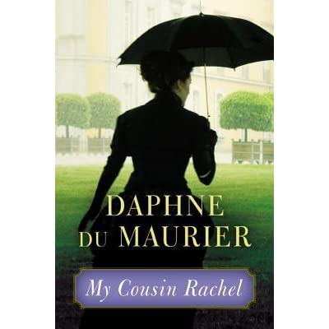

1. How did the narrator’s father die?

He was fighting in the war against the French in 1815.

1. Who became the narrator’s guardian?

His cousin.

1. What was his cousin’s name?

Ambrose.

1. Why weren’t there any female servants in the Ashley house?

Because Ambrose did not want women in the house.

1. What was the narrator’s routine after dinner?

He used to drink wine with Ambrose and sit in the library beside the fire.

1. What does it mean when the narrator says ‘I was his heir’?

It means that when Ambrose dies, the house and the land will be his.

1. How did Rachel die?

She was killed.

1. What’s the narrator’s name?

His name is Philip Ashley.

Teacher: Mirna Nawaf Al-Sahawneh.

Coordinator’s Signature: -------------------