Modals of speculations/possibilities

(must, can’t, might)

1. Must, can’t, might + Inf…………

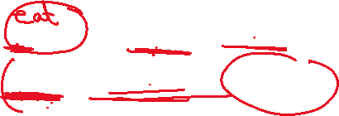

(Present simple, continuous perfect / future)

1. Must, can’t, might+ have + past participle…(past simple .con)



1. Mutual subjects



I am sure that she spoke in English during the seminar.



She must ____________________

It is impossible that they revise regularly.



They can’t ______________________

I am certain that Laith writes novels.



Laith must ____________



Perhaps my students are waiting impatiently for the exam.



My students might_____________________



It is unlikely that she was chosen to represent the country.



She can’t _____________________

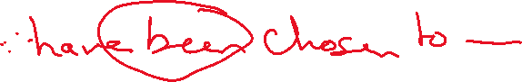

Sure Must



Certain

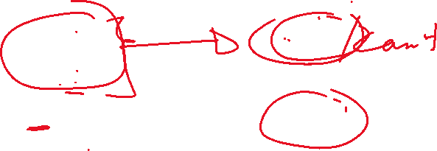

Impossible can’t



unlikely



Possible might



Possibly



Probably

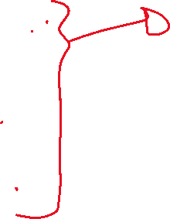

Probable

Perhaps



Think



1. Cases with Sure /certain

+ + must

+ _ can’t

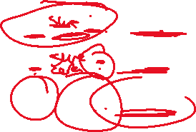

_ +/_ Might

I am sure that he writes……

He …………………

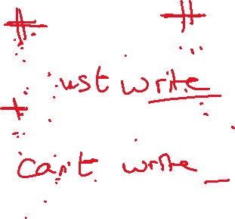

I am sure that he doesn’t write….

He ……………..

I am not sure/unsure that he writes……..

He …………………………



Ex:



I am sure that the employees will produce new things.



The employees__________________________

It is unlikely that Sami has failed such an interview.



Sami ________________________________

Ahmad works day and night. I am sure that he is much tired.

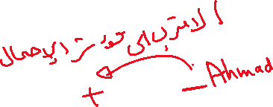

Ahmad_______________________________



Muna is a first ranking student. It is impossible that she postpones her study.



Muna ________________________________

Perhaps Ali’s book was found.

Ali’s book___________________________

I am sure that the teacher’s book has got more examples.

The teacher’s book _______________________

Exercise

**1.I am unsure that he emigrated to the USA.**

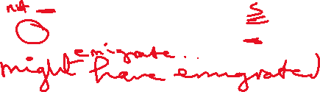

He _________________________________

**2. I am sure that he goes by plane.**



He ________________________________

**3.I am sure that she is more mature than her** **sister.**



She_______________________________



**4.I am sure she was more far- sighted than her sister.**

She ___________________________________



**5.It is unlikely that she will adhere to such rules.**



She__________________________________



**6.I am sure she was sending messages yesterday morning.**

She____________________________________

**7.I am sure Sami isn’t 38 years old.**

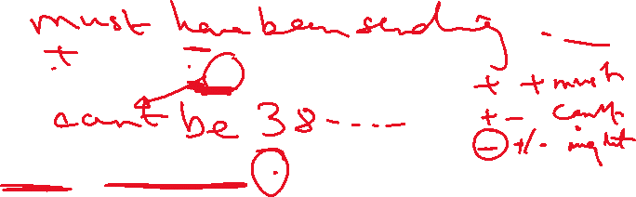

Sami __________________________________

**8.Perhaps Issa’s phone is broken.**

Issa’s phone ___________________________



9.**It is impossible that the farmer has watered the plants.**



The farmer _____________________________

10**.Mahmoud was walking home when it started to rain. I am sure that he has got very wet.**



Mahmoud _____________________________